INTEGRATED PAPERLESS DOCUMENT TRACKING AND WORKFLOW SYSTEM FOR DSWD UTILIZING SUPPORT VECTOR MACHINE CLASSIFICATION

A Research Project
Presented to the Faculty of the
School of Computer Studies
Arellano University, Manila
By:
GIZZLE MONTEMAYOR
ABNER T. DUARTE, JR.
ACE VERGEL S. CORREA
Co-Author:
JONNIFER C. MANDIGMA, MSIT
In Partial Fulfillment
of the Requirements for the Degree
Bachelor of Science in Computer Science

Date of Final Defense
09 September 2026

TABLE OF CONTENTS
PRELIMINARIES
Title Page i
Approval Sheet ii
Acknowledgement iii
Abstract v
Table of Contents vii
List of Tables x
List of Figures xi
Chapter 1 - INTRODUCTION
Introduction 5
Background of the Study 6
Statement of the Problem 8
Objectives of the Study 9
Scope and Limitations of the Study 12
Significance of the Study 13
Chapter 2 - REVIEW OF RELATED STUDIES AND LITERATURE
Theoretical Background 16
Technical Background 20
Related Literatures, Studies and Systems 22
Developmental Tools 28
Evaluation System 32
Conceptual Model 36
Synthesis 38
Operational Definition of Terms 39
Chapter 3 - DESIGN AND METHODOLOGY
Project Design 42
Project Development 46
System Design and Development Model/Approach 53
Operation and Testing Procedure 57
Evaluation Procedure 61
Research Instruments Used 63
Population and Sample 64
Statistical Treatment of Data 66
Chapter 4 - RESULTS AND DISCUSSION
Project Description 67
Project Structure 68
Project Capabilities and Limitations 76
Project Testing 78
Project Evaluation 80

Chapter 5 - SUMMARY OF FINDINGS, CONCLUSIONS, AND RECOMMENDATIONS
Summary of Findings 82
Conclusions 83
Recommendations 84
References 85
Appendices
Appendix A - Testing Instrument 88
Appendix B - Evaluation Instrument 90
Appendix C - Testing Results per Criterion 91
Appendix D - Evaluation Results per Criterion 104
Appendix E - Summary of Testing by the User-respondents 105
Appendix F - Summary of Evaluation by the Evaluator-respondents 106
Appendix G - User's Manual 107
Appendix H - Transcripts of Interview / Observation (with photos) 118
Appendix I - Topical Outline 123
Appendix J - Interview Questionnaire 124
Researcher's Profile

Chapter 1

THE PROBLEM AND ITS BACKGROUND

Introduction

Efficiency, transparency, and flexibility have become the hallmarks of good governance in the modern era of public service delivery. For government agencies tasked with providing essential social services—especially those handling public assistance and disaster response—fast, uncomplicated administrative processes aren't just convenient; they're critical, since any delay can directly affect the well-being of the citizens who depend on them. Yet manual routing, localized filing systems, and stacks of physical paperwork still dominate day-to-day operations in much of the public sector. Beyond the high overhead costs these outdated methods carry, they're also prone to processing bottlenecks, human error, and physical wear and tear—all of which ultimately slow down the delivery of services citizens rely on.
The shift toward hybrid work arrangements worldwide has only made administrative modernization more urgent. For government agencies operating across central, regional, and satellite offices, keeping operations running smoothly when staff are split between on-site and remote setups is no small feat. Physical files, by their very nature, are tied to a single location—which makes traditional paper-based document tracking fundamentally at odds with hybrid work, and makes real-time collaboration and oversight nearly impossible.
Historically, the Department of Social Welfare and Development has relied on legacy administrative processes, including manual logbooks, physical routing slips, and localized filing cabinets, to manage official correspondence and track disaster relief reports. These traditional methods are heavily dependent on manual data entry and physical hand-to-hand transmittals across multiple offices, which inherently introduce severe processing bottlenecks, geographical delays, and high risks of file misplacement. Furthermore, current technological approaches in many public sector offices remain limited to standalone spreadsheets or basic barcode inventories that track physical goods in isolation without integrating document management or real-time workflow tracking. To overcome the profound operational friction and lack of visibility caused by these legacy systems, modern administrative modernization requires replacing fragmented tools with a centralized digital ecosystem.

Background of the Study

A document tracking system serves as the foundational mechanism for managing an organization's vital records, encompassing the systematic identification, classification, secure storage, rapid retrieval, and continuous monitoring of documents as they circulate within and between offices. Within the complex machinery of government governance, an efficient document tracking framework is essential for maintaining administrative transparency, enforcing accountability, and ensuring that official correspondence, letters, notes, and office orders are processed without delay. Historically, public sector institutions have relied heavily on manual encoding through logbooks and physical file cabinets to monitor document movements. However, these traditional, paper-based tracking methods introduce severe operational vulnerabilities, including prolonged processing bottlenecks, high susceptibility to file misplacement or permanent loss, and a lack of real-time visibility into a document's exact station. Recognizing these critical shortcomings, modern public administration increasingly demands advanced digital tracking infrastructures that eliminate fastidious manual tracing, minimize follow-up burdens, and prompt responsible personnel to execute their administrative duties within the shortest possible period.
The Department of Social Welfare and Development (DSWD) acts as the primary social safety net in the Philippines, processing an enormous volume of life-saving transactions daily, including disaster relief and public assistance. Because the speed of these administrative operations directly impacts vulnerable citizens, operational efficiency is critical. However, the agency currently depends on a convoluted, paper-based document tracking system that requires physical routing and wet signatures across multiple offices. This reliance on physical paperwork creates severe bottlenecks, significantly slowing down critical operations like the consolidation of disaster relief distribution reports.
This outdated manual workflow introduces several major operational hurdles. Physical routing is inherently slow, leading to geographic barriers where documents are stalled in transit or left waiting on desks for approval. Furthermore, the global shift to hybrid work arrangements has exacerbated these delays; whenever key decision-makers work remotely, processes tied to physical files come to a complete standstill. Additionally, the current system lacks real-time visibility, turning administrative tracking into a "black box" where finding a document's status requires digging through manual logbooks.
To resolve these inefficiencies, transitioning to a cloud-based system is presented as an operational necessity rather than just an option. A centralized, digital infrastructure will decentralize data access, allowing personnel to securely route, review, and approve documents—as well as compile relief reports—instantly from any location. Ultimately, this modernization efforts aligns with the Ease of Doing Business Act (RA 11032) and equips the DSWD to respond much faster when Filipino families need assistance the most.

Statement of the Problem

The main problem dealt with the continued reliance of the Office of the Secretary of the Department of Social Welfare and Development on manual, paper-based methods in tracking official documents and monitoring disaster relief distribution, which results in delayed document processing, difficulty in locating and monitoring the status of documents, and the absence of a reliable and real-time way of recording and monitoring relief goods and their distribution to affected communities.
Specifically, the study sought to answer the following problems:
- Currently, administrative bottlenecks in the manual document tracking of the DSWD Office of the Secretary cause processing delays and file misplacement. This study identifies these operational issues to establish system requirements.
- Presently, workflow delays arise from manual categorization and physical document transfers. This study develops a paperless system integrating RBAC, QR code tracking, real-time dashboards, automated routing, and an SVM classification model.
- In the existing architecture, security vulnerabilities and data handling risks compromise official records during transfers. This study implements Role-Based Access Control (RBAC), document encryption, and tamper-proof audit logging to ensure data security, confidentiality, and record integrity across all system users.
- Under current practices, quality verification gaps limit the formal assessment of digital tools in evaluating overall platform quality using the ISO/IEC 25010 in terms of:
3.1 Functional Suitability;
3.2 Performance Efficiency;
3.3 Usability;
3.4 Reliability; and
3.5 Security?

Objectives of the Study
Broadly, this study aimed to develop, design, and implement a cloud-enabled paperless document tracking, workflow management system, and disaster relief distribution reporting module tailored specifically for the Department of Social Welfare and Development (DSWD), with the goal of optimizing administrative efficiency within a hybrid work environment.
Specifically, this study it aims to:
- Design the software with the following features/modules:
- User Management & Role-Based Access Control (RBAC) Module. Manages user authentication and restricts system access according to assigned roles to protect sensitive data;
- SVM Document Classification Module. Extracts text features using TF-IDF and uses a Support Vector Machine (SVM) model to automatically categorize incoming administrative files for faster processing;
- Automated Workflow & Routing Engine. Automatically forwards classified documents along official office approval paths, handling multi-stage sequential or parallel reviews without manual hand-to-hand transfers;
- Scannable QR Code & Retrieval Module. Generates unique QR codes embedded into official documents and manifests to allow rapid status lookup, verification, and physical-to-digital document tracking;
- Real-Time Tracking Dashboard & Analytics. Displays live status updates, processing turnaround times, active bottlenecks, and workflow logs across departments for administrative oversight;
- Disaster Relief Distribution & Reporting Module. Tracks disaster relief inventories, records goods allocations, links distribution manifests to official approval workflows, and automatically generates relief summary reports; and,
- Security, Encryption & Audit Trail Module. Applies document encryption protocols and maintains an immutable, tamper-proof history log that permanently records every action, approval step, and timestamp for full accountability.
- Create the software application using PHP for backend logic, MySQL for database management, and HTML5/CSS3/JavaScript for a responsive user interface, ensuring seamless integration of all property management modules.
- Test and improve the software based on functional suitability, performance efficiency, usability, reliability,
- Evaluate the performance and adequacy of the developed software using the selected software quality characteristics of ISO/IEC 25010:2023, specifically in terms of functional suitability, performance efficiency, interaction capability (usability), compatibility, reliability, security,

Scope and Limitations of the Study

This study covers the design, creation, testing, improvement, and evaluation of the cloud-enabled paperless document tracking and workflow management system with disaster relief distribution reporting, built specifically around the operational dynamics of the Department of Social Welfare and Development (DSWD). Its focus stays on secure and efficient workflows, anchored by a robust Role-Based Access Control (RBAC) mechanism that lets DSWD employees—whether on-site or remote, and regardless of whether they're encoders, reviewers, approvers, or high-level administrators—operate with permissions tailored to their role. Rounding it out, a centralized dashboard offers real-time tracking and a comprehensive audit trail, giving full visibility into a document's current station, the time it's spent at each office, and an immutable history log of every modification and approval to keep transparency intact.
The study was conducted within School Year 2026, and its intended users were the Administrators, Approver, Logistics / Relief Officers, and Department Users of the Office of the Secretary, who were responsible for testing and evaluating the system's features. The system covered the encoding, routing, and monitoring of official documents; the recording and monitoring of relief inventory and distribution; and the generation of relief manifests for official routing and approval, all accessible through a single, role-based platform.

Beyond these intentional boundaries, the study also faces a few inherent limitations outside the researchers' control. The platform's overall uptime and security depend heavily on the stability of the third-party cloud service provider's infrastructure, and its day-to-day performance hinges entirely on the user's internet connectivity—leaving it vulnerable to latency issues in low-bandwidth or remote satellite areas. System adoption may also be slower in practice due to varying levels of digital literacy and some cultural resistance to change among traditional bureaucratic personnel. The study also did not cover the physical printing, packing, or delivery of relief goods to evacuation centers, as these remain the responsibility of the department's existing logistics personnel; the system was limited to the electronic recording, monitoring, and reporting of these activities. Furthermore, the QR code feature of the system was limited to generating and reading QR codes for document identification and retrieval only, and did not extend to the tracking of individual relief goods through QR code or similar means.

Significance of the Study

This study centers on the design, creation, testing, improvement, and evaluation of an Integrated Paperless Document Tracking and Workflow System for DSWD Utilizing Support Vector Machine Classification. A number of stakeholders stand to benefit significantly, as the study promotes more responsive, transparent, and environmentally friendly government operations. It will be of particular value to the following:
The Office of the Secretary and Administrators: This study gives leadership a clear overview of organizational workflows. With access to real-time analytics and tracking, administrators can quickly spot systemic bottlenecks, objectively monitor employee performance, and make data-driven decisions to optimize workforce allocation in hybrid settings.
The employees of the Office of the Secretary (On-site and Remote): The administrators, department users, and logistics/relief officers who operate the system on a daily basis will directly benefit from a platform that reduces the time and effort spent on manually routing documents and recording relief distributions, allowing them to accomplish their tasks more efficiently and with greater accountability.
The disaster-affected communities: As the ultimate beneficiaries of the system's purpose, the families and evacuation centers that receive disaster relief will benefit the most in real terms, since a more accurate and better-monitored distribution process helps ensure that relief goods reach them quickly, fairly, and without unnecessary delay.
The Department of Social Welfare and Development. Once proven effective at the Office of the Secretary, the system is intended to be deployed to DSWD's other offices and field offices nationwide, allowing the department as a whole to benefit from a more organized and accountable way of managing its documents and relief operations.
The students, the faculty, and future researchers. While these groups are not direct users of the system, they stand to benefit from this study as an academic reference, whether in understanding how a computerized system is applied to real government operations, in using this study as discussion material in relevant subjects, or in building on this research for related studies in the future.

Chapter 2

REVIEW OF RELATED LITERATURE AND STUDIES
This chapter presents the existing literature and other publicly available information that supports the need for this research study. Conceptual and research literature is presented, which serves as references and sources of insights for the researcher. It also includes conceptual models or frameworks in order to establish the probable solution to the research problem. In addition, a synthesis is also presented to summarize, give analysis, and conclude on the literature and studies presented.

Theoretical Background

This study is guided by the concept of workflow management, which refers to the coordination of tasks, information, and people involved in completing a particular process from start to finish. In the context of this study, workflow management is applied through the idea of a finite state machine (FSM), a concept used to describe a process that moves through a limited and clearly defined set of stages, where a task can only move from one stage to another based on a specific action taken by a user. This concept directly supports the research problem of this study, since it explains how a document's progress, from the moment it is created up to the moment it is marked complete, can be represented as a series of defined stages such as Draft, Pending Routing, In Transit, Received, and Completed, allowing its exact status to be identified and monitored at any given time.
This study is also guided by the concept of relational database management, which refers to the organization of data into related tables that are connected to one another through common fields, allowing information to be stored accurately while avoiding unnecessary repetition. Alongside this, the study makes use of the concept of Atomicity, Consistency, Isolation, and Durability, commonly referred to as ACID properties, which describe the conditions that must be met for a series of related database operations to be considered complete and reliable. These concepts connect directly to the objectives of this study, since they explain how the system is able to maintain accurate and consistent records of both documents and relief inventory, particularly in ensuring that relief goods are not mistakenly distributed in excess of what is actually available.

The Technology Acceptance Model (TAM), developed by Fred Davis in 1989, complements this operational focus by offering a framework for understanding and predicting how users will adopt the new digital platform. TAM holds that two cognitive factors mainly drive a user's acceptance of a technology: perceived usefulness—the belief that the system will improve job performance—and perceived ease of use, the belief that using it will take little effort. Because moving the DSWD from long-standing manual paperwork to a cloud platform could create friction among staff with different levels of digital literacy, TAM directly informs the system's user experience design. This keeps the platform accessible and intuitive, which lines up directly with the usability standards assessed later in the ISO/IEC 25010 software evaluation.
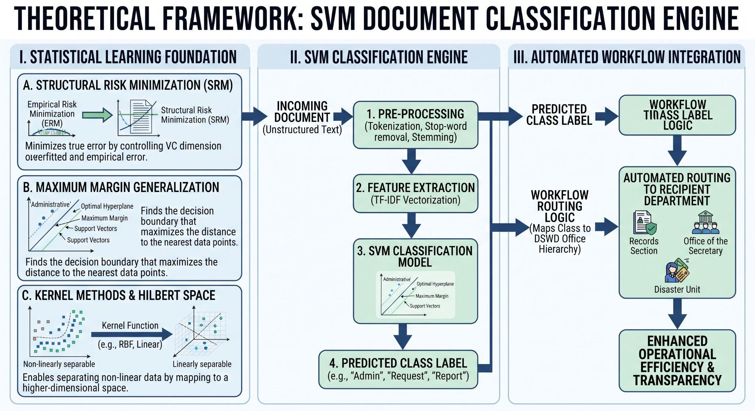
Figure 1. Theoretical Framework SVM Document Classification Engine

Figure 1 illustrates the complete conceptual and operational architecture of the Support Vector Machine (SVM) Document Classification Engine integrated into the DSWD document tracking system, organized across three core sequential phases. The first phase, Statistical Learning Foundation, establishes the mathematical framework governing the classification model. It encompasses Structural Risk Minimization (SRM), which moves beyond basic Empirical Risk Minimization (ERM) to minimize true error by controlling the VC dimension and preventing overfitting on varied administrative texts; Maximum Margin Generalization, which identifies the optimal hyperplane that maximizes the geometric distance between the decision boundary and the nearest support vectors from each class; and Kernel Methods & Hilbert Space, which employ kernel functions (such as RBF or Linear) to implicitly project non-linearly separable text data into a higher-dimensional space where linear separation becomes possible. The second phase, SVM Classification Engine, details the data processing pipeline for incoming documents. It begins with Pre-Processing (tokenization, stop-word removal, and stemming to clean raw, unstructured text), moves to Feature Extraction (utilizing TF-IDF vectorization to convert raw text into quantifiable numerical feature vectors), passes through the SVM Classification Model to evaluate the vectors against the learned hyperplane, and outputs a Predicted Class Label (such as Admin, Request, or Report). Finally, the Automated Workflow Integration phase translates the classification output into administrative action. Using Workflow Routing Logic, the system maps the predicted class label to the proper institutional channels within the DSWD office hierarchy—such as the Records Section, Office of the Secretary, or Disaster Unit—automatically dispatching documents to the appropriate recipient department to replace manual handovers with a streamlined digital path that achieves enhanced operational efficiency and accountability.

Technical Background

Back End Development
The development of this study made use of several tools, platforms, and programming languages suited for building a web-based information system. The system's back-end was developed using PHP, an object-oriented, server-side scripting language, together with MySQL as its relational database management system (RDBMS) for storing and managing document and relief distribution records. Bootstrap was used to design a responsive and modern front-end interface, while JavaScript, together with the Asynchronous JavaScript and XML (AJAX) technique, was used to allow the system to process actions such as saving, routing, and searching for documents without requiring the page to reload. Supplementary libraries were also incorporated into the system, including Data Tables for organizing and searching through large sets of records, SweetAlert2 for displaying user notifications, Chart.js for visualizing relief distribution trends, and a QR code generation and scanning library for producing and reading document QR codes through a device camera. The system was developed and tested using Laragon, a local development environment that allowed the researchers to simulate a live server environment composed of Apache and MySQL prior to actual deployment.

Front-end Development

Similar problems in the past have been addressed through simpler, standalone approaches, such as spreadsheet-based logs for document tracking or manual inventory sheets for relief distribution, neither of which offered real-time monitoring, routing, or an integrated view of both concerns at once. Some organizations have also adopted barcode-based inventory systems solely for tracking physical goods, without extending this capability to official document management, which is one of the gaps that this study intends to address by combining both functions into a single platform. In developing and testing the system, the researchers anticipated certain technical difficulties, particularly those related to browser and device compatibility, since the QR code scanning feature depends on a device's camera and on browser support for QR code detection, which may not function consistently across all browsers or older devices. Compatibility concerns were also expected in relation to the database management system, as differences between MySQL versions can affect default authentication methods and require manual configuration before a connection can be established. These anticipated difficulties were considered during development in order to ensure that the system remains functional and reliable despite variations in the hardware and software environment in which it may be deployed.
Role-Based Authentication
A secure authentication layer to manage Role-Based Access Control (RBAC), and an asynchronous queueing infrastructure that offloads data-heavy processes—like automated PDF generation and notification dispatches—without slowing down user response times.

Data and Privacy Concerns
Data persistence and relational integrity are maintained through a centralized MySQL or PostgreSQL database management system. Acting as the system's ledger, this relational backend houses normalized tables for user credentials, permission matrices, office routing protocols, and document metadata. Actual file uploads—digital administrative attachments, text records, PDF documents—are kept separate from the main relational database and offloaded onto high-availability cloud object storage, such as Google Cloud Storage or Amazon S3, to avoid bogging down database performance. To keep query speeds fast and maintain data redundancy, the relational database stores only the files' cryptographic hashes and secure, encrypted URLs.

Related Literature, Studies and Systems

Document Tracking System
According to Jaquilmo and Sarmiento (2023), a document tracking system refers to the professional practice of managing an organization's documents, covering the identification, classification, storage, security, retrieval, tracking, and preservation of records as they move within and between offices. Their study noted that many government offices, particularly the Department of Social Welfare and Development Field Office V, still relied on manual encoding through logbooks to track official documents, a practice that made locating files difficult, wasted time in archiving and searching, and sometimes resulted in documents being permanently lost. This observation supports the general problem addressed by the present study, in which similar manual practices at the Office of the Secretary create comparable delays and difficulties in monitoring document status.
To address this problem, Jaquilmo and Sarmiento (2023) developed a Web-Based Electronic Document Tracking Management System equipped with a QR code scanner, email, and SMS support, allowing documents to be created, routed, and tracked electronically among different offices within a region. Their system was evaluated by information technology experts and actual office users based on its functionality, reliability, usability, efficiency, maintainability, and portability, obtaining an overall mean rating of 4.257, which was interpreted as exceeding what was expected of the system. This finding demonstrates that a computerized, QR code-supported document tracking system is both a feasible and effective replacement for a manual, logbook-based process, supporting the direction taken by the present study in developing a similar system for the Office of the Secretary.
Disaster Relief Distribution Monitoring
In the study conducted by Rodriguez, Serrano, and Balan (2017), it was found that local government units in the Philippines commonly lacked a proper database or system for monitoring relief goods and donations during disaster response, based on assessment findings by the Commission on Audit. The same study reported that lapses in the documentation and recording of donated relief goods and supplies made it difficult to determine an accurate inventory of relief items, which in turn affected the ability of decision-makers to plan and distribute assistance appropriately during a calamity. To address this gap, the researchers developed Anduyog, a web-based application capable of monitoring relief distribution, casualty information, and inventory for local government units, which was evaluated positively by barangay, municipal, and provincial-level users across several usability measures, including learnability, efficiency, error handling, and overall satisfaction.
As a result, based on the barcode and Quick Response (QR) code technology used in a study conducted by Piloton, Gamboa, Dela Cerna, and Reyna (2023), it was found that replacing a manual, handwritten logbook with a QR code-based records tracking system allowed a university office to record, transmit, and retrieve documents more efficiently, with the resulting system meeting the ISO 25010 software product quality standards during evaluation. This finding further supports the inclusion of a QR code-based feature in the present study's system, since it demonstrates that scannable codes are an effective and already-proven method of speeding up document identification and retrieval when replacing a manual, paper-based tracking process.
Importance of Document Tracking System in the Government
According to Castro Flynn et., all (2022) . A web-based document tracking system, an in-house developed system, is developed to keep track of the movements of all types of documents, e.g., letters, files, notes, and office orders [3][4]. On th2022e website of the Department of Public Works and Highways (DPWH) [5], the Document Tracking System, also known as DoTS, was conceptualized to come up with a system that would respond immediately to queries regarding the status of the Civil Works documents and, more importantly, prompt those in charge to perform their tasks in the least possible period of time. Since the implementation of DoTS in August 2003, it has been observed that processing offices are now more conscious of the number of processing days the document is taking in them. Furthermore, aside from the transparency in operations, another benefit from DoTS is that, if before, searching for or tracing the documents was one of the most fastidious tasks that could ever be undertaken, now contractors could just simply visit the DoTS Center and all the information would be readily available, thus minimizing follow-ups. The quest for benchmarks in this information seems never-ending. According to White [6], it is very common to see that employees spend 2.5 hours a day searching for information
Paperless Office Automation System (OAS) and Online Tracking of Non-automated documents

According to Nath Chandrayee et al. A paperless OAS is being introduced in the offices with aims to reduce the use of paper documents and manual processes in offices by digitizing and automating workflows. By implementing workflow automation, document management systems, electronic signatures, cloud storage and optical character recognition (OCR), organizations can move closer to achieving a truly paperless office and reap the benefits of increased efficiency, cost savings, and reduced environmental impact.
In the Government of india, Our office automation activities is inspired by Digital India campaign launched by the Government of India . At present mixed mode of operation i.e. fully automation (paperless), partial paperless and fully manual workflows with hard copy of documents are being followed in Figure 1.
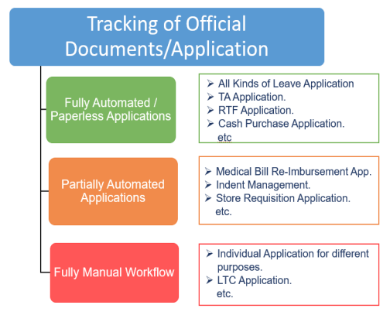

Figure 2. Tracking of Official Documentation/Application
Source:https://www.researchgate.net/publication/373825391_Paperless_Office_Automation_System_OAS_and_online_tracking_of_non-automated_documents

Implementation of Paperless System for Documentation Process
In the study of Syahputra Irwan et., al (2024). The use of paperless applications provides convenience for employees in managing archives, correspondence, and carrying out various other administrative tasks. The implementation of this system allows employees to complete work faster and on time. For example, the implementation of paperless in a company can operate optimally, providing convenience for employees, while increasing the effectiveness and efficiency of work time.
The implementation of a paperless system also has a positive impact on employee productivity, as seen from the increase in their performance and the ability to complete tasks according to the specified schedule. This application can be used to support inter-department correspondence systems, letter validation, sending information in the form of memos between departments, document archiving systems, and managing external and internal documents. In addition, the paperless application also allows recording of activity logs, such as the time the letter was read and sent, so as to minimize the potential for miscommunication between employees in terms of correspondence. The email delivery feature also makes it easier to distribute documents to external parties.

The History of Document Management
In 1898, Edwin Grenville Seibels devised the vertical file system, in which paper documents are organized in drawers contained in stacked cabinets (Saunders, 2021). This system persists to this day, but has notable issues. The physical presence of file cabinets occupies substantial space, posing a challenge for businesses operating within confined office environments. Moreover, the arduous task of sifting through stacks of paper to locate specific documents demands considerable time and effort, as does manually completing fields on physical forms. These activities frequently divert employees, managers, and business owners from their vital duties. Adding to the predicament, paper documents are commonly misplaced and are susceptible to theft or destruction due to calamities such as fires and floods (Amiras, 2021).

Development Tools

Visual Studio Code
Visual Studio Code served as the central workstation where all the programming for the system was written, tested, and managed. Rather than relying on a basic text editor, VS Code offers syntax highlighting, automatic code completion, and error detection that speed up development considerably. It also let the developers manage both the frontend (HTML/CSS) and backend (PHP) in one unified window, and it integrates smoothly with version control systems like Git to track code changes throughout the rapid development of the document routing modules.
PHP (Hypertext Preprocessor)
PHP, short for Hypertext Preprocessor, is a widely used, open-source, server-side scripting language designed primarily for building dynamic and interactive web applications. It was chosen as the primary programming language for this study because of its strong support for object-oriented programming, its compatibility with the MySQL database management system, and its wide adoption in developing government and enterprise web-based systems similar to the one proposed in this study.
- Workflow Logic: When a DSWD hybrid worker uploads a document or clicks “Approve,” PHP captures that action, processes the logic behind it, and routes the document to the next person in line.
- Database Communication: PHP acts as the bridge between the website and the database, running the SQL queries that securely save document statuses, fetch user profiles, and record the exact timestamps behind the digital audit trails.
- Security & Sessions: PHP handles user authentication—when a remote worker logs in, PHP verifies their credentials and manages their “session,” making sure only authorized personnel can access sensitive government files.
HTML
The Frontend Architecture / User Interface (UI). HTML builds the structure of the system, creating the digital forms used to upload files, the tables that display routing history, and the navigation menus.
CSS
The Frontend Architecture / User Interface (UI). CSS handles the visual styling and layout. Since this system is built for a hybrid work environment, employees will access it from office desktops, home laptops, or even tablets—so CSS makes the system “responsive,” meaning the tracking dashboard automatically resizes and adjusts to look professional and function well on any screen size.

Laragon
Local Web Server and Database Environment. Before a system goes live on a government cloud server, it needs to be built and tested locally, and Laragon provides a complete “server-in-a-box” environment for exactly that.
- Apache (The Web Server): This lets a local computer process PHP code and display the system in a web browser, just like a live website.
- MySQL / MariaDB (The Database): This is where the system's data actually lives. Laragon hosts the database tables that store all user accounts, document metadata, and workflow audit logs, allowing the entire document tracking process—from upload to final approval—to be tested safely without needing an internet connection or a paid server during development. It was selected as the database management system of this study because of its reliability, its native support for transactions that ensure data remains accurate even when multiple operations occur at the same time, and its seamless integration with PHP through the PHP Data Objects (PDO) extension.

Bootstrap
Bootstrap is an open-source front-end framework that provides pre-designed components and a responsive grid system, allowing a website to automatically adjust its layout depending on the size of the screen it is viewed on. It was used in this study to design a modern, professional, and mobile-friendly interface without requiring the researchers to build every visual component from scratch.

JavaScript and AJAX. JavaScript
A client-side scripting language that allows a webpage to respond to user actions without requiring the entire page to reload, while Asynchronous JavaScript and XML (AJAX) is a technique that allows a webpage to send and receive data from the server in the background. Both were used in this study to allow actions such as saving a document, routing it to another user, or recording a relief distribution to be processed instantly, providing a smoother and more responsive experience for the system's users.

EVALUATION
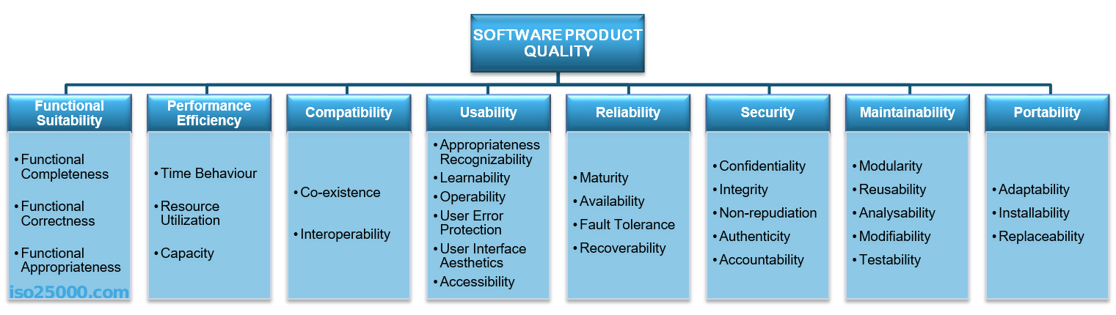
ISO/IEC 25010

Figure 2: ISO 25010
Source: https://iso25000.com/images/figures/en/iso25010.png

The International Organization for Standardization (ISO) and the International Electrotechnical Commission (IEC) developed the widely used ISO/IEC 25010 System and Software Quality Model to regulate and assess the overall quality of software products. The framework is built around eight quality characteristics—Functional Suitability, Performance Efficiency, Compatibility, Usability, Reliability, Security, Maintainability, and Portability—each broken down into specific sub-characteristics. Replacing the earlier ISO/IEC 9126 standard, it offers a structured, objective model that gives software developers, quality assurance experts, and institutional stakeholders a rigorous, unbiased way to assess how well an application meets both explicit functional requirements and implicit user expectations, making it one of the standard benchmarks for software engineering research today.
The following are the criteria set for ISO/IEC 25010:
- Functional Suitability. Through three sub-characteristics, Functional Suitability evaluates how well the developed platform meets the DSWD's operational mandates and document routing requirements. Functional Completeness assesses how well the implemented feature set—tracking dashboards, Role-Based Access Control (RBAC), and the workflow engine—covers all the administrative duties and document-handling procedures laid out in the study's objectives. And Functional Appropriateness assesses whether the application supports only the essential operational steps, cutting procedural bloat so DSWD staff can complete document transmittals with as few actions as possible. Based on the developed system, functional suitability is addressed through its ability to correctly create, edit, route, and archive documents; generate and scan QR codes for quick document retrieval; record relief inventory and automatically deduct distributed goods from available stock; and generate relief manifests that are routed through the same workflow as any other document.
- Performance Efficiency. This refers to the degree to which the system makes appropriate use of resources, such as processing time, while performing its intended functions. Based on the developed system, performance efficiency is addressed through the use of AJAX, which allows actions such as saving or routing a document to be processed without reloading the entire page, and through the use of indexed database queries, which allow a document to be located instantly when its exact tracking number is scanned or searched.
- Compatibility. This refers to the degree to which the system is able to exchange information with other systems and to function correctly while sharing a common hardware or software environment. Based on the developed system, compatibility is addressed through its use of standard web technologies that allow it to run on commonly used browsers and devices, while its camera-based QR code scanning feature is optimized to perform best on Chromium-based browsers such as Google Chrome and Microsoft Edge.
- Usability. This refers to the degree to which the system can be used by its intended users to achieve their goals effectively, efficiently, and with satisfaction. Based on the developed system, usability is addressed through a clean, role-based dashboard for each type of user, a responsive interface built with Bootstrap that adjusts to different screen sizes, toast notifications that confirm whether an action succeeded or failed, and a QR code scanning feature that allows a document to be located without manually searching through a list.
- Reliability. This refers to the degree to which the system performs its intended functions consistently and without failure under normal conditions of use. Based on the developed system, reliability is addressed through the use of database transactions that ensure a relief distribution and its corresponding inventory deduction are always recorded together, through pessimistic row-locking that prevents relief stock from being oversold when two users record distributions at the same time, and through a complete audit trail that logs every action taken on a document so that no step in its history is lost.
- Security. This refers to the degree to which the system protects information and data from unauthorized access, modification, or disclosure. Based on the developed system, security is addressed through password hashing that ensures passwords are never stored in plain text, protection against Cross-Site Request Forgery (CSRF) on every action that changes data, the use of prepared statements to prevent SQL injection, role-based access control that limits certain features to Administrators and Logistics/Relief Officers, and strict validation of uploaded files to ensure only legitimate PDF or Word documents can be attached to a record.
- Maintainability. This refers to the degree to which the system can be modified, corrected, or improved by its developers or administrators. Based on the developed system, maintainability is addressed through its object-oriented design, which organizes the system's logic into separate, well-defined classes for documents, relief operations, users, and file uploads, allowing a specific feature to be corrected or improved without affecting unrelated parts of the system.
- Portability. This refers to the degree to which the system can be transferred from one environment to another. Based on the developed system, portability is addressed through its use of widely supported technologies such as PHP and MySQL, which allow it to be deployed to different servers with minimal adjustment, supporting its intended rollout from the pilot office to DSWD's other offices and field offices nationwide.

Conceptual Model
Building on the concepts, theories, and findings drawn from related literature and studies, a conceptual model was developed to guide the conduct of this study.

INPUTS PROCESS OUTPUT

System/Project Design
- Database Schema
- User Interface
- Routing Workflow
System/Project Development
- System Design
- Database Design
- User Interface Design
- System Development
- Secure File Repository Integration
- QR Code Generation and Scanning
System/Project Testing
- Unit/Functional Testing (PHPUnit)
- Integration Testing
- User Acceptance Testing (UAT)

Knowledge Requirements
- Document Routing
- Relief Operations
- Data and Reports Analytics
- Web Development
- Integration of Paperless
- Support Vector Machine Classification
Software Requirements
- Visual Studio Code, Git/GitHub
- PHP 8 (OOP, PDO), MySQL 8
- HTML5/CSS3, JavaScript, Bootstrap 5, Chart.js
- Laragon (Apache, MySQL, PHP), PHPUnit
Hardware Requirements
- Desktop/Laptop
- Internet Connection
- QR Code Scanner/Document Printer
- Mobile Device

INTEGRATED PAPERLESS DOCUMENT TRACKING AND WORKFLOW SYSTEM FOR DSWD UTILIZING SUPPORT VECTOR MACHINE CLASSIFICATION

Evaluation

Figure 4. The Conceptual Model of the Study

Figure 4 illustrates the study's conceptual model through an Input-Process-Output (IPO) framework combined with an evaluation phase. The Input block covers the baseline needs—human resources, knowledge, software (Visual Studio Code, PHP(MySQL, Bootstrap), HTML/CSS, JavaScript/AJAX, Laragon), and hardware requirements. The Process block outlines the system's execution lifecycle: project design (gathering and analysis), project development (system, database, and user interface design alongside cloud storage integration and QR code generation), and rigorous testing (functional testing and user acceptance testing). The Output block represents the final deliverable—the Integrated Paperless Document Tracking and Workflow System for DSWD Utilizing Support Vector Machine Classification—which then goes through the final Evaluation phase.

Synthesis

This study focuses on developing, deploying, and evaluating an integrated, cloud-enabled system built to transition paper-heavy government workflows into an efficient digital space. Guided by an extended Input-Process-Output (IPO) framework, the project outlines core foundational inputs—from human roles like system admins and approving officers to hardware setup and a modern software stack featuring PHP (MySQL, Bootstrap), JavaScript/AJAX, Laragon, and Visual Studio Code. These elements drove a structured software development lifecycle, steering the team through thorough requirements gathering, database architecture, cloud and QR code integration for live tracking, and complete validation via functional testing and User Acceptance Testing (UAT).

Operational Definition of Terms
This section briefly defines each term based on how it is functionally used, specifically describing how it applies within this study.
Integrated Paperless Document Tracking and Workflow System for DSWD Utilizing Support Vector Machine Classification – Refers to the specific software output developed in this study using Visual Studio Code, PHP(MySQL, Bootstrap), HTML/CSS, JavaScript/AJAX, and Laragon. It functions as the central platform to digitize, monitor, and route organizational documents without physical paper, utilizing cloud storage and QR code tracking.
Input – Represents the foundational baseline requirements gathered at the start of the study, which include human resources (Administrators, Approver, Logistics/Relief Officers, and Department users); hardware (laptops, printers, and mobile devices); and software tools needed to initiate the project.
Process – Refers to the systematic systems development lifecycle (SDLC) phases executed in this study, which encompass requirement gathering, system analysis, database and user interface design, cloud and QR integration, and system testing.
Output – The tangible, completed technological innovation resulting from the development process—specifically, the operational document tracking system ready for deployment.

Evaluation – The final phase of the study where the developed system is assessed for its efficiency, usability, and technical performance, ensuring it meets the project's goals and user requirements.
QR Code Generation – The specific technical process integrated during development to create unique, scannable quick-response codes that are attached to documents to facilitate real-time tracking via mobile devices or scanners.
Support Vector Machine (SVM) - refers to the main decision boundary that separates different classes of data points in the feature space, while support vectors refers to the specific data points lying closest to this boundary that directly dictate its position and orientation. The margin refers to the physical distance between the decision hyperplane and these closest support vectors from each respective class. When dealing with complex datasets, the kernel trick refers to the mathematical technique of transforming original, non-linearly separable input data into a higher-dimensional space where a linear hyperplane can separate it, and gamma refers to the parameter in these non-linear kernels that determines the radius of influence of a single training example on the model's decision boundary. To control the model's strictness, the regularization parameter (C) refers to the penalty term applied to misclassifications, managing the trade-off between maximizing the margin width and minimizing training errors. Consequently, a soft margin refers to an SVM configuration that permits some margin violations to handle noisy, overlapping data and prevent overfitting, whereas a hard margin refers to a configuration that strictly prohibits any misclassifications, functioning optimally only when the dataset is perfectly linearly separable.
User Acceptance Testing (UAT) – The final testing phase where actual end users (Department Staff, Approving Officers, etc.) interact with the system to validate its features, usability, and readiness for official implementation.

Chapter 3
DESIGN AND METHODOLOGY
This chapter presents the project design, project development, systems development model, methods and instruments used in testing and evaluating the software, population and sample, as well as the statistical treatment of data.

Project Design

This study used both descriptive and developmental research methods. The descriptive method was used to systematically collect, analyze, and document the current workflow challenges, knowledge requirements, and technical needs of the stakeholders, while the developmental method guided the design, construction, testing, and evaluation of the technical solution itself—specifically, a structured software development lifecycle that translated these requirements into the functional Cloud-Enabled Paperless Document Tracking and Workflow Management System.
The descriptive method, specifically, was used to compile, evaluate, and record the institution's technical system requirements, stakeholder workflows, and manual document tracking procedures.
The researchers then applied the developmental method to design, build, test, and refine the software architecture, ultimately producing a working Integrated Paperless Document Tracking and Workflow System for DSWD Utilizing Support Vector Machine Classification based on the requirements gathered.
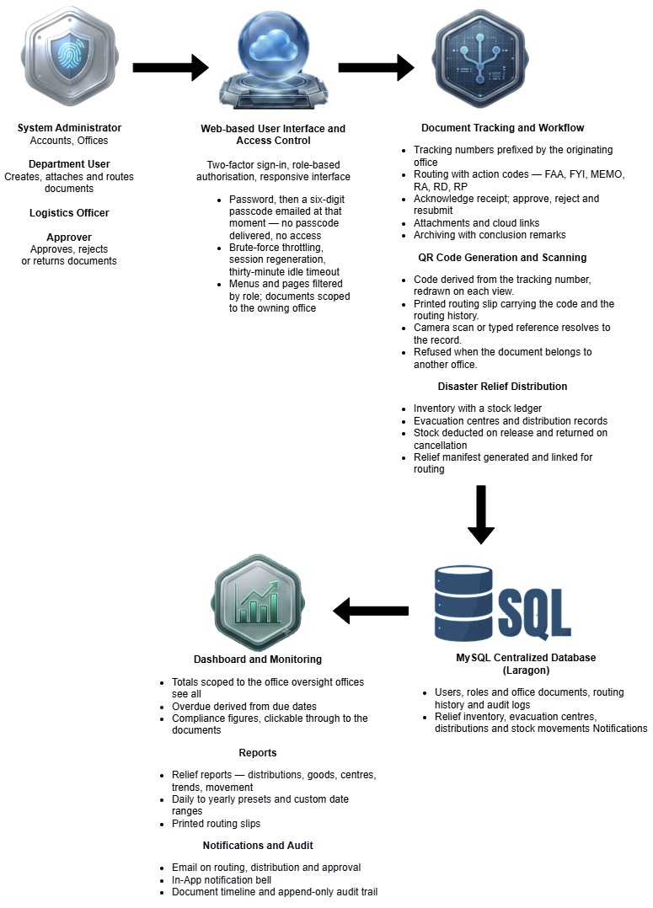
Figure 5. The Framework of the Document Tracking and Workflow System
Figure 5 shows the architecture and operational flow of the proposed document system built for DSWD staff. System users—both on-site and remote DSWD personnel—are the first to engage with three interconnected software modules: (1a) Security Management and Role-Based Access Control (RBAC), which enforces role-specific permissions; (1b) the Dynamic Workflow Automation and Routing Engine, which manages standardized document creation, assignment, and routing; and (1c) the Immutable Audit Trail and Real-Time Tracking Dashboard, which keeps a secure record of document status, processing times, and historical logs across offices. Together, these modules feed into a centralized, cloud-enabled infrastructure that safely hosts and processes users, documents, routing rules, and audit logs, continuously syncing across the system. The end result is a paperless, transparent, and efficient document workflow for the DSWD.

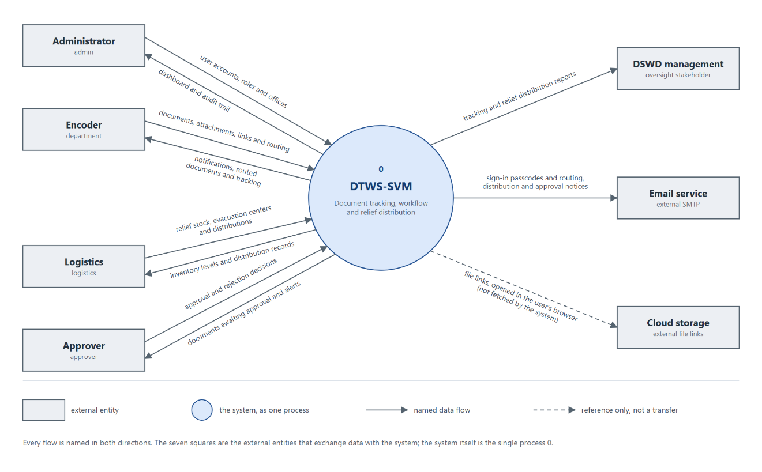
Figure 6. The Context Diagram of the System
Figure 6 presents the context diagram of the system, hereafter DTWS-SVM, the Document Tracking and Workflow System with Support Vector Machine classification, showing the single process boundary and every external entity that exchanges data across it. Four staff roles interact with the system directly. The administrator supplies user accounts, roles and offices and receives the agency-wide dashboard and audit trail. Encoders submit documents, attachments and cloud links and route them onwards, receiving notifications, routed documents and tracking information in return. Logistics officers maintain relief stock, evacuation centers and distribution records and receive inventory levels and distribution histories. Approvers return approval and rejection decisions and receive the documents awaiting them. Beyond these, DSWD management receives consolidated tracking and relief distribution reports, and two external services sit on the boundary: an email service, which carries sign-in passcodes and routing, distribution and approval notices, and external cloud storage, whose files are referenced by stored links and opened in the user's browser rather than retrieved by the system itself.
The role names used throughout this study correspond to the access levels implemented in the system as follows.
Role in this study | System access level | Responsibilities
Administrator | admin | User accounts, offices, agency-wide oversight
Encoder (Department User) | department | Creates documents, attaches files and cloud links, initiates routing
Logistics Officer | logistics | Relief stock, evacuation centers, distribution records
Approver / Reviewer | approver | Approves, rejects or returns routed documents

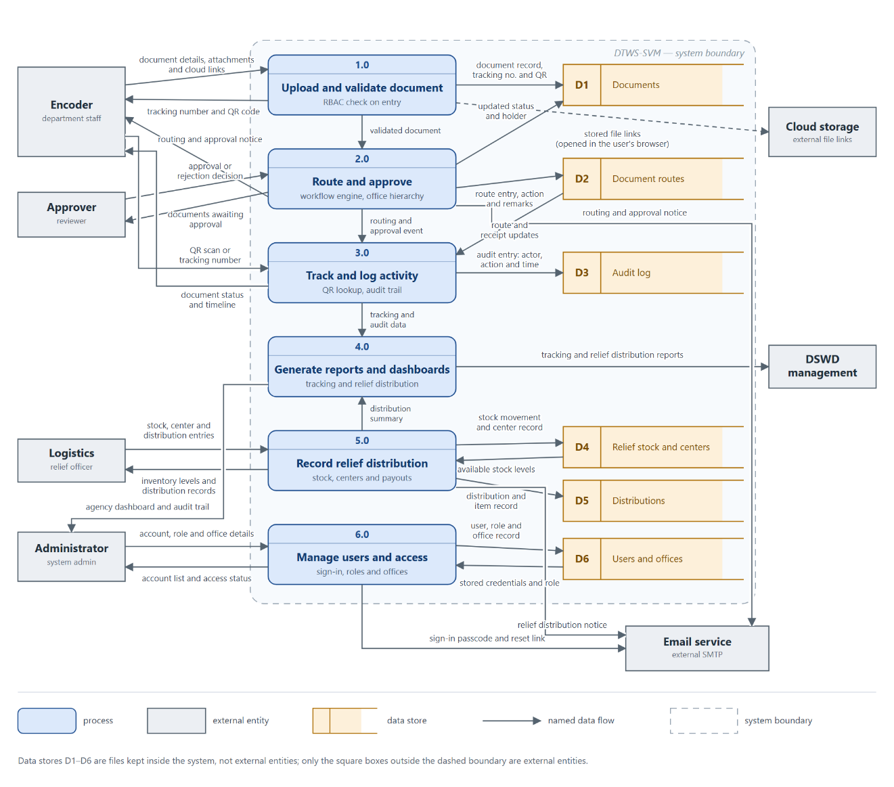
Figure 7. The Dataflow Diagram of the System
Figure 7 expands the single process of Figure 6 into a Level-0 data flow diagram, keeping the same seven external entities so that the two figures balance, and naming every flow after the data it carries. The encoder submits document details, attachments and cloud links to 1.0 Upload and validate document, which checks the sender's role, writes the document record, tracking number and QR code to D1, and returns the tracking number and QR code; the file links it captures point to external cloud storage that the user's browser opens directly rather than the system fetching it. The validated document passes to 2.0 Route and approve, which writes each route entry, action and remarks to D2, updates the status and current holder in D1, presents the approver with the documents awaiting them, takes back their approval or rejection decision, and notifies the encoder. Each routing and approval event moves to 3.0 Track and log activity, which reads route and receipt updates from D2, writes an audit entry naming the actor, action and time to D3, and answers a QR scan or tracking number with the document's status and timeline. 4.0 Generate reports and dashboards consolidates that tracking and audit data with the distribution summary from 5.0 Record relief distribution, which writes stock movements and evacuation center records to D4, reads available stock levels back, records each distribution and its items in D5, and returns inventory levels and distribution records to the logistics officer. 6.0 Manage users and access keeps the account, role and office details supplied by the administrator in D6 and reads the stored credentials and role at sign-in. Processes 2.0, 5.0 and 6.0 pass their routing, relief distribution and sign-in notices to the external email service. Reports leave 4.0 as tracking and relief distribution reports to DSWD management and as the agency-wide dashboard and audit trail to the administrator. The dashed boundary marks the system itself: D1 to D6 are files held inside it, while only the square boxes outside the boundary are external entities.

Project Development
The Department of Social Welfare and Development (DSWD) personnel and observed manual routing processes to understand operational bottlenecks. These insights guided the database design, resulting in normalized tables for user roles, document records, workflow statuses, audit logs, and relief distribution data to maintain a single source of truth. The user interface was then constructed using HTML and CSS to ensure the login screens, role-specific dashboards, and data-entry forms were responsive and accessible across desktops, laptops, and tablets.
With the foundation established, the core programmatic modules were systematically built. The Login and RBAC module was developed in PHP to authenticate users and restrict system access based on their specific departmental roles. Following this, the Workflow Automation and Routing Engine was integrated to replace physical routing slips, allowing documents to be forwarded sequentially or concurrently according to the DSWD's organizational hierarchy. To maintain administrative transparency, the Real-Time Tracking Dashboard and Audit Trail module was implemented to log every user action and status transition in an immutable digital record.
The final development stages introduced specialized tracking and reporting capabilities. The QR Code Generation and Scanning Module was added to assign unique, scannable codes to documents and relief records, enabling instant status verification via mobile devices. The Disaster Relief Distribution Reporting Module was subsequently developed to allow staff to encode relief allocation data and generate consolidated management reports during emergency responses. Once all modules were fully integrated, the proponents conducted internal functional testing to resolve flaws before deploying the unified system on Laragon for formal user acceptance testing.
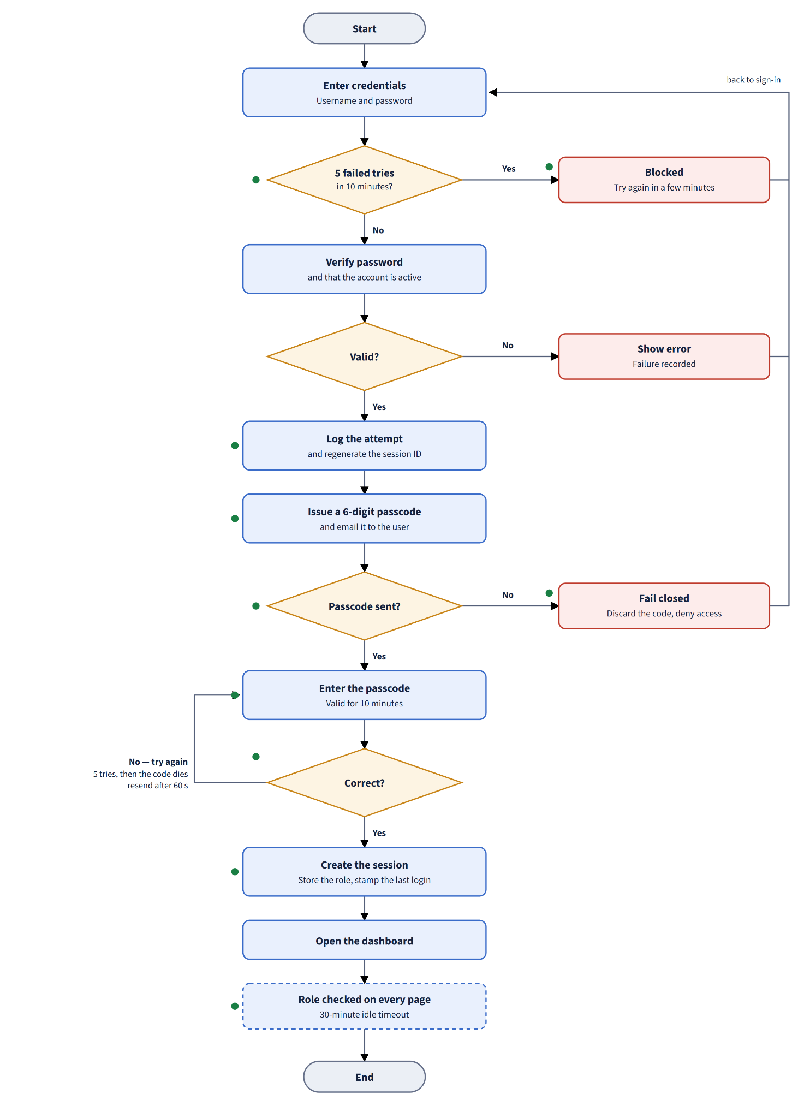

Figure 8. User Authentication Procedure
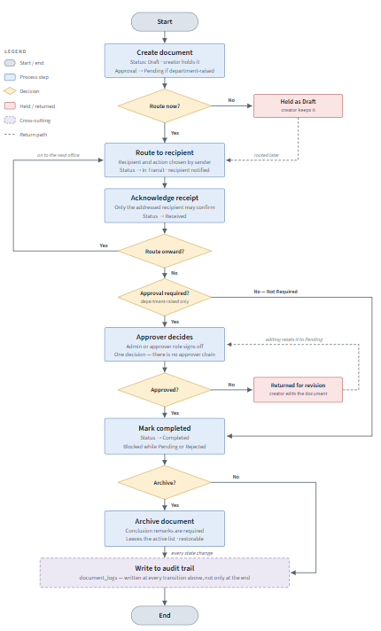
Figure 8 illustrates the system's user authentication and role-based access control (RBAC) flowchart, outlining the logical steps needed to protect dashboard access. The process starts at the Start node, where the user enters a username and password. The system then verifies those credentials against the database. A decision point checks whether the input is valid: if not, the user loops back to the input step and sees an error for invalid credentials; if valid, the system performs an RBAC lookup to check the user's role, which ultimately determines whether dashboard access is granted with a role-specific view, before the process ends at the End node.

Figure 9. Program Flowchart of Feature #2
Figure 9 illustrates the system's workflow routing flowchart, mapping the steps a document goes through from creation to approval. The process starts when an encoder completes the create-document task, after which the system immediately assigns routing based on the document type. The file then moves to the Send to Reviewer step, following the organizational hierarchy. A decision point then checks whether the document is approved: a “No” sends it back to the encoder with comments, resetting the process to the creation stage. A “Yes” triggers a follow-up check for additional approvers—if there are more, the process loops through the hierarchy to the next approver and returns the file to the reviewer phase; if there are none left, the system logs the event and notifies users through the update audit trail function before ending at the End node.

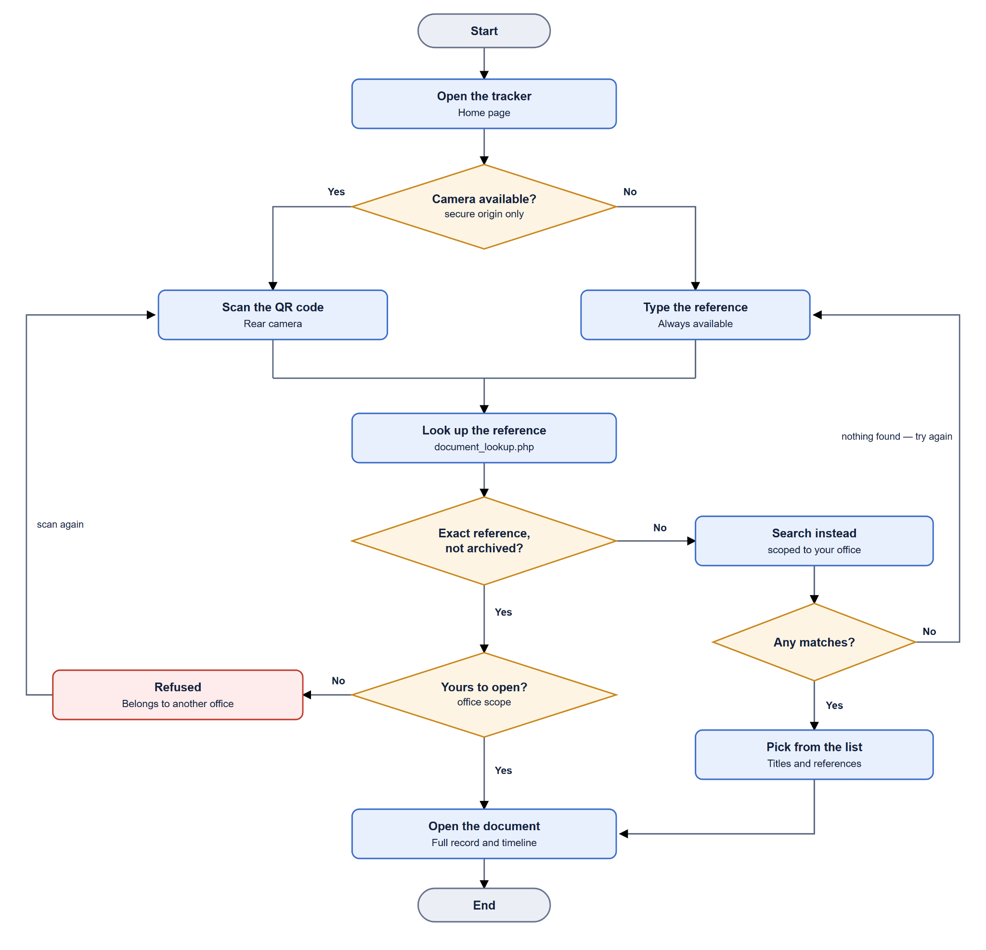

Figure 10. Program Flowchart of Feature #3
Figure 10 illustrates how the process begins with creating a unique QR code for every individual record, which is then embedded directly into the relevant document. Once in the field, staff scan the QR code to confirm its validity. If the code turns out to be invalid or expired, the system shows a “not found” error and reroutes the workflow back to the scanning stage; if the code is successfully recognized, the system retrieves the record and loads its details.
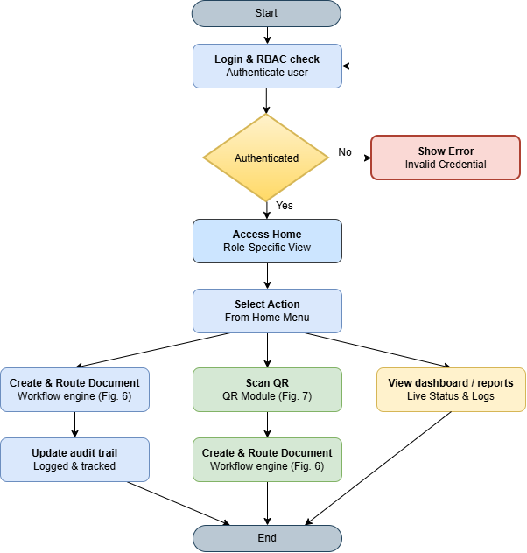
After a successful retrieval, the system checks the record type to determine whether it qualifies as a relief record. If it does, the system encodes the relief data—including the recipient and the amount—and generates a report confirming that the data has been saved before the process ends. If it isn't a relief record, the process simply ends after displaying the general tracking status, skipping the encoding steps altogether.

Figure 11. System Flowchart
Figure 11 illustrates the overarching system flow, which begins by authenticating the user through a Login and RBAC check. If the login attempt fails, the system returns the user to the login phase and displays a “Show error” response; if it succeeds, the user is granted dashboard access with a role-specific view. From there, the user can choose an action from the dashboard menu, which branches into three main workflows:
- Document Management: The workflow engine lets the user create and route documents, which then updates the audit trail so the action is tracked and recorded before moving on.
- QR and Relief Processing: The user can use the QR module to scan or encode relief data, which prompts the system to generate a relief report and save the transaction to the database before moving on.
- Reporting: Alternatively, the user can select View dashboard/reports, which takes them straight to monitoring live status and logs.

System Design and Development Model/Approach
The Integrated Paperless Document Tracking and Workflow System for DSWD Utilizing Support Vector Machine Classification was developed using the Waterfall Model. This sequential development approach was chosen because it's a natural fit for the DSWD's document processing procedure, which already follows a set, linear sequence from encoding to review to approval. It also meant the requirements gathered at the start of the study directly shaped the database and interface design, which in turn guided the actual coding, before the completed modules were finally tested and integrated as a whole. Each phase was finished and validated before the next one began—a methodical, phase-by-phase progression that let the researchers trace any flaws or design gaps back to a specific stage of development, and helped ensure the final system reflected the DSWD's actual workflow rather than early assumptions.
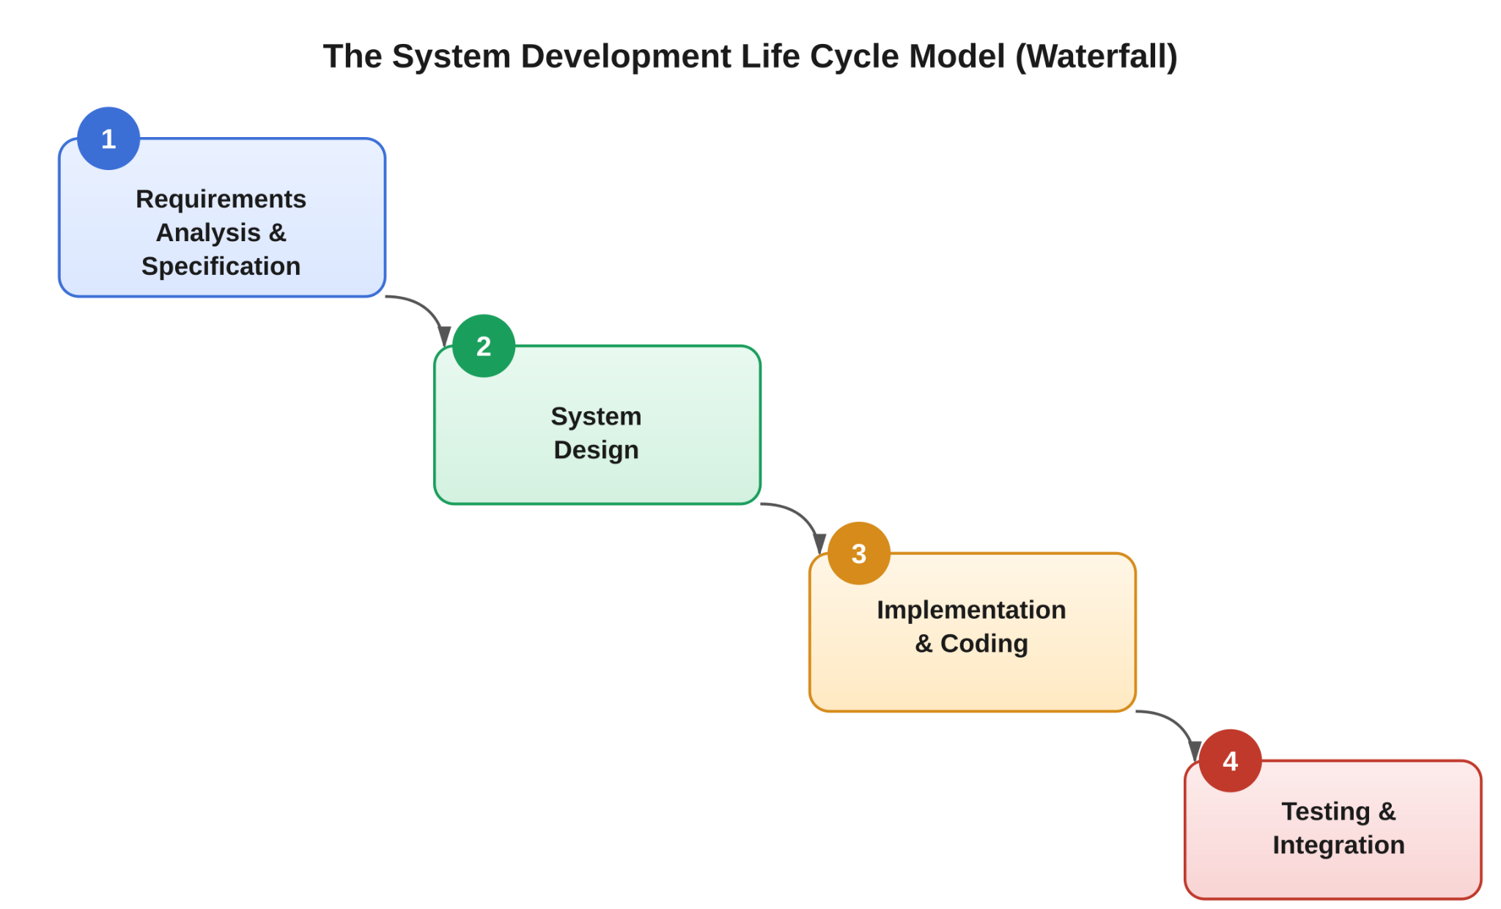
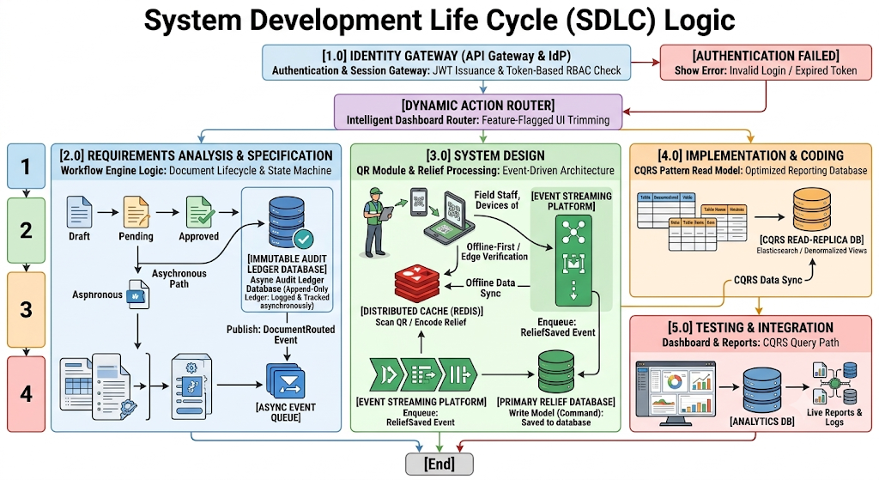
Figure 12. The System Development Life Cycle Model
Figure 12 maps the system's main operational workflows—Identity Management, Dynamic Document States, High-Throughput QR Processing, and the CQRS Read-Model Architecture—across the conventional Waterfall development phases, giving a thorough picture of the System Development Life Cycle (SDLC) logic.
Using the waterfall model, the following are the phases considered to undergo the development process:
- Requirements Analysis and Specification. The researchers gathered all the information and data needed for the proposed system by interviewing organization personnel and observing the processes under study.
- System Design. The engineering blueprint translates structural requirements into decoupled software design patterns, with a strong emphasis on edge verification techniques and asynchronous flow mechanics. Rather than static layout elements, the design uses dynamic dashboard routing—an automated interface router that checks token claims at runtime to fully block unauthorized views. It also incorporates state machine logic, modeling documents through strict, deterministic states: Draft, In Review, and Approved. These state changes trigger isolated asynchronous pathways so that database persistence never locks up or interferes with ongoing user interactions. Finally, the high-throughput QR module is designed around offline-first edge validation, embedding cryptographic record signatures directly inside the QR data matrix and enabling instantaneous cache confirmation through local Redis replicas to keep performance efficient in the field.
- Implementation and Coding. During this phase, the architectural specifications are fully realized through optimized coding frameworks and clear database separations. A core piece of this stage is asynchronous audit logging, implemented through transactional event streaming using tools like SQS or RabbitMQ: whenever a document's state changes, a DocStateTransitioned event publishes downstream to an unchangeable, append-only audit ledger. Relief event streams work the same way, with QR scan events triggering asynchronous queue insertions marked as a ReliefSavedEvent—a design choice that keeps operations non-blocking for field workers by separating scanning execution from the primary database write engine. The write model is also kept isolated to enforce the Command Query Responsibility Segregation (CQRS) pattern, with relational tables highly normalized along this path to ensure fast, single-row writes for all transactional tracking information. single-row writes for all transactional tracking information; and,
- Testing and Integration. This phase runs verification cycles to confirm that all decoupled microservices stay in sync and that analytical read speeds consistently meet user benchmarks. A major focus here is CQRS read path optimization, which thoroughly validates the asynchronous background replication mechanism—such as Elasticsearch or denormalized read replicas—connecting the write database to the query database. Live analytics verification is also carried out to load-test dashboard summary outputs, demonstrating zero lock interference against the operational transactional databases and confirming system stability under heavy load, since log aggregation streams and heavy reporting metrics pull exclusively from the Query Path replica.

Operation and Testing Procedure

In designing, developing, testing, and evaluating the Cloud-Enabled Paperless Document Tracking and Workflow Management with Disaster Relief Distribution Reporting System, the proponents used the ISO/IEC 25010 software quality model, an international standard for evaluating software. It identifies eight criteria: (1) Functional Suitability, (2) Performance Efficiency, (3) Compatibility, (4) Usability, (5) Reliability, (6) Security, (7) Maintainability, and (8) Portability.

The researchers created a testing instrument (see Appendix B), a survey questionnaire based on the ISO/IEC 25010 criteria above, to collect structured feedback from evaluator-respondents on the system's functionality, performance, dependability, and general quality.
To keep the testing process on track, the software was tested to confirm that all of its main modules—the Disaster Relief Distribution Reporting module, the Workflow Automation and Routing Engine, the Real-Time Tracking Dashboard and Audit Trail, the QR Code Generation and Scanning feature, and the Login and RBAC system—operated as intended, with any flaws noted, fixed, and retested before the final assessment with the respondents.
Table 1
Testing Procedure Undertaken by the User-respondents
Module | Test Conducted
Login and RBAC Module | In order to confirm that access was appropriately restricted to their designated permissions, user-respondents logged in using accounts under each role (Encoder, Logistics Officer, Approver, and Administrator).
Workflow Automation and Routing Module | To ensure that every document followed the proper order through the office hierarchy, user-respondents created, routed, and approved sample documents.
Real-Time Tracking Dashboard and Audit Trail | In order to confirm that updates and logged actions appeared in real time, user respondents examined the status of routed documents.
QR Code Generation and Scanning Module | To ensure accurate retrieval, user-respondents created and scanned QR codes on relief records and sample documents.
Disaster Relief Distribution Reporting Module | To ensure accuracy and completeness, user-respondents created reports after encoding sample relief distribution data.
Notification System | User respondents confirmed that they were promptly notified when documents were ready for action.

Table 1 shows the testing procedures undertaken by the user-respondents, listing each module alongside the test conducted on it. This let the researchers confirm that every core function of the system—from authentication down to relief distribution reporting—worked as intended from the perspective of an actual DSWD user, not just the developers.

The proponents also ran their own tests to catch errors, starting with unit testing on each module individually, followed by integration testing once the modules were combined, and tracking every defect found until it was corrected and re-verified—before handing the system over to the user-respondents.
Table 2
Testing Procedure Undertaken by the Proponents
Module | Test Conducted
Login and RBAC Module | Each user type's role-based permission enforcement and authentication logic are unit tested.
Workflow Automation and Routing Module | Integration testing of rejection/return handling, approval sequencing, and routing rules throughout the office hierarchy.
Database | Data storage, retrieval, and document, user, and relief distribution record integrity are tested.
Real-Time Tracking Dashboard and Audit Trail | Verifying that all actions were accurately recorded and that logs could not be changed or removed.
QR Code Generation and Scanning Module | Testing the accuracy of code generation and the dependability of scans on various devices.
Disaster Relief Distribution Reporting Module | Report output is tested against manually validated encoded relief distribution data.
Security | Checking for timeout behavior, session management, and illegal access attempts.

Table 2 shows the testing procedures undertaken by the proponents, listing the system modules and components alongside the functional and integration tests the researchers conducted before releasing the system for user-respondent testing. These validation cycles evaluated both the isolated execution of individual modules and their interaction once fully integrated into the unified system.
These tests were repeated throughout development, with each defect recorded, fixed, and retested to confirm stability, before the system was handed to the user-respondents for the testing process outlined in Table 1.

Evaluation Procedure
To measure the system's performance, a survey based on the ISO/IEC 25010 software quality standard was administered to the identified evaluator-respondents following a live demonstration and hands-on walkthrough of the system's modules. This questionnaire gathered the respondents' ratings and written feedback on the system's functionality, performance, and overall quality, using the five-point scale shown in Table 3.
The following were the steps undertaken by the evaluator-respondents during the evaluation:
- The researchers presented a demonstration on how to operate the software to the group of evaluator-respondents, made up of IT and software quality professionals identified to evaluate the system.
- Evaluator-respondents were then given time to explore and interact with the software.
- Survey questionnaires were distributed to the same group of evaluator-respondents.
- Evaluator-respondents then rated the system's performance on a five-point scale, from 5 (Excellent) down to 1 (Poor).

Table 3
Likert Scale
Numerical Rating | Interpretation
5 | Excellent
4 | Very Good
3 | Good
2 | Fair
1 | Poor

Table 4
Rating Scale for Interpreting the Evaluation Result

Numerical Rating | Interpretation
4.51 – 5.00 | Excellent
3.51 - 4.50 | Very Good
2.51 – 3.50 | Good
1.51 – 2.50 | Fair
1.00 – 1.50 | Poor

Research Instruments Used

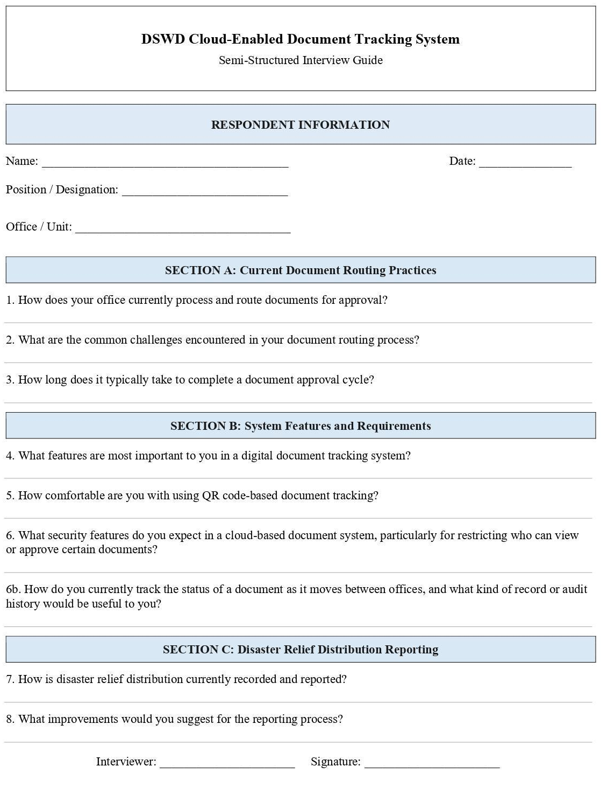
To gather the data needed for this study, the researchers interviewed Atty. Franky Luigi Albano, an executive assistant at the Office of the Secretary, DSWD Central Office.

Figure 13. Interview Questionnaire Form Layout
Figure 13 shows the questionnaire answered in an interview conducted on July 16, 2026. It confirmed that the office's document processing was still largely manual, with delays in routing and approval stemming from the lack of a centralized tracking system, and that a QR-based tracking feature paired with role-based access would directly address the challenges raised (see the actual questionnaire in Appendix J).
Once the system was fully developed, respondents were asked to answer one of two survey questionnaires: one for user-respondents, and one for evaluator-respondents using the ISO/IEC 25010 evaluation instrument. Testing and evaluation were then conducted based on the criteria set out in that framework.
The software was tested with the identified user-respondents, who were given hands-on access to its core modules—the Login and RBAC module, the Workflow Automation and Routing Engine, the Real-Time Tracking Dashboard and Audit Trail, the QR Code Generation and Scanning feature, and the Disaster Relief Distribution Reporting module—to confirm each one functioned as intended in an actual working environment before answering the corresponding testing questionnaire (see Appendix A).
The evaluator-respondents, meanwhile, reviewed the system's technical quality against the eight ISO/IEC 25010 characteristics after a live demonstration and hands-on interaction with the system, rating its performance using the evaluation instrument provided (see Appendix B).

Population and Sample

The respondents in this study were DSWD personnel directly involved in document processing and disaster relief distribution at the Office of the Secretary, DSWD Main Office. The population consisted of all personnel in that office who handle document routing, approval, and relief distribution reporting. Using purposive sampling, the researchers selected twelve (12) user-respondents—encoders, reviewing officers, and approving officers—who tested the system's day-to-day functions (Appendix A), and one (1) evaluator-respondent—IT expert/developer—who assessed the system against the ISO/IEC 25010 criteria (Appendix B). Respondents were chosen for their direct involvement in the office's existing document tracking and relief distribution process, making them the most qualified to judge whether the system meets its intended purpose.
Table 5
Distribution List of Respondents
User Role / Respondent Category | System Access Level / Function | Proposed Sample Size (n)
Focal Person (Per department) | Encoder (Uploads documents, initiates routing, and monitors document status)  Logistics Officer (Maintains relief inventory, evacuation centers, and distribution records) | 9
Staff (Office of the Secretary | Reviewer / Approver (reviews, approves, or returns routed documents). | 3
IT Expert | Administrator / Evaluator (manages user access, configures RBAC, Creation of Department/Offices and evaluates technical performance) | 1
Total |  | 13

Statistical Treatment of Data

The weighted mean was applied to the survey responses to assess the system's degree of acceptability. This statistical tool let the researchers turn the respondents' individual ratings into a single average score per criterion, making it possible to objectively assess the system's performance against each of the eight ISO/IEC 25010 characteristics as well as its overall quality. Microsoft Excel was used to tabulate and compute the quantitative data, consisting of numerical ratings on a five-point scale.
After the questionnaires were collected, a tally sheet was prepared, and the data was recorded, computed, tabulated, and subjected to statistical treatment. To determine the qualitative score, the following formula was used:
Formula:
Weighted Mean = Σ(fx) / N
where:
f = frequency of responses per rating
x = weight assigned to each rating (1–5)
N = total number of respondents

Chapter 4
RESULTS AND DISCUSSION
This chapter presents the project description and structure, capabilities and limitations, project test results, and the final evaluation outcome of the project.

Project Description
The Integrated Paperless Document Tracking and Workflow System for DSWD Utilizing Support Vector Machine Classification is a comprehensive web-based platform tailored specifically for the Department of Social Welfare and Development (DSWD). The project is designed to modernize the agency's traditional administrative machinery by replacing manual, paper-based document routing with a centralized, cloud-based infrastructure. This digital transition aims to eliminate operational bottlenecks, accommodate hybrid work arrangements, and ensure the rapid delivery of social services and disaster relief to vulnerable communities.
From a technical standpoint, the platform is developed using PHP for server-side logic, MySQL for relational database management, and Bootstrap, HTML, CSS, and JavaScript for a responsive user interface. A defining technical feature of the project is the integration of a Support Vector Machine (SVM) Document Classification Engine. By extracting text features through TF-IDF, this machine learning module automatically categorizes incoming administrative files, significantly accelerating the initial stages of document processing.
Functionally, the system bridges the gap between office-based and remote operations through several interconnected modules. It features a robust Role-Based Access Control (RBAC) mechanism to secure sensitive data, an automated routing engine that handles multi-stage approvals, and scannable QR codes that bridge physical and digital document tracking. Additionally, it provides a dedicated disaster relief distribution module to consolidate inventory reports and a real-time tracking dashboard backed by an immutable audit trail—guaranteeing total transparency, data security, and accountability across all agency workflows.

Project Structure

The project serves as a unified platform designed for routing official documents and managing disaster relief distribution. It is built to ensure transparency, speed, and accountability across every office and relief operation.
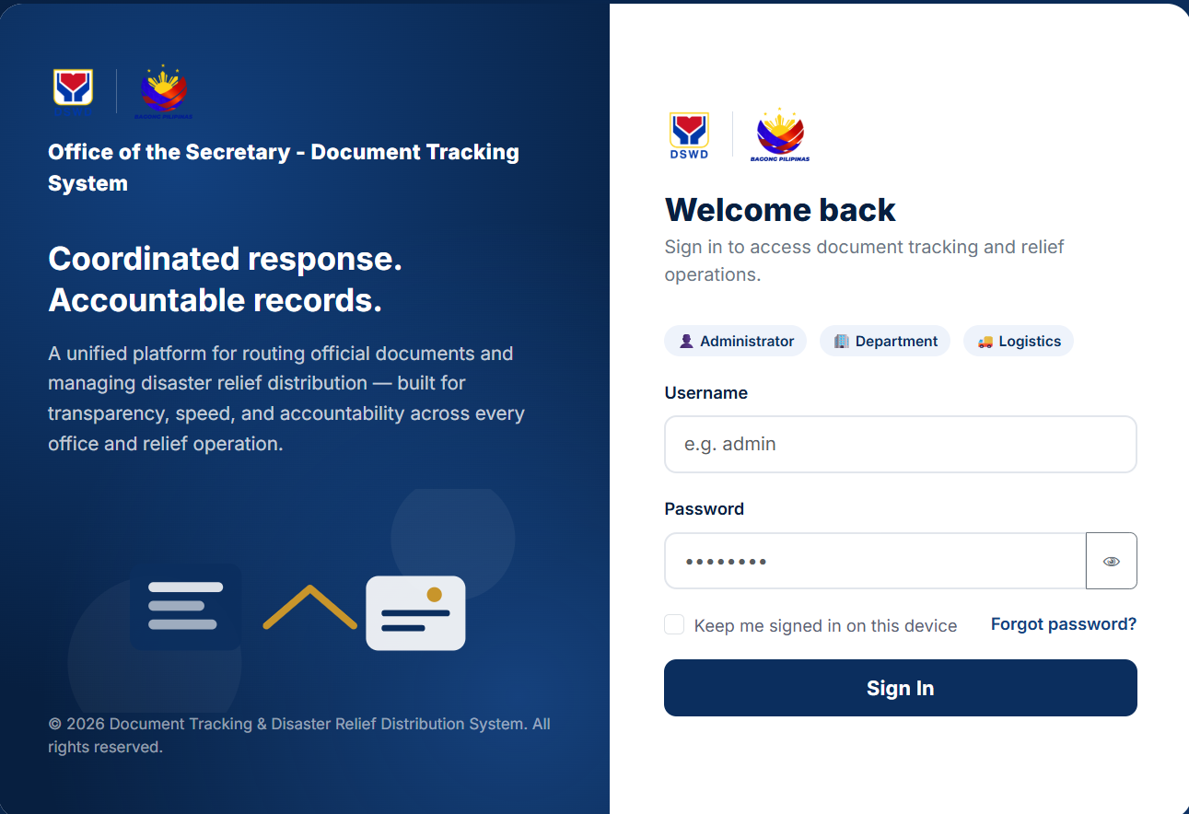
To achieve this, the architecture integrates cloud technology to transition the agency from a manual, paper-based setup to a decentralized digital framework. At its core, the structure utilizes a Support Vector Machine (SVM) classification engine to automatically categorize incoming administrative files for faster processing. It employs a dynamic workflow automation engine combined with a rigorous Role-Based Access Control (RBAC) module to ensure that documents are securely routed and accessible to both on-site and remote personnel based on their specific permissions. Furthermore, the system leverages scannable QR codes and an immutable digital audit trail to provide real-time visibility, ensuring all document routing and disaster relief reporting remains accurate, secure, and compliant with national efficiency mandates.
Figure 14. Login Screen
Figure 14 illustrates the successful implementation of secure authentication and Role-Based Access Control (RBAC). By requiring credentials and token-based verification, it ensures that access to sensitive government records and workflow operations is strictly limited to authorized personnel based on their assigned roles (Administrator, Department User, and Logistics Officer).
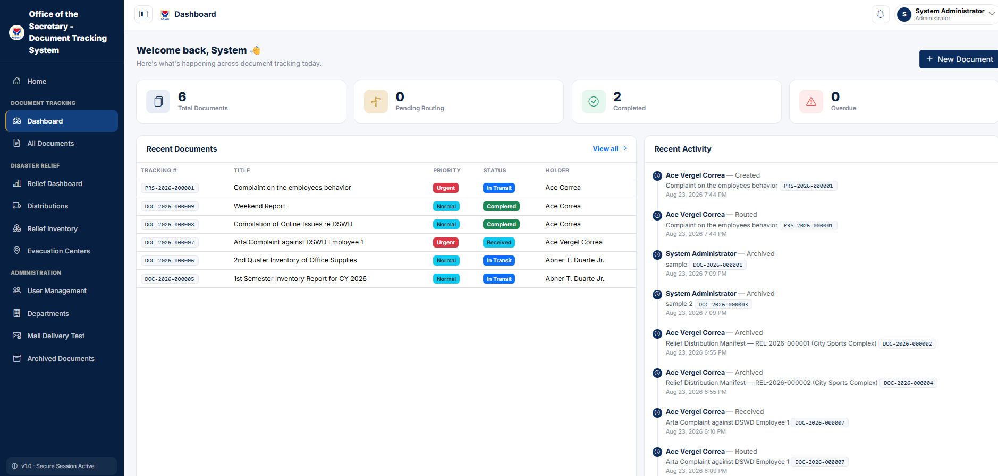
Figure 15. Main Dashboard
Figure 15 demonstrates real-time administrative oversight and system-wide monitoring. By aggregating numeric metrics for total documents, pending routing, and completed tasks alongside a live activity log, it proves the system's ability to eliminate operational "black boxes" and provide leadership with immediate visibility into workflow bottlenecks.

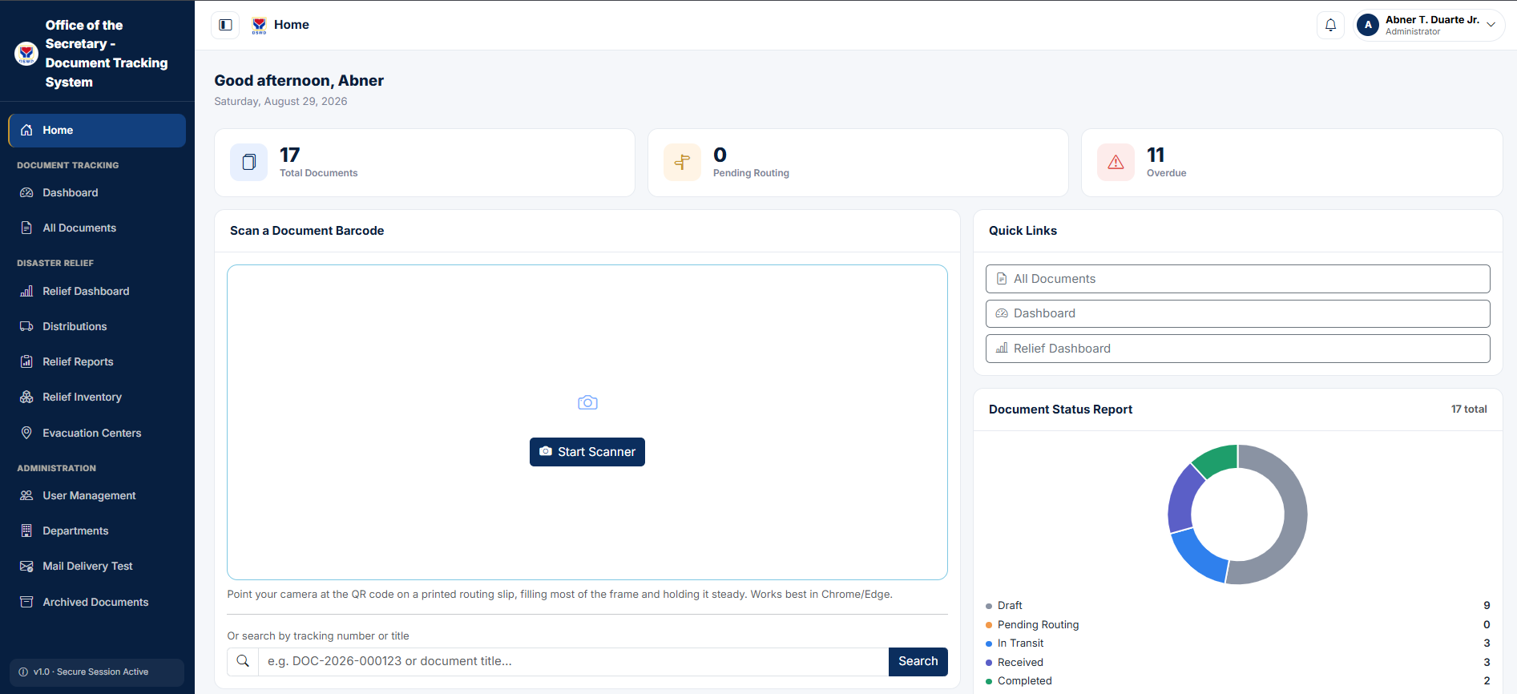
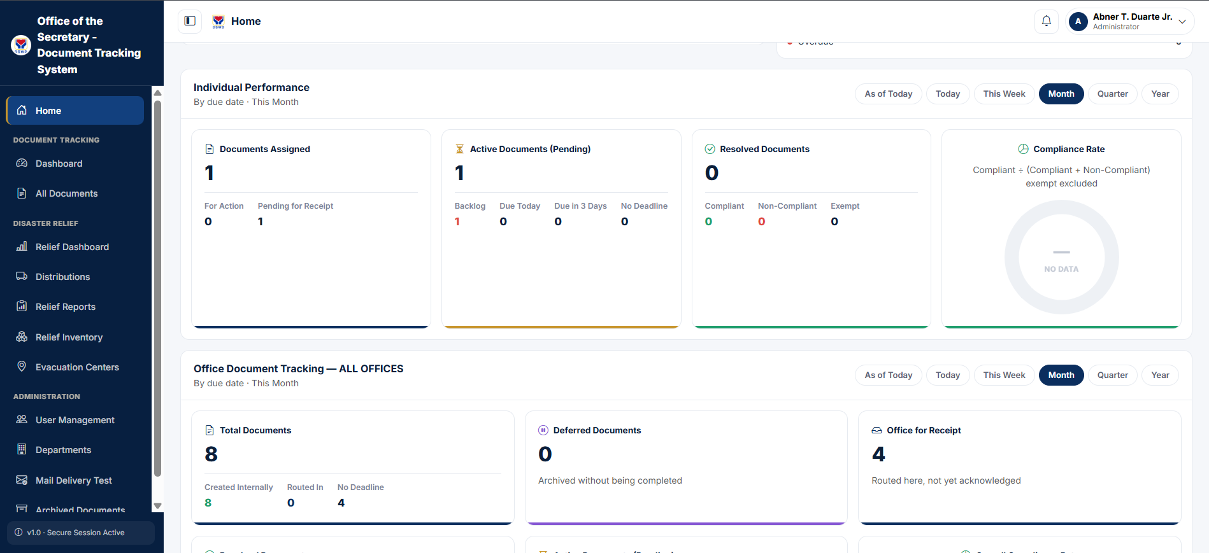
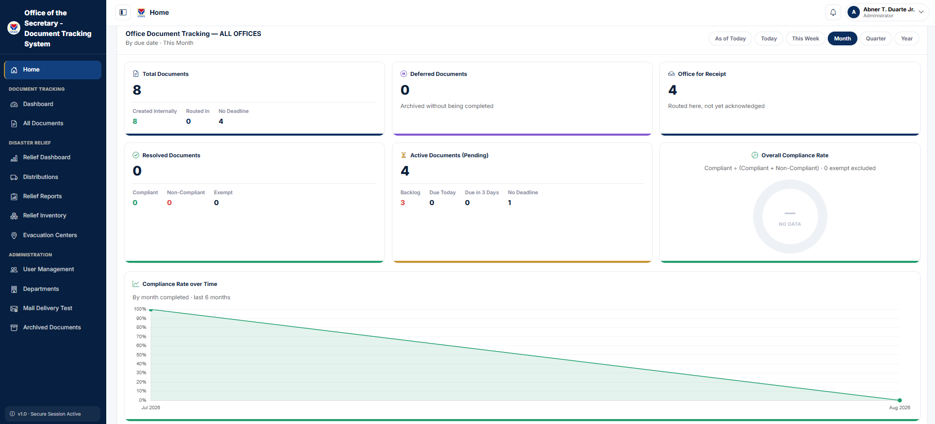
Figure 16. Home Page
Figure 16 illustrates the operational capability for rapid, hybrid-ready document identification and retrieval. It proves that staff can bypass manual logbook searches either by utilizing device-integrated camera scanning for QR codes or by executing direct tracking number lookups.
Figure 17. Dashboard Analytics

Figure 17 shows the system's capacity for granular performance tracking and compliance monitoring. By rendering detailed individual and office-wide analytics (such as document processing turnaround times and completion rates), it proves that administrators can objectively evaluate workflow efficiency and adherence to administrative schedules.

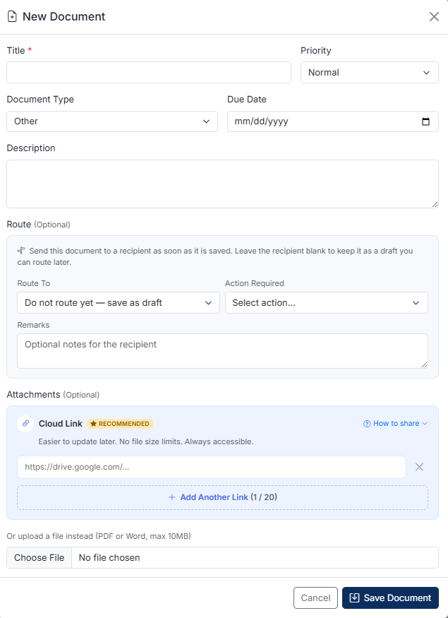

Figure 18. Add New Document Dashboard
Figure 18 shows the smooth execution of document intake, automated classification metadata association, and flexible routing initiation. It demonstrates how users can seamlessly input critical attributes, attach cloud links to avoid database bloat, and dictate immediate routing pathways.
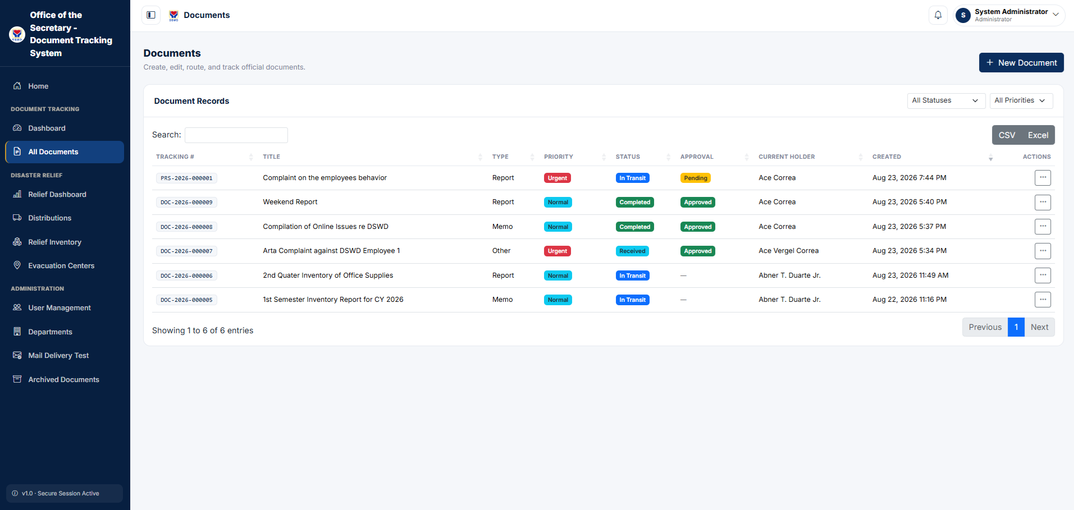
Figure 19. Tracking Documents

Figure 19 shows the realization of complete data centralization and transparency. By providing structured data tables with advanced filtering capabilities, it proves that users can instantly locate, sort, and review the exact status of any official document across the agency.

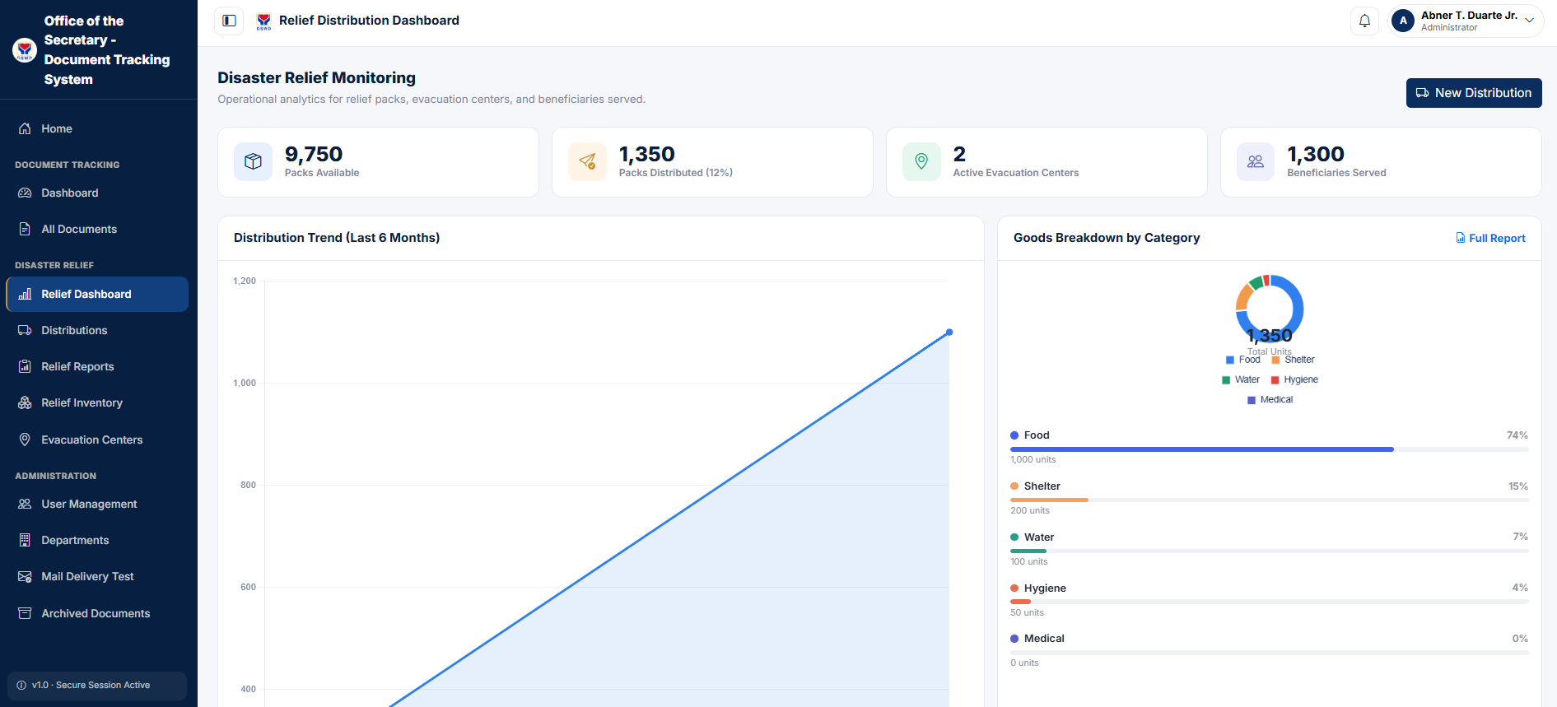
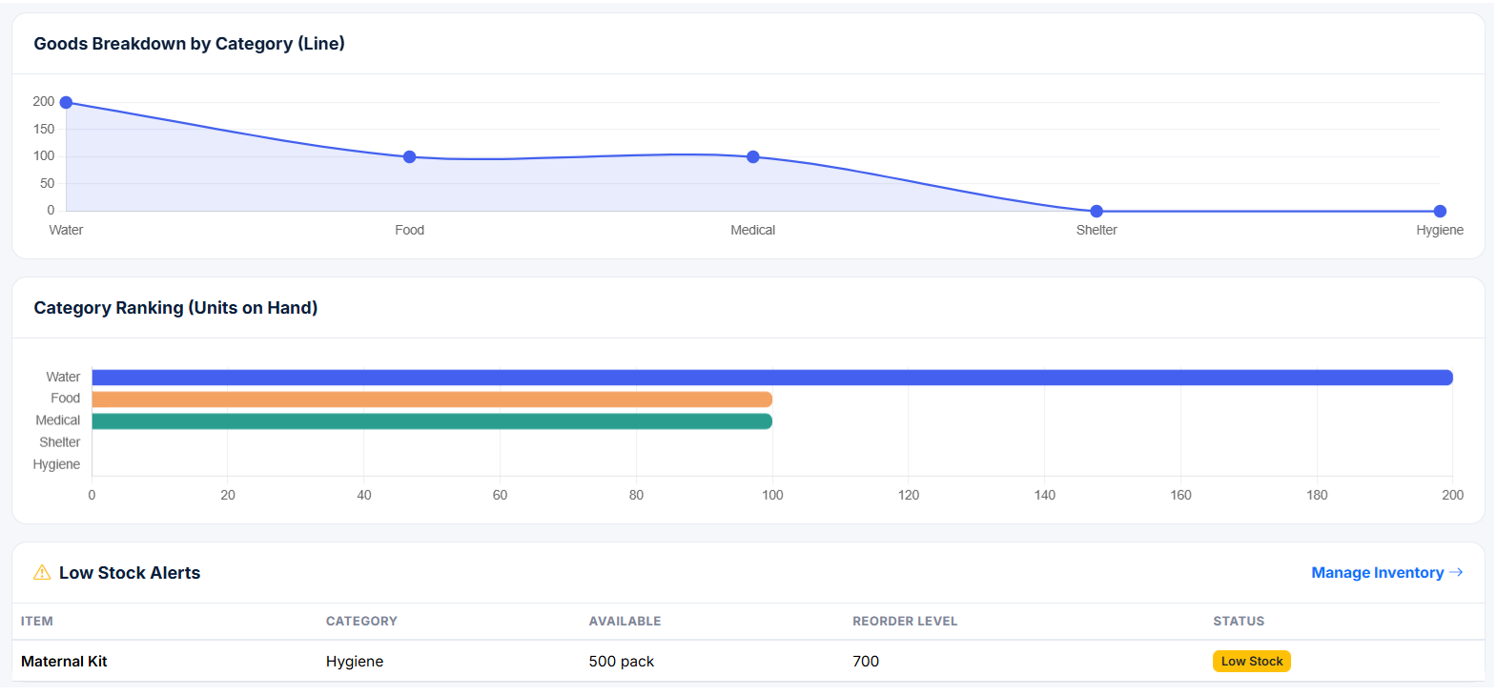
Figure 20. Relief Operations Monitoring Dashboard

Figure 20 illustrates the system's integrated capacity to manage disaster response logistics alongside administrative workflows. By dynamically tracking distributed goods, beneficiary reach, distribution trends, and automated low-stock alerts, it proves that the platform prevents inventory miscalculations during emergency operations.

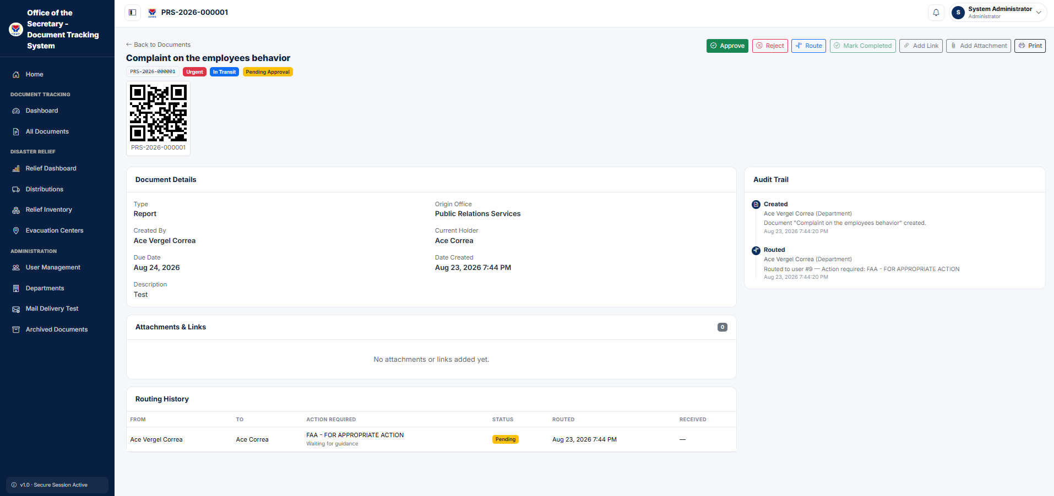
Figure 21. Document Tracking with QR Code

Figure 21 shows the implementation of absolute accountability and tamper-proof auditing. By consolidating the document's metadata, a scannable identification QR code, a complete routing history, and an immutable action log onto a single page, it proves that every lifecycle transition is permanently and transparently recorded.

Project Capabilities and Limitations
The following are the capabilities of the project:
- Role-Based Access Control (RBAC): The system manages user authentication and strictly restricts access based on assigned roles (e.g., Administrator, Department User, Logistics) to protect sensitive data.

- SVM Document Classification: It utilizes a Support Vector Machine (SVM) model and TF-IDF text feature extraction to automatically categorize incoming administrative files, significantly speeding up document processing.
- Automated Workflow and Routing: The platform automatically forwards classified documents along official approval paths, handling both multi-stage sequential and parallel reviews without the need for manual, physical handovers.
- QR Code Retrieval and Tracking: The system generates unique QR codes that are embedded into official documents and relief manifests, enabling rapid status lookups and bridging the gap between physical and digital tracking.
- Real-Time Analytics and Audit Logging: It provides a real-time dashboard that displays live status updates and bottlenecks, alongside an immutable, tamper-proof audit trail that permanently records every user action and timestamp for absolute accountability.
- Disaster Relief Reporting: The system features a dedicated module to track disaster relief inventories, record the allocation of goods, and automatically generate consolidated relief summary reports.

The following are the limitations of the project:
- Infrastructure Dependency: The platform's overall uptime and security rely heavily on the stability of the third-party cloud service provider's infrastructure.
- Connectivity Constraints: Day-to-day operational performance hinges entirely on internet connectivity, making the system vulnerable to latency in remote satellite offices or low-bandwidth areas.
- User Adoption Challenges: The practical implementation of the system may face slower adoption due to varying levels of digital literacy and potential cultural resistance to procedural changes among traditional staff.
- Exclusion of Physical Logistics: The system is limited to electronic recording and monitoring; it does not cover the physical printing, packing, or delivery of relief goods to evacuation centers.
- QR code Scope: The code scanning feature is exclusively designed for document identification and retrieval, and it does not extend to tracking individual physical relief items.

Project Testing
The project testing phase was conducted to systematically evaluate the performance, functionality, and operational viability of the Integrated Paperless Document Tracking and Workflow System for DSWD Utilizing Support Vector Machine Classification. Following internal unit and integration tests, user acceptance testing was administered to designated user-respondents from the Office of the Secretary, including administrative staff, department focal persons, and approving officers. The respondents interacted directly with core features, such as role-based authentication, automated document routing, QR code tracking, and disaster relief reporting, to assess their behavior under realistic administrative conditions. Standardized metrics aligned with the ISO/IEC 25010 software quality model—specifically Functional Suitability, Performance Efficiency, Usability, and Reliability—were utilized to capture quantitative user feedback and verify whether the platform fulfills its intended objectives. The compiled ratings and statistical results of this testing phase are detailed in Table 5.
Table 5
Testing Results of the Respondents’ Rating for the Testing of the Integrated Paperless Document Tracking and Workflow System For Dswd Utilizing Support Vector Machine Classification

Criteria | Mean Score | Interpretation
Functional Suitability | 4.44 | Very Good
Performance Efficiency | 4.33 | Very Good
Usability | 4.60 | Excellent
Reliability | 4.78 | Excellent
Overall Mean | 4.54 | Excellent

Table 5 presents the result of the test conducted to ensure that desired characteristics were achieved. Results showed that the evaluation results for the integrated paperless document tracking and workflow system for dswd utilizing support vector machine classification demonstrate a highly positive reception from the three respondents, achieving an overall mean score of 4.54, which translates to an "excellent" rating. the system performed exceptionally well in reliability and usability, scoring 4.78 and 4.60 respectively, both interpreted as "excellent". functional suitability and performance efficiency received slightly lower but still highly commendable scores of 4.44 and 4.33, earning a "very good" interpretation. overall, these metrics indicate that the system is highly dependable, user-friendly, and effective, with only minor potential areas for optimizing task coverage and response times.

Project Evaluation
The project evaluation phase was conducted to formally assess the technical architecture, security, and overall software product quality of the developed system. Guided by the international standards of the ISO/IEC 25010 software quality model, this phase shifted the focus from day-to-day user operation to technical robustness. The evaluation was administered to identified IT and software quality professionals, who participated in a live demonstration and a hands-on walkthrough of the platform's underlying infrastructure and core modules. Following this technical review, the evaluator-respondents rated the system across key quality characteristics—specifically Functional Suitability, Performance Efficiency, Usability, and Reliability—using a structured five-point Likert scale instrument. The quantitative results and technical assessment from this evaluation are presented in Table 6.
Table 6
IT expert's rating for the testing of the integrated paperless document tracking and workflow system for dswd utilizing support vector machine classification.
Criteria | Mean Score | Interpretation
Functional Suitability | 5.00 | Excellent
Performance Efficiency | 5.00 | Excellent
Usability | 5.00 | Excellent
Reliability | 5.00 | Excellent
Overall Mean | 5.00 | Excellent

Table 6 shows the evaluation conducted by the IT expert yielded perfect scores across all evaluated criteria, resulting in a unanimous overall mean score of 5.00, which signifies an "Excellent" rating. Specifically, the system achieved a maximum score of 5.00 in Functional Suitability, Performance Efficiency, Usability, and Reliability. In his qualitative feedback, the expert noted that the system is user-friendly, responsive, easy to navigate, and that its features actively support efficient processing, monitoring, and overall operational needs. This indicates complete technical satisfaction with the software's architecture, interface, and execution.

Chapter 5
SUMMARY OF FINDINGS, CONCLUSIONS, AND RECOMMENDATIONS
This chapter presents the summary of findings derived from the testing and evaluation of the system, the conclusions drawn from these results, and the recommendations provided for the future enhancement of the project.

Summary of Findings
The study successfully developed the Integrated Paperless Document Tracking and Workflow System for DSWD Utilizing Support Vector Machine Classification for the DSWD Office of the Secretary, effectively transitioning the agency from manual logbooks to a secure digital infrastructure equipped with Support Vector Machine (SVM) automated document classification, strict Role-Based Access Control (RBAC), and scannable QR codes. During project testing, the system garnered a highly positive reception from the three user-respondents, achieving an overall mean score of 4.54, interpreted as "Excellent." The platform performed exceptionally well in Reliability (4.78) and Usability (4.60), while Functional Suitability (4.44) and Performance Efficiency (4.33) received highly commendable "Very Good" ratings, proving the system to be highly dependable and user-friendly for day-to-day administrative tasks. This operational success was further validated by a formal technical evaluation conducted by an IT expert, who awarded the platform a perfect mean score of 5.00 ("Excellent") across all assessed ISO/IEC 25010 criteria, highlighting its responsive architecture, ease of navigation, and strong support for processing needs. Ultimately, the integration of this digital workflow engine successfully eliminates the need for manual, physical document transfers, efficiently manages multi-stage approvals, and provides real-time visibility through an immutable audit trail, making it highly effective for supporting disaster relief inventories and the agency's hybrid work arrangements.

Conclusions
Based on the findings of the study, the following conclusions were drawn:
- The transition from a manual, paper-based workflow to a cloud-enabled digital platform effectively eliminates the administrative bottlenecks and geographic barriers previously experienced by the DSWD's Office of the Secretary.
- The implementation of a centralized tracking dashboard and scannable QR codes provides the real-time visibility necessary to support the agency's hybrid work arrangements, ensuring no document is lost in transit.
- The integration of the Support Vector Machine (SVM) classification model and automated routing engine significantly cuts down processing times and manual hand-to-hand transfers, complying directly with the Ease of Doing Business Act (RA 11032).
- The system meets the rigorous quality standards of ISO/IEC 25010, proving it is highly secure, reliable, and suitable for handling sensitive government public service data.
Recommendations

Based on the findings and conclusions of the study, the following recommendations are proposed for the system's improvement to facilitate future
enhancements:

- For the DSWD Office of the Secretary: The management should conduct comprehensive digital literacy and training seminars for all users (Administrators, Encoders, Reviewers, and Logistics Officers) prior to full deployment to overcome cultural resistance and ensure smooth system adoption.
- For the IT Department / Management: Given the system's reliance on internet connectivity, the agency must ensure stable bandwidth and a highly reliable cloud infrastructure, particularly when deploying the system to remote satellite offices.
- For Future Researchers: Future studies should explore extending the barcode and QR code scanning capabilities beyond just document identification to include the tracking of individual physical relief goods from warehouses directly to evacuation centers.

REFERENCES
Jaquilmo, C. A., & Sarmiento, J. R. (2023). Web-based electronic document tracking management system. Global Scientific Journal, 11(5), 1108–1119.

Piloton, A. J., Jr., Gamboa, G. Z., Jr., Dela Cerna, M. A., & Reyna, R. A. (2023). Development of records tracking management system with QR code. International Journal for Multidisciplinary Research (IJFMR), 5(4).

Rodriguez, R. L., Serrano, E. A., & Balan, A. K. D. (2017). Anduyog: A web-based application for relief and casualty monitoring and early warning system for local government units in the Philippines. In 2017 IEEE Region 10 Symposium (TENSYMP) (pp. 1–5). IEEE. https://doi.org/10.1109/TENCONSpring.2017.8070002

Gemma G. Acedo1, John Gregory M. Bola2, Andrea S. Morales (2025). Web-Based Document Tracking System for Catanduanes State University with QR-Code Technology: In Alignment with Republic Act No. 11032. Journal of Information Systems Engineering and Management 2025 10(6s), e-ISSN: 2468-4376. https://www.jisem-journal.com/

Darwin G. Raralio., Wreloyd Q. Manzano., Angelo Nathaniel L. Lomibao (2025): Development of Document Tracking and Archiving System for Procurement Management Office’s Purchase Request in Apayao State College; International Journal of Research and Scientific Innovation (IJRSI)

Cesar Augusto Vega-Quintana, Jhonar Angel Gallardo-Andrés, Carlos Enrique Chinga-Ramos (2024). Implementing A Web-Based Document Management System to Optimize Operational Efficiency in Engineering., Pakistan Journal of Life and Social Sciences Pak. j. life soc. Sci. (2024), 22(2):13715-13725 E-ISSN: 2221-7630;P-ISSN: 1727-4915 https://doi.org/10.57239/PJLSS-2024-22.2.00984

Khoshaba O.M. Tsuhel R.S., UDK 004.4:005.92:005.5: Design of an Electronic Document Management System with Configurable Approval Routing and Assignment Deadline Control for IT Companies in Vinnitsia National Technical University

Zeng Xiangdong (2024). Guangdong Vocational College of Innovation and Technology. Document Management System. The Light Explorer, 9(2). ISSN (Print): 2546 – 0102; ISSN (Online): 2423 – 3080; The Light Explorer. 766319378@qq.com

Claudya Tuuk, Arje Cerullo Djamen, Johan Reimon Batmetan (2025). Web-Based Document Management System in the Department of Information and Communication
Technology Education, Manado State University ISSN XXX-XXX, Vol. 1 No. 1, 2025. Department of Information and Communication Technology Education, Manado State University 20208007@unima.ac.id

Vince Simulle D. Lauron; Bryan James B. Desuyo; Arjie Magallanes; Arabelle Villarosa; Dino L. Ilustrisimo, PhD; John Philip V. Parilla; Nino Jhoevann Villaceran; Remlan Jamili; May Manatad; Kurt Bryan S. Alegre, MIT (2026). Design and Development of a Document Request and Tracking System for Madridejos Community College; ISSN 2320–088X; IMPACT FACTOR: 7.056; International Journal of Computer Science and Mobile Computing. IJCSMC, Vol. 15, Issue. 4, April 2026, pg.28 – 37.

Flynn V. Castro, Eileen Rose C. Quilon, Arpee C. Arruejo (2022). DocTrack: A Dynamic Document Tracking System for the University of Northern Philippines. Journal of Innovative Technology Convergence Vol. 4, No. 2 December 2022, pp. 23-34., http://creativecommons.org/licenses/by-nc/4.0/

Rochin Demong, Lailatul Faizah Abu Hassan, Tuan Badrol Hisham Tuan Besar, and Zulhaimi Zulkifli; Electronic Document Tracking System (EDTS): A Prototype. Faculty of Office Management and Technology Universiti Teknologi MARA 40450 Shah Alam, Selangor Darul Ehsan, Malaysia.

Ying Zhang (2025). Governance Strategies for Paper and Electronic Documents in a Dual-Track Archives System. Information Resources Management Journal
Volume 38 • Issue 1 • January-December, https://orcid.org/0009-0008-8987-5597

Irwan Syahputra, Muhammad Iqbal. Implementation of Paperless System for Documentation Process Efficiency at PT Everbright. BIOS: Jurnal Informatika dan Sains
Volume 2 Number 02, 2024, DOI 10.54209/bios.v2i02
E.SSN 2988-6910(Online) https://seaninstitute.or.id/bersinar/index.php/bios/index

Yasmin Makki Mohialden, Nadia Mahmood Hussien, Nada Thanoon Ahmed, Kapil Joshi (2023); IOT-Based Document Tracking Software Development Process. Proceedings of the Iraqi Academics Syndicate 3rd International Conference on Arts and Humanities SciencesIraqi Academic Syndicate, Baghdad- Iraq 10-10 March 2023. https://ssrn.com

Chandrayee Nath, Rupesh Kumar, Vineet Kumar Rakesh. Paperless Office Automation System (OAS) and online tracking of non-automated documents., Variable Energy Cyclotron Centre (VECC) c.nath@vecc.gov.in, rupesh.k@vecc.gov.in, vineet@vecc.gov.in

Niño Derex C. Nagrama, Marc Louise D. Lingating, Justine T. Calleno, Renzse Kristiña A. Rato, Mark Lester P. Catungal, Philipcris C. Encarnacion (2024). Web-based Document Management System., International Journal of Science and Applied Information Technology Vol. 13, No. 3, May-June 2024 www.warse.org/IJSAIT/static/pdf/file/ijsait031332024.pdf, https://doi.org/10.30534/ijsait/2024/031332024

Shyra Joy C. Rellon, April Jay C. Diolata, Noel P. Sobejana, IT.D. Web-Based Document Tracking System Using Barcode Technology with SMS Notification. Institute of Computing Engineering Technology, Information Technology Department, Matti, Digos City, Davao del Sur Philippines. https://ssrn.com

Z Zainal Abidin, N A Zakaria, N Harum, M S Suhaimi, Z Abal Abas, A Idris, K Wan Mohd Ghazali and M H Abdul Hamid. Document Tracking using Internet-of-Things Devices for Fast Data Retrieval., 2nd Joint Conference on Green Engineering Technology & Applied Computing 2020 IOP Conf. Series: Materials Science and Engineering 864 (2020) 012057 IOP Publishing doi:10.1088/1757-899X/864/1/012057 https://iopscience.iop.org/article/10.1088/1757-899X/864/1/012057
APPENDIX A
Testing Instrument
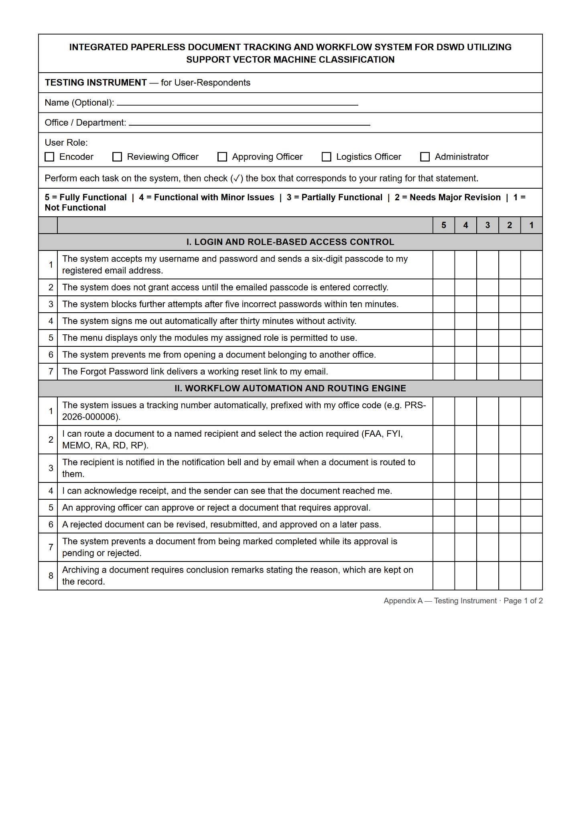

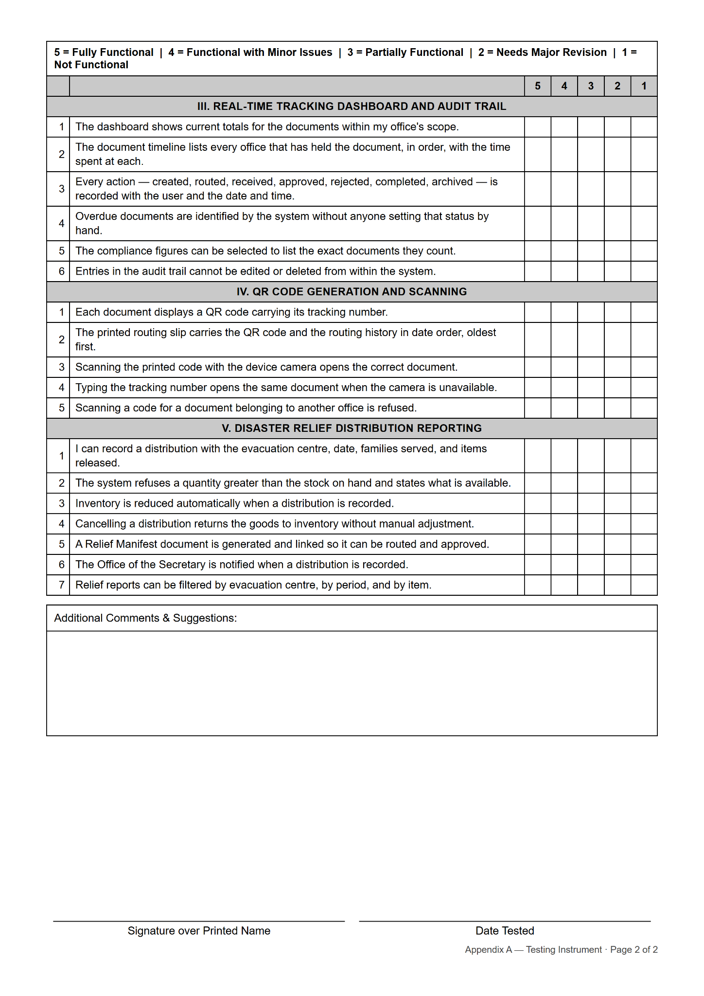

APPENDIX B
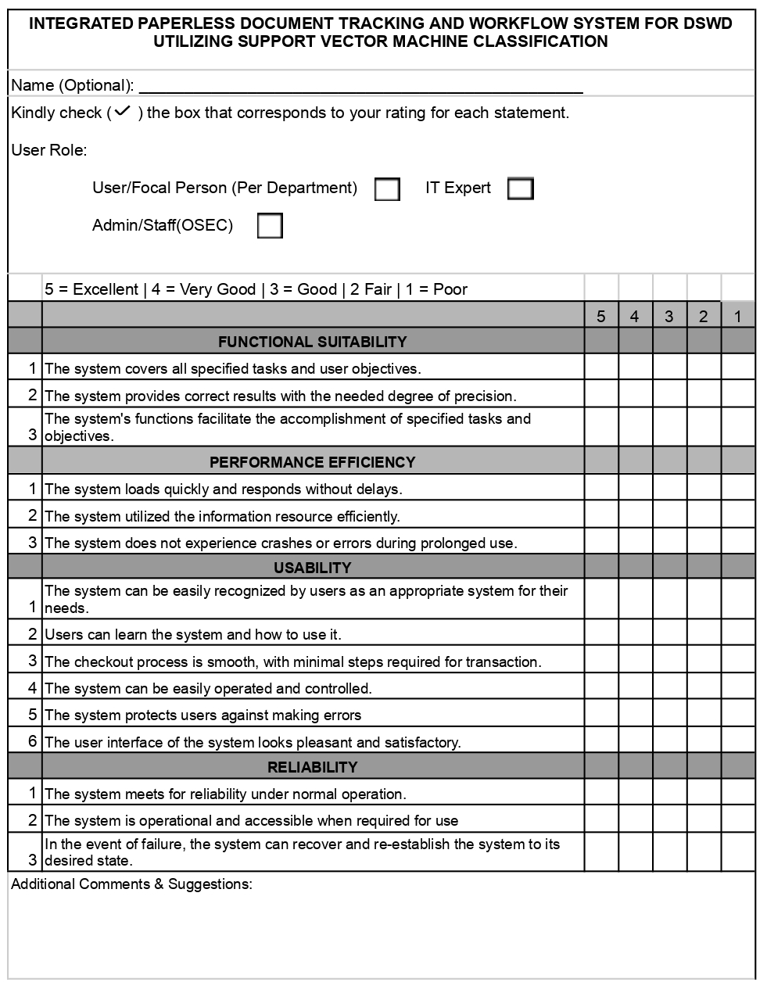
Evaluation Instrument

APPENDIX C
Testing Results per Criterion
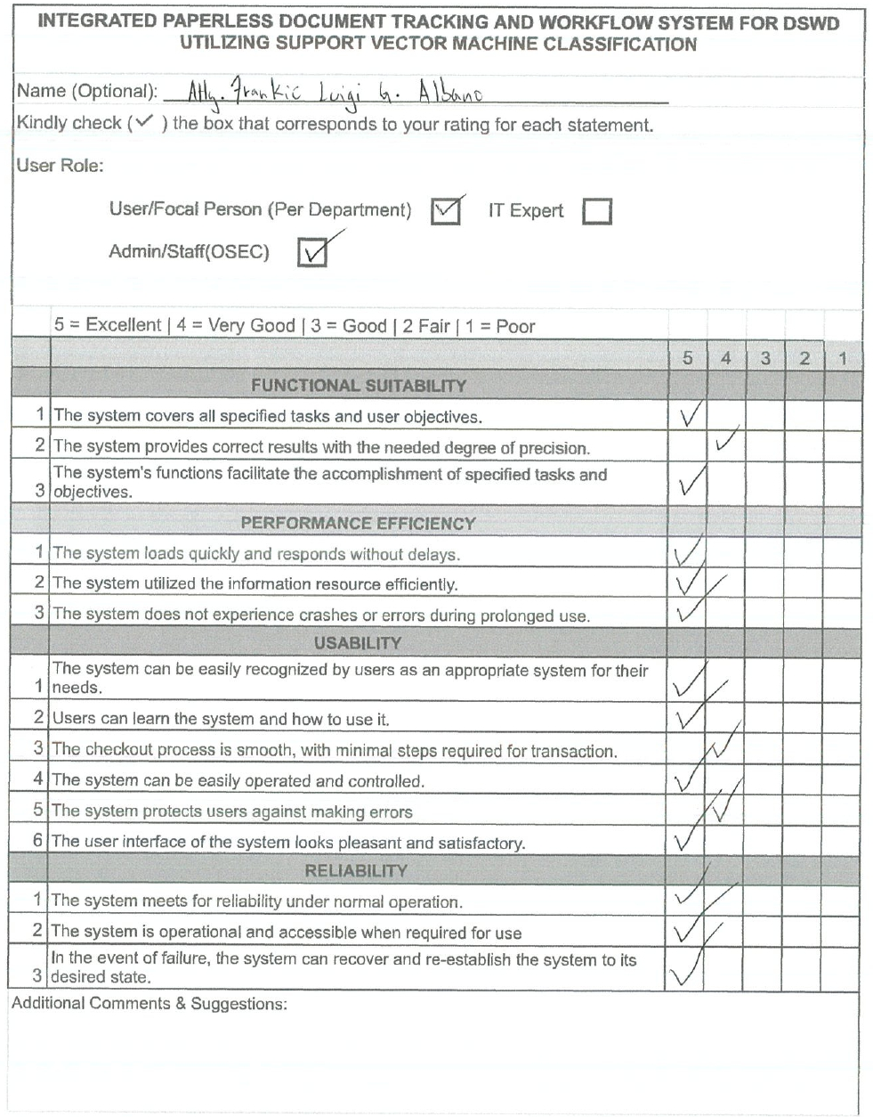

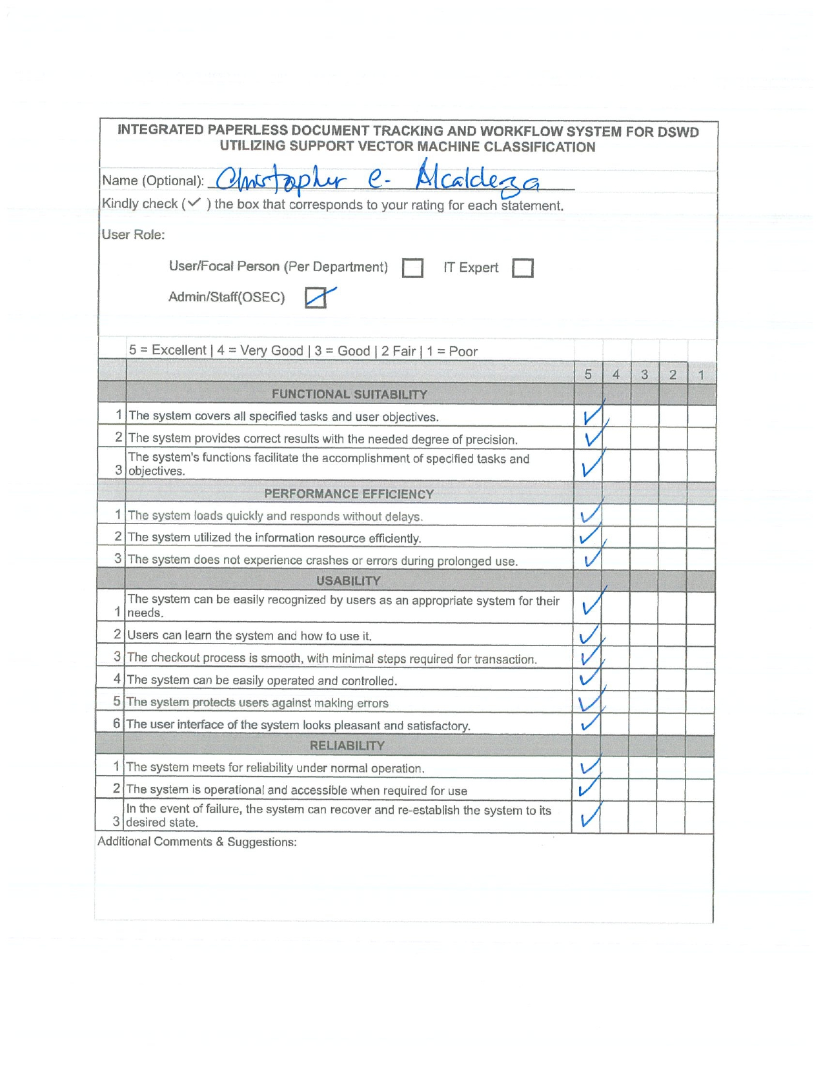

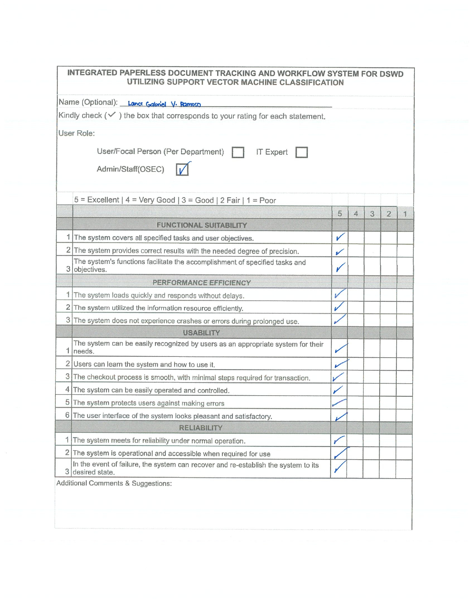

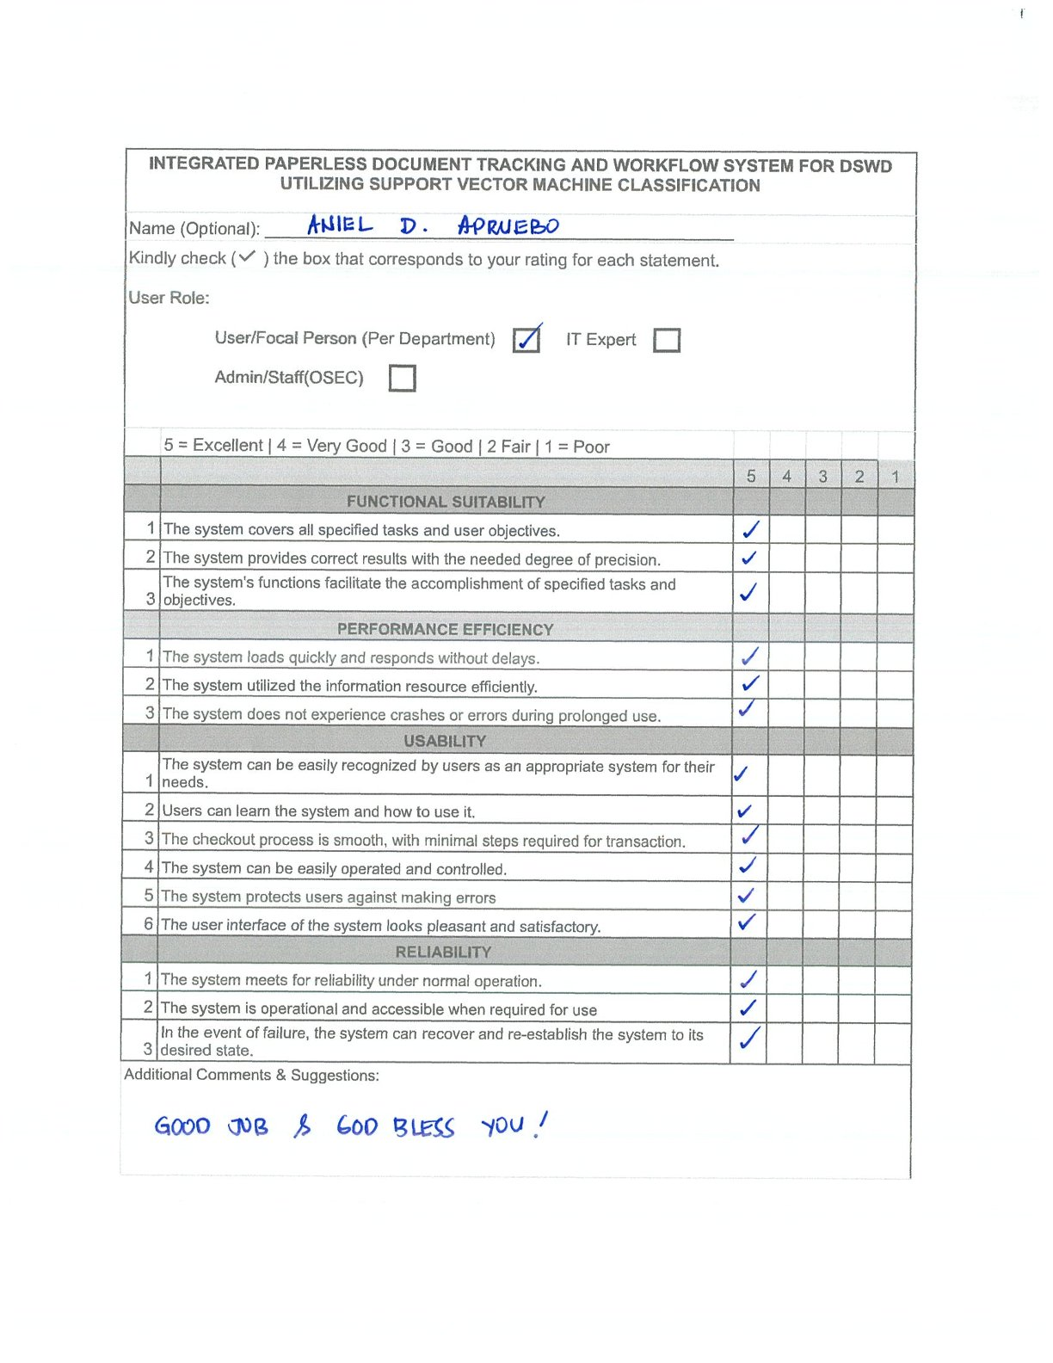

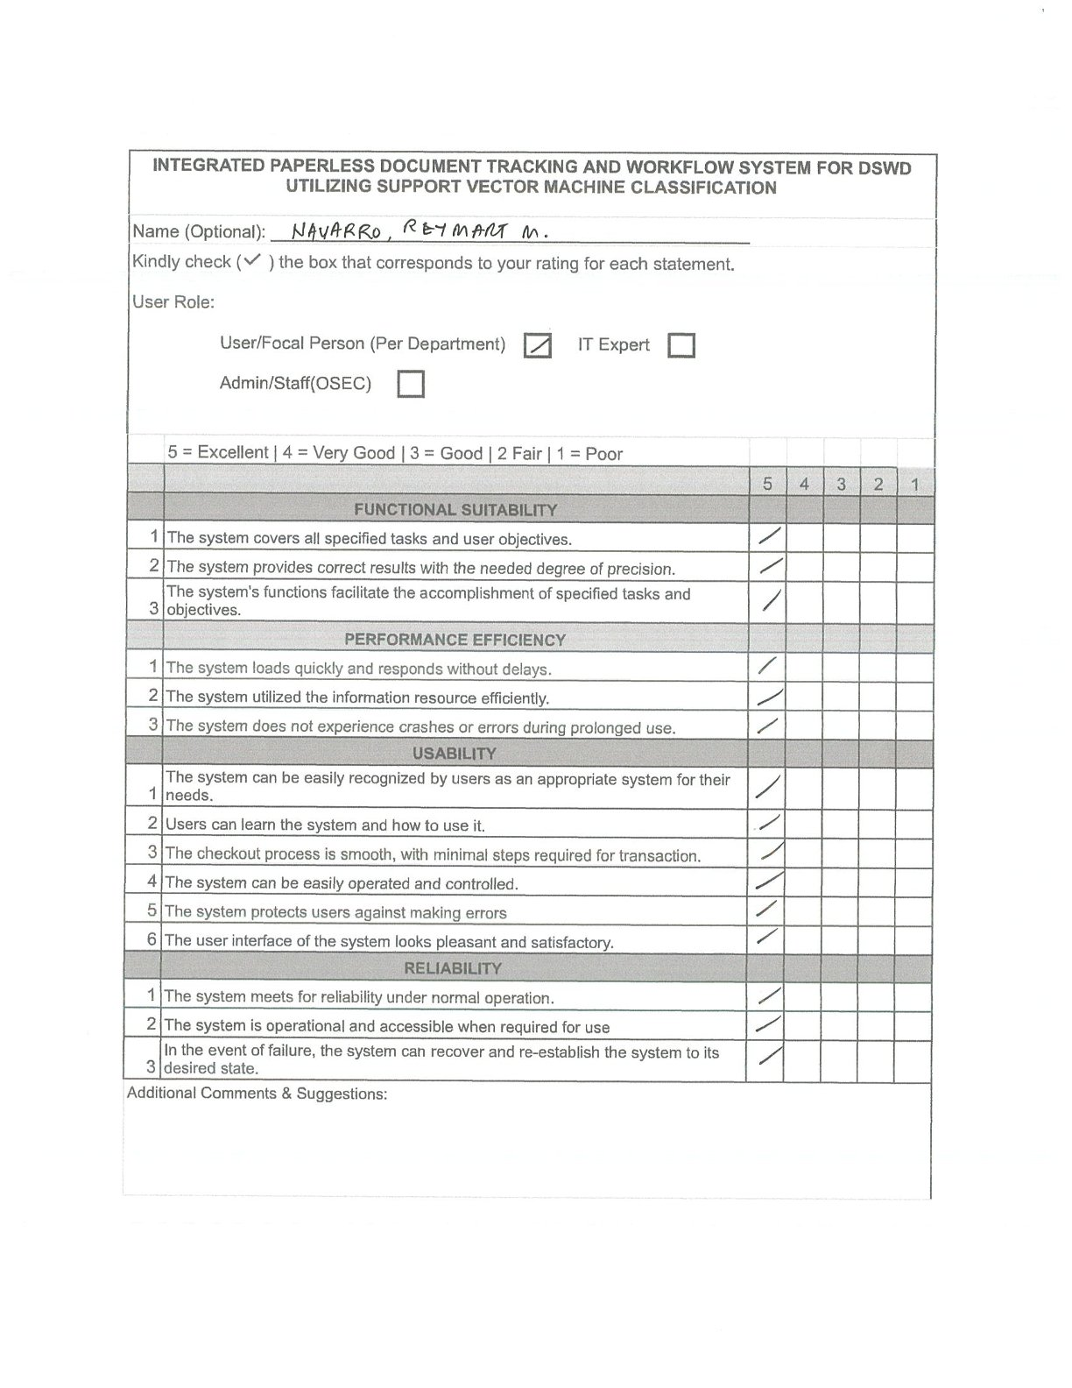

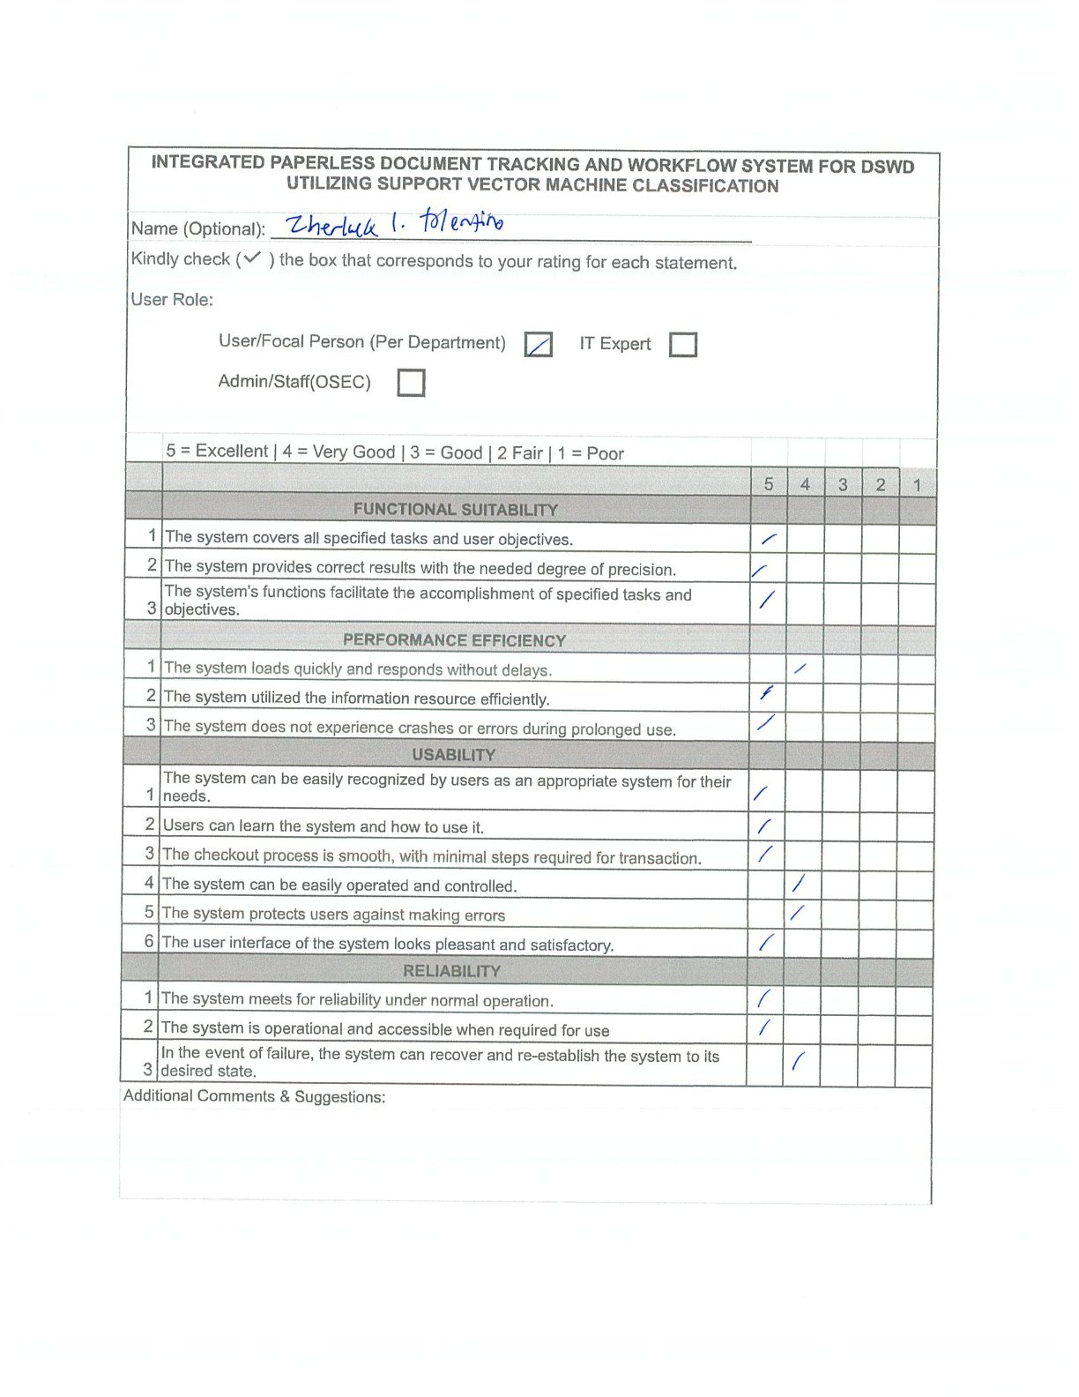

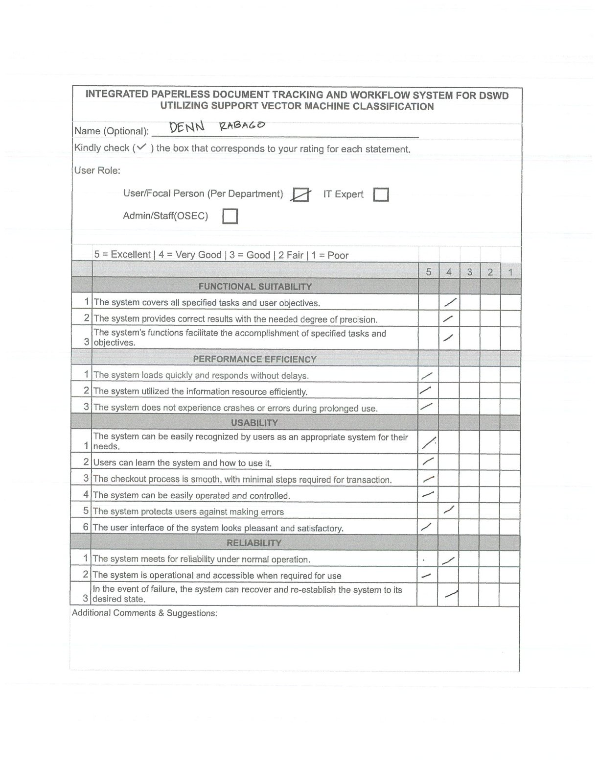

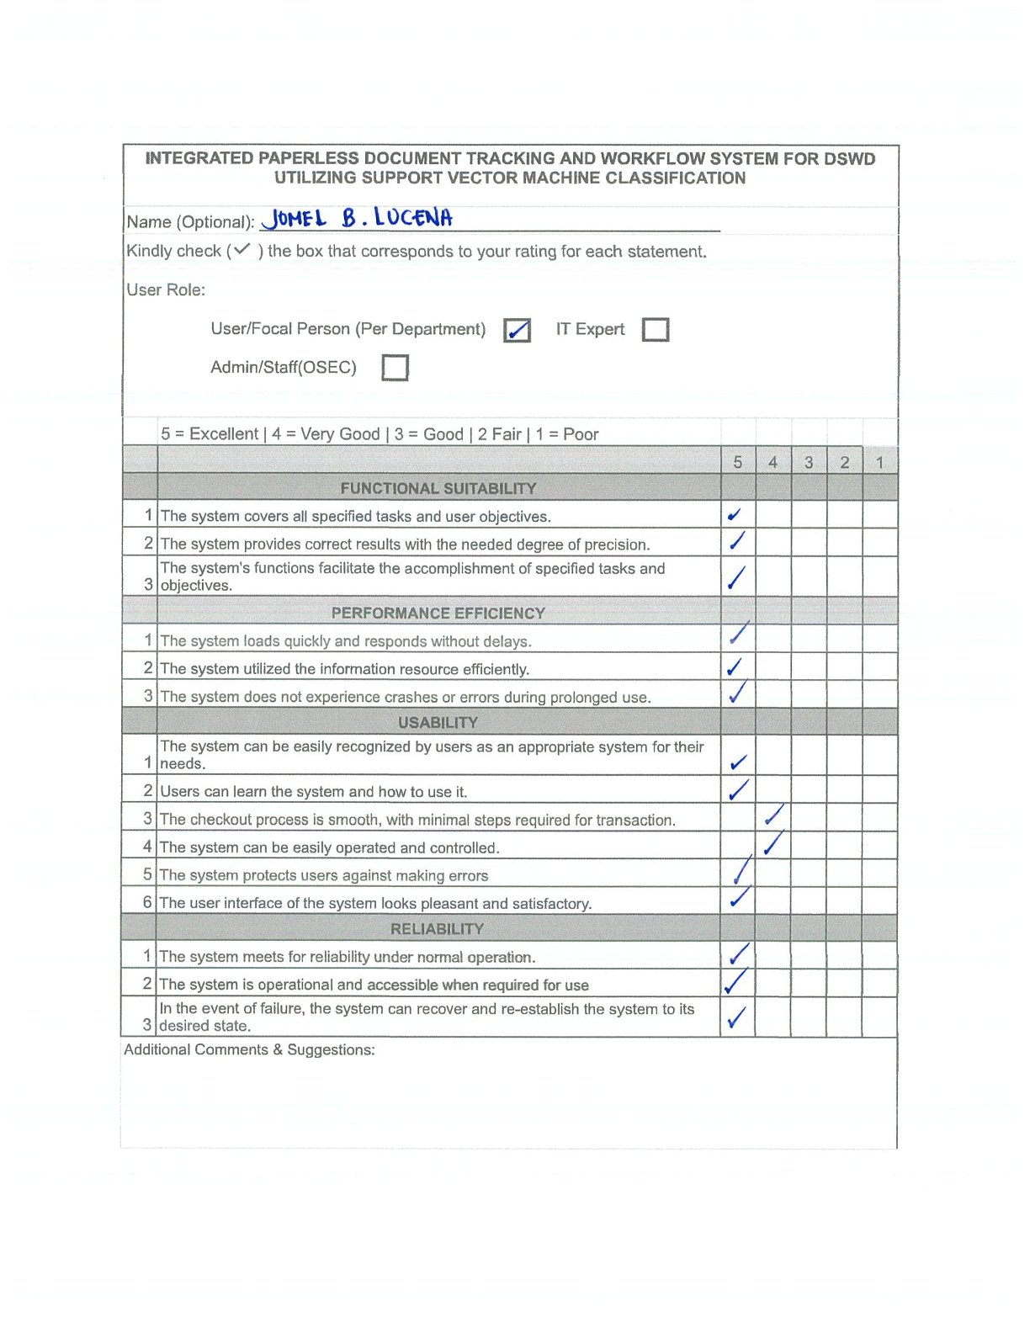

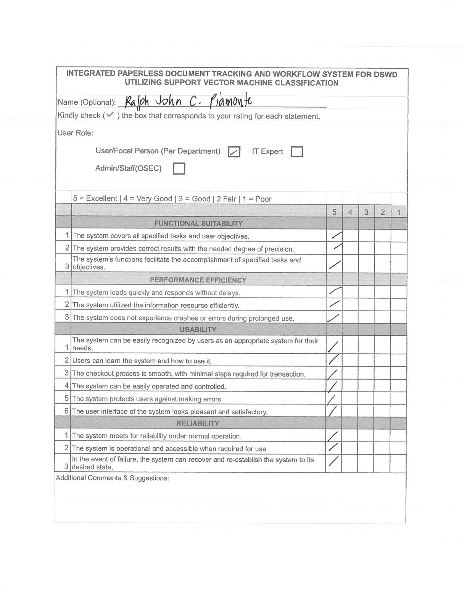

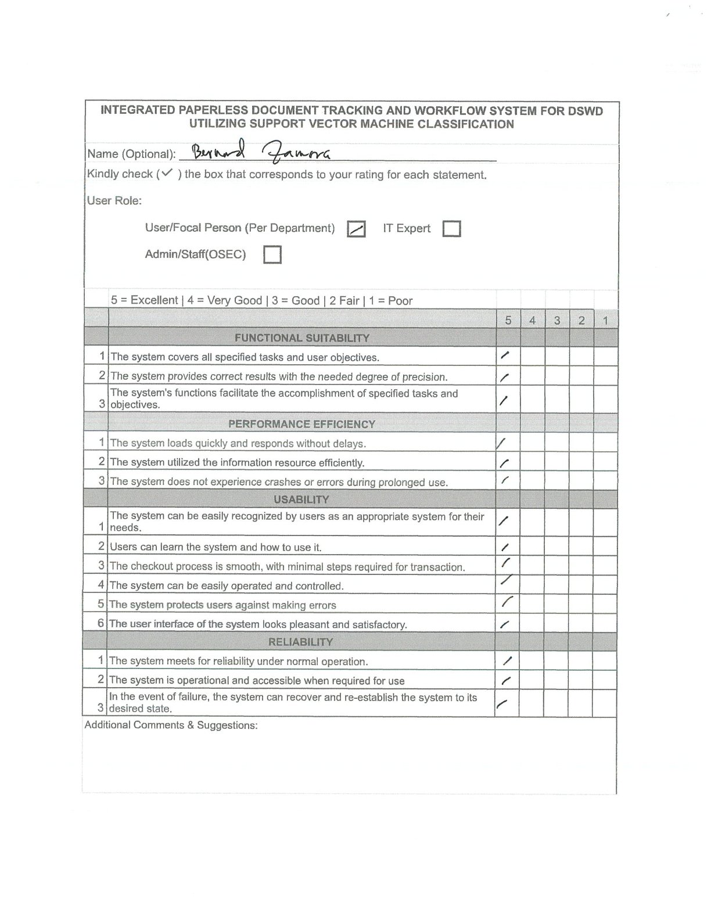

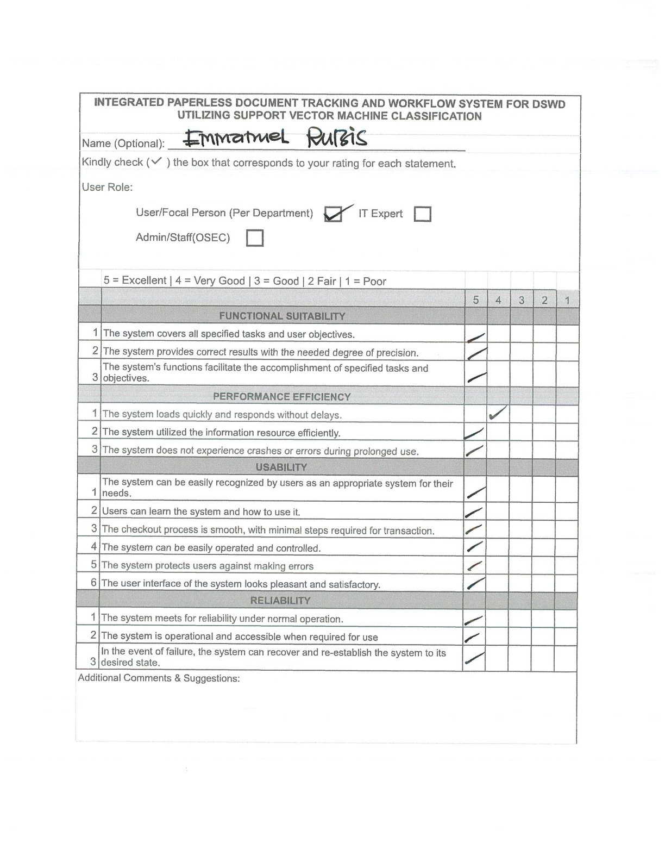

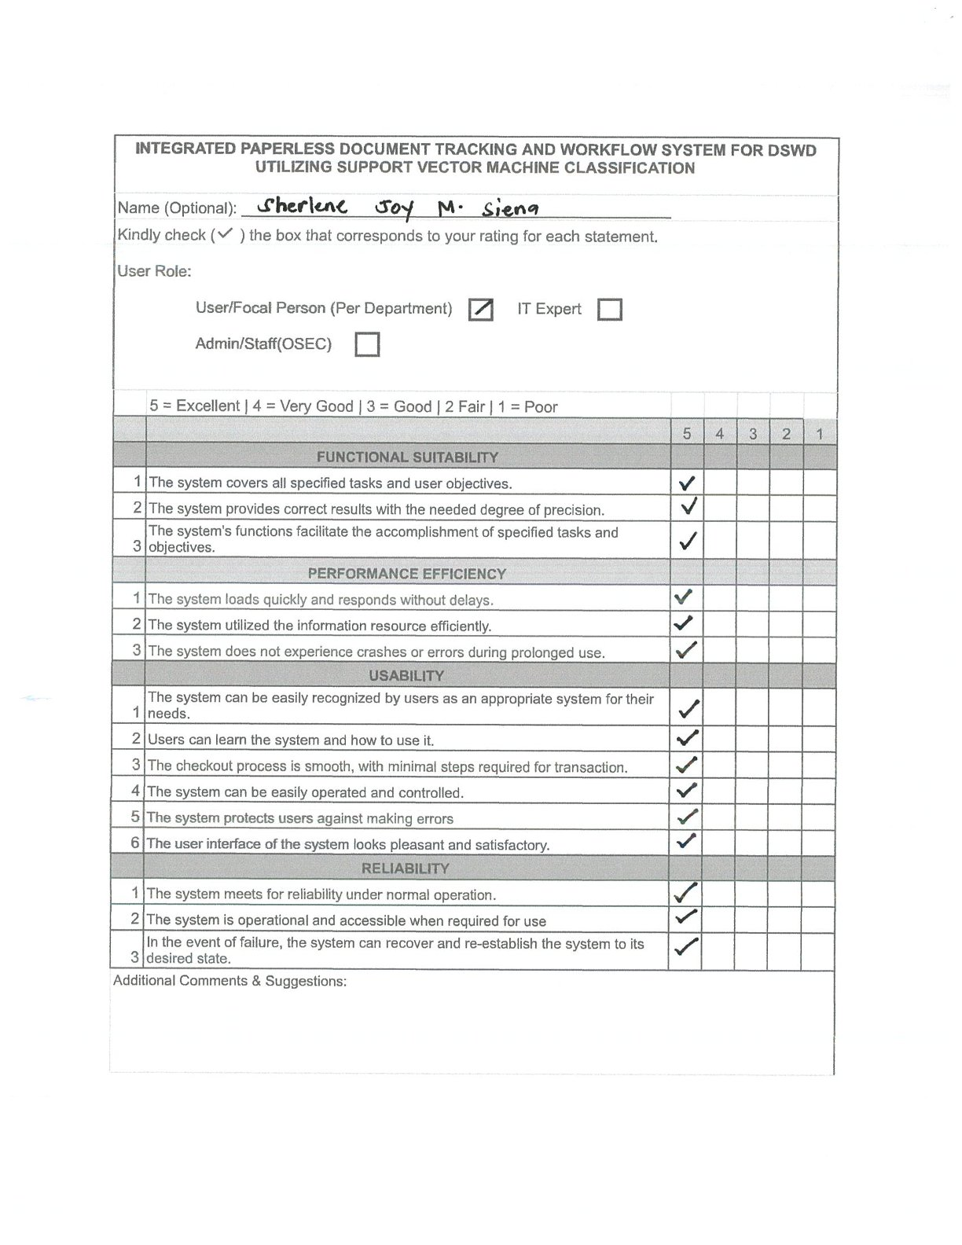

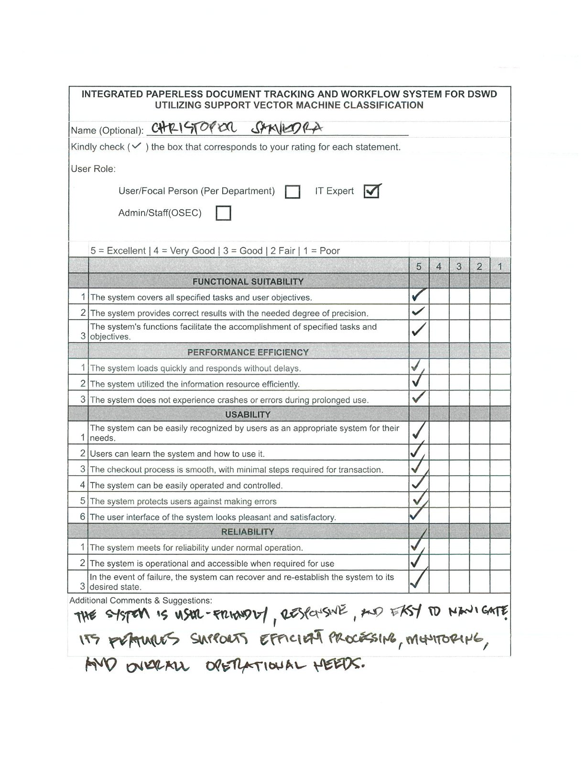

APPENDIX D
Evaluation Results per Criterion
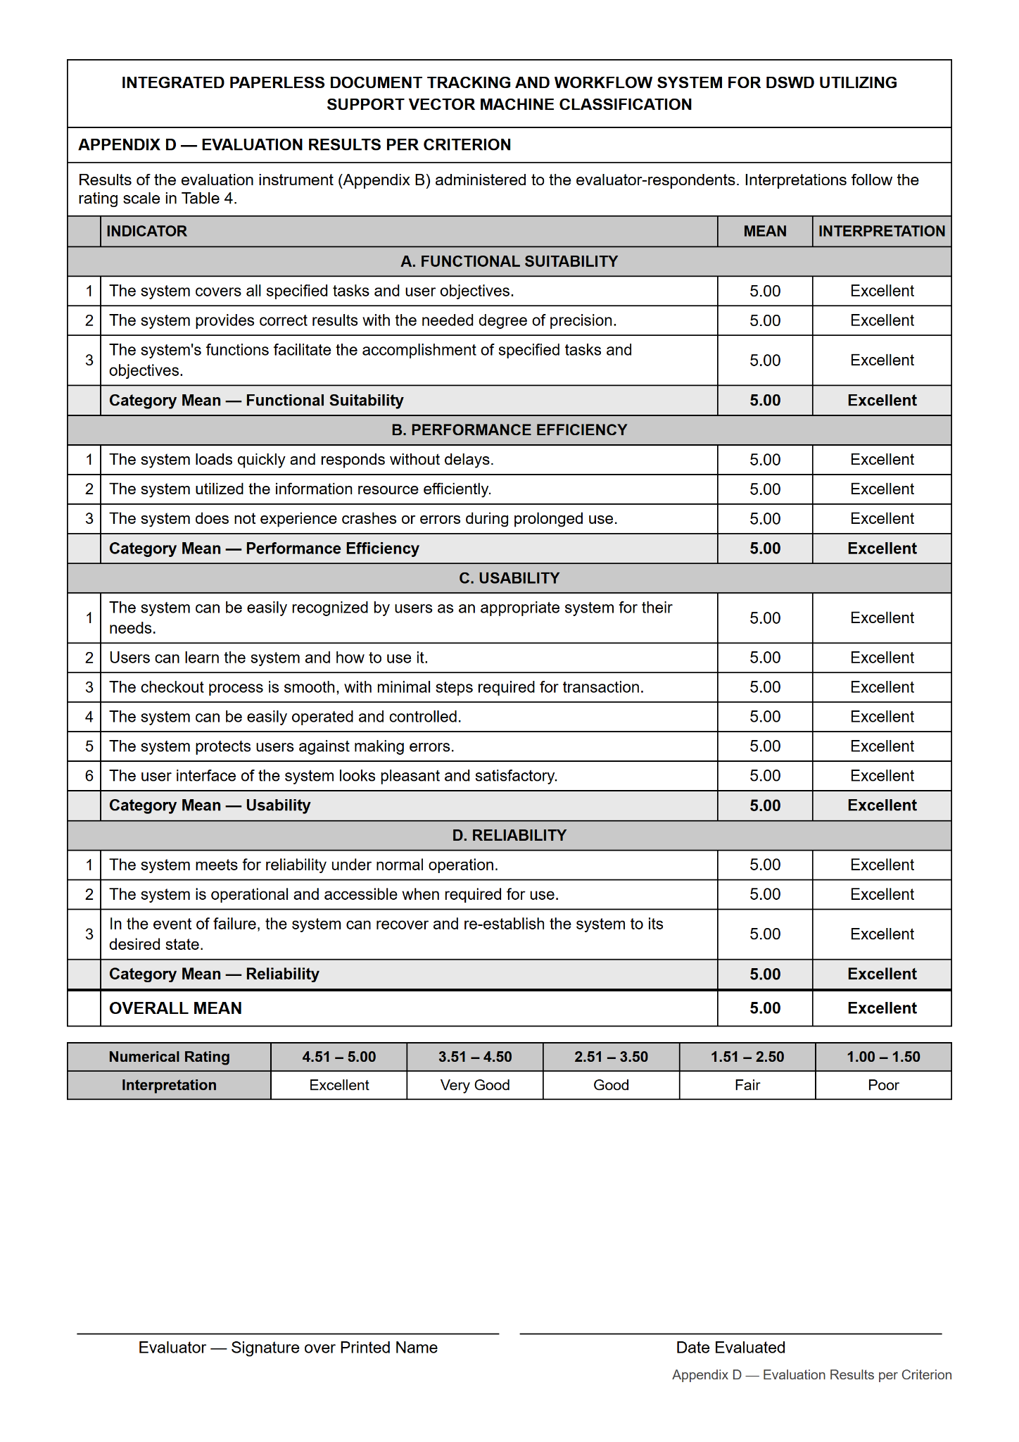
APPENDIX E
Summary of Testing by the User-Respondents
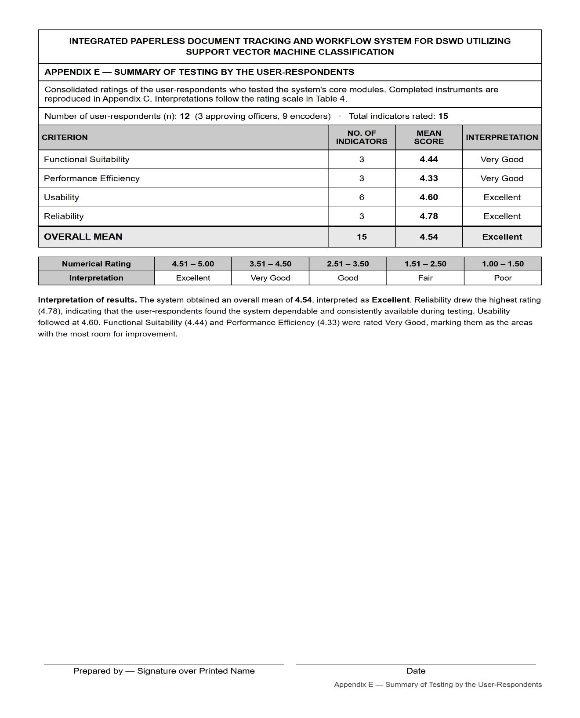
APPENDIX F
Summary of Evaluation by the Evaluator-respondents
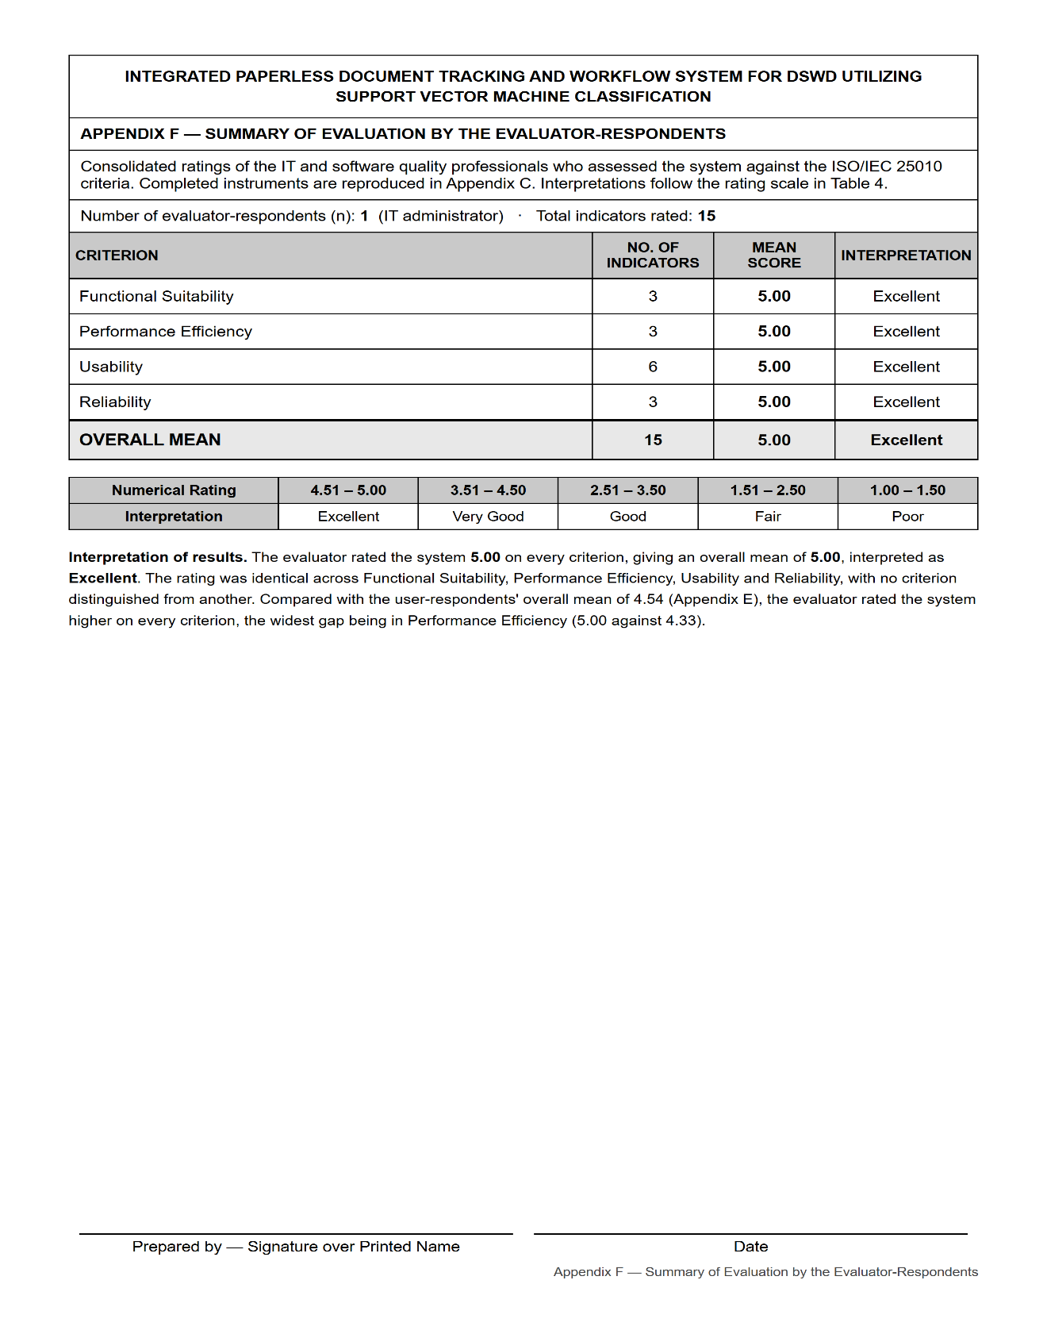
APPENDIX G
User's Manual
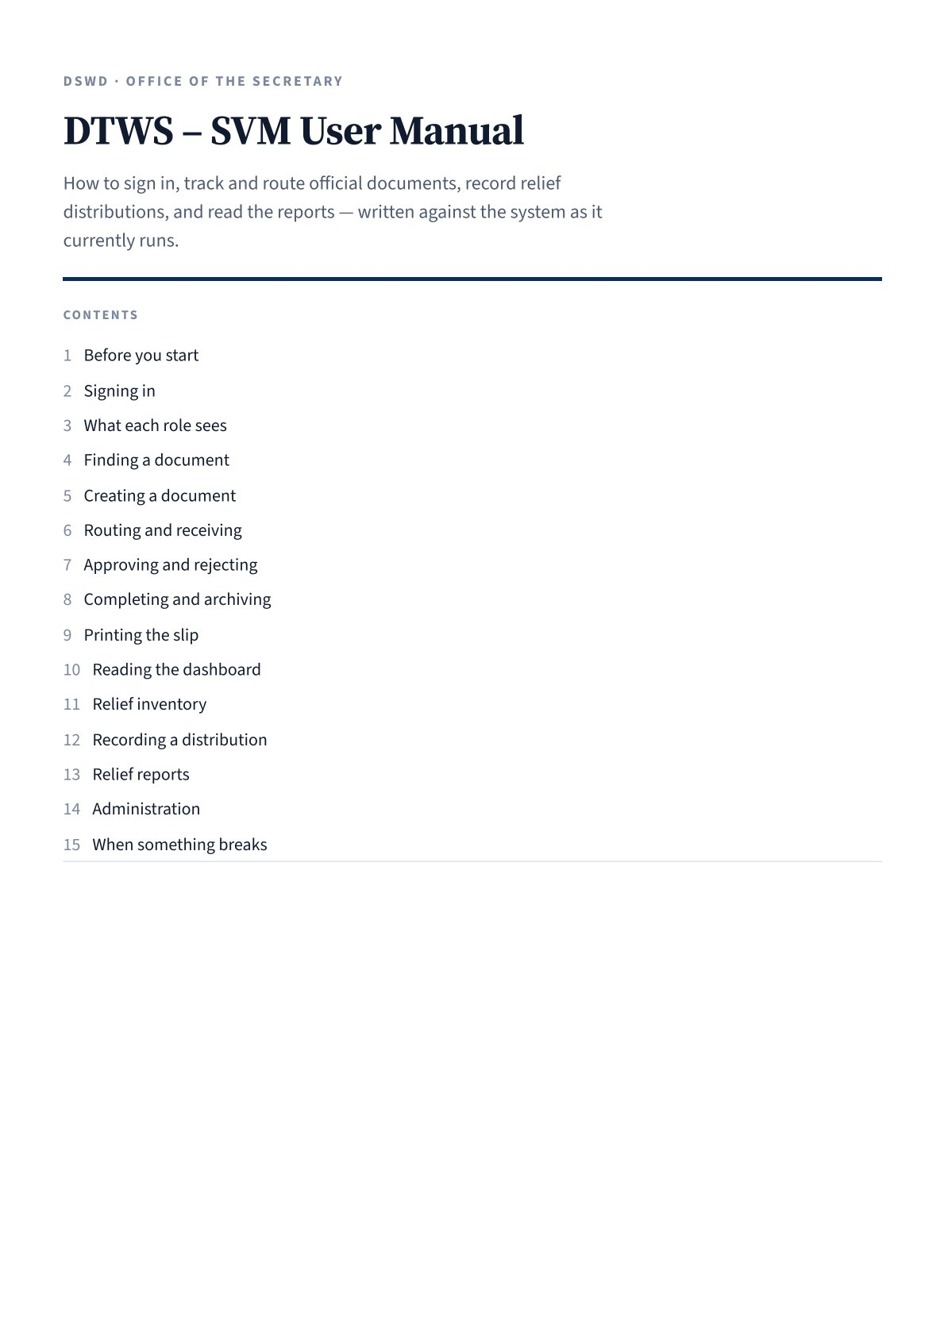

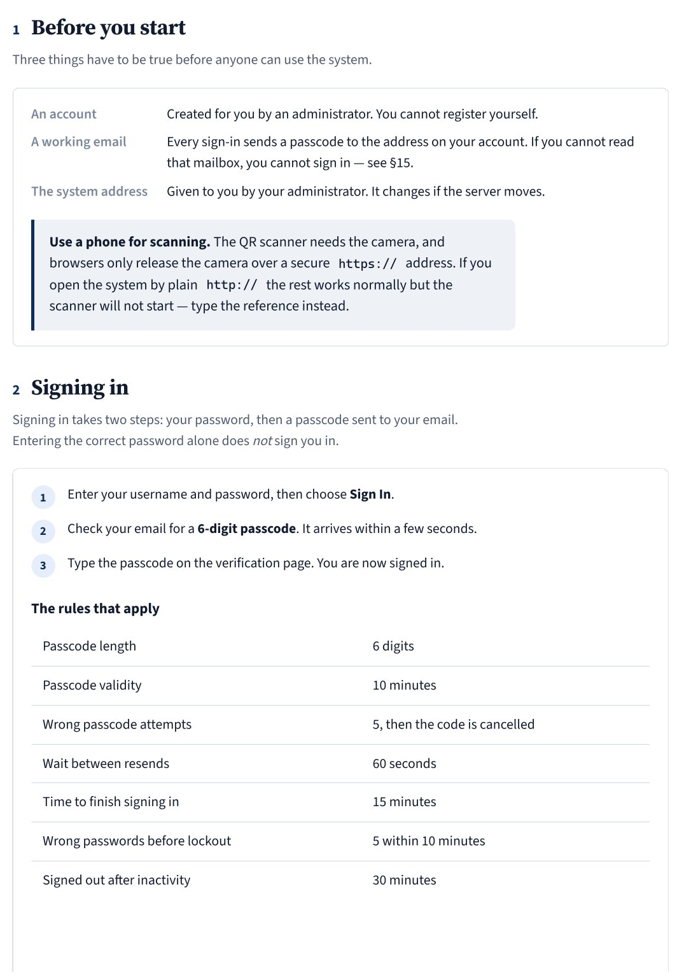
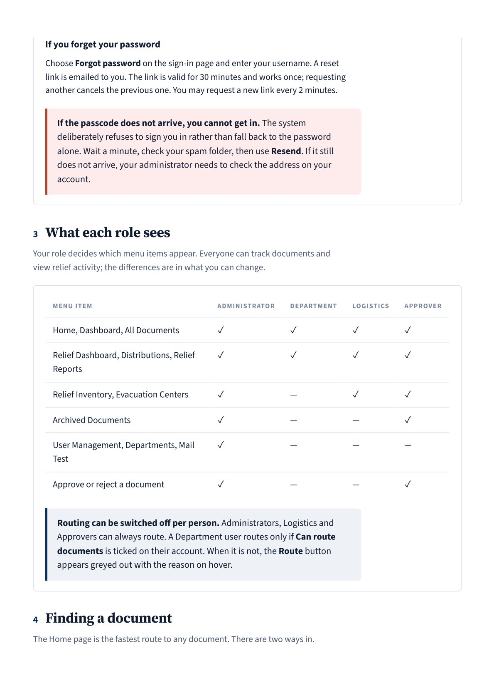
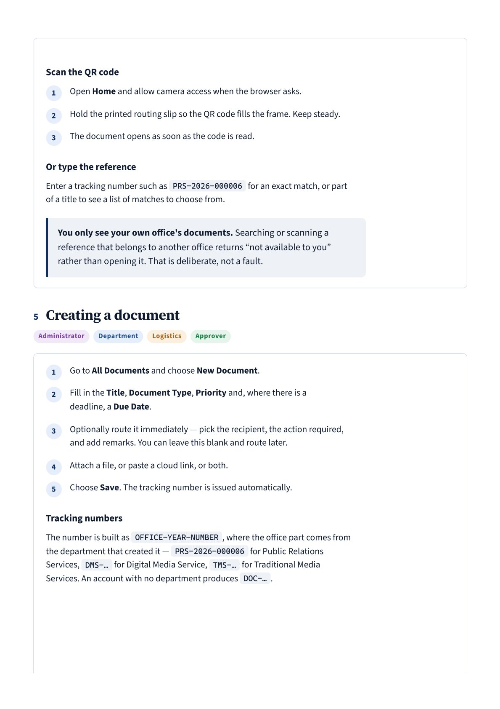
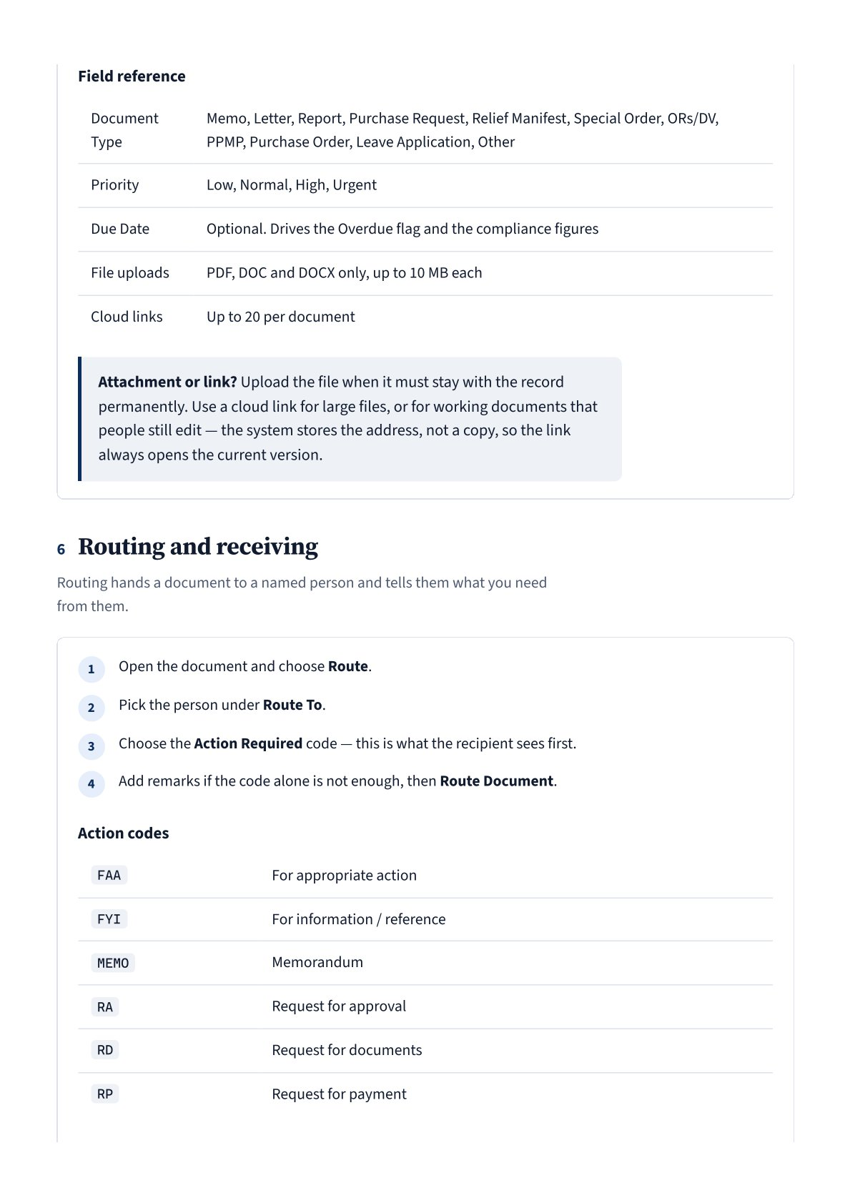
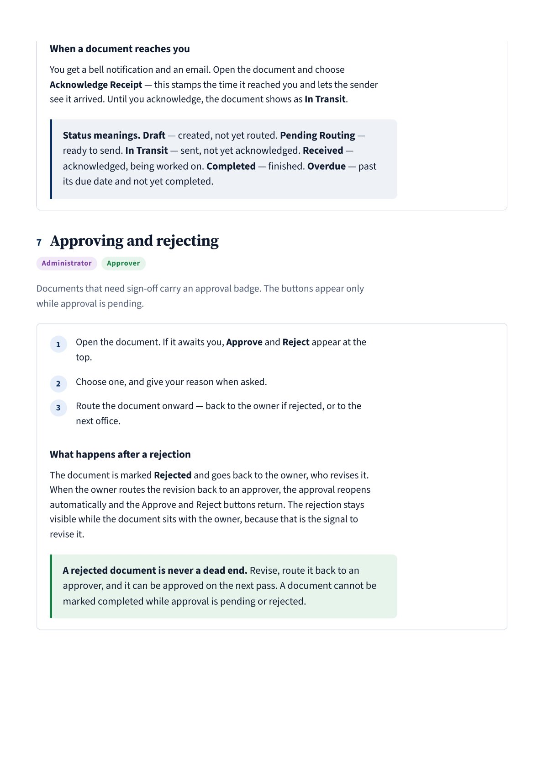
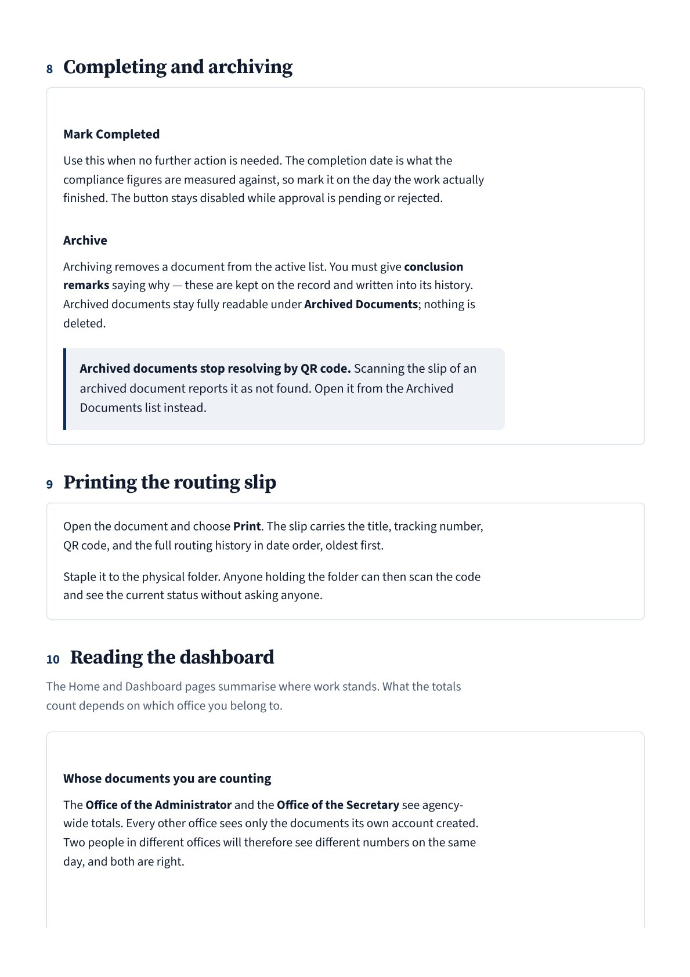
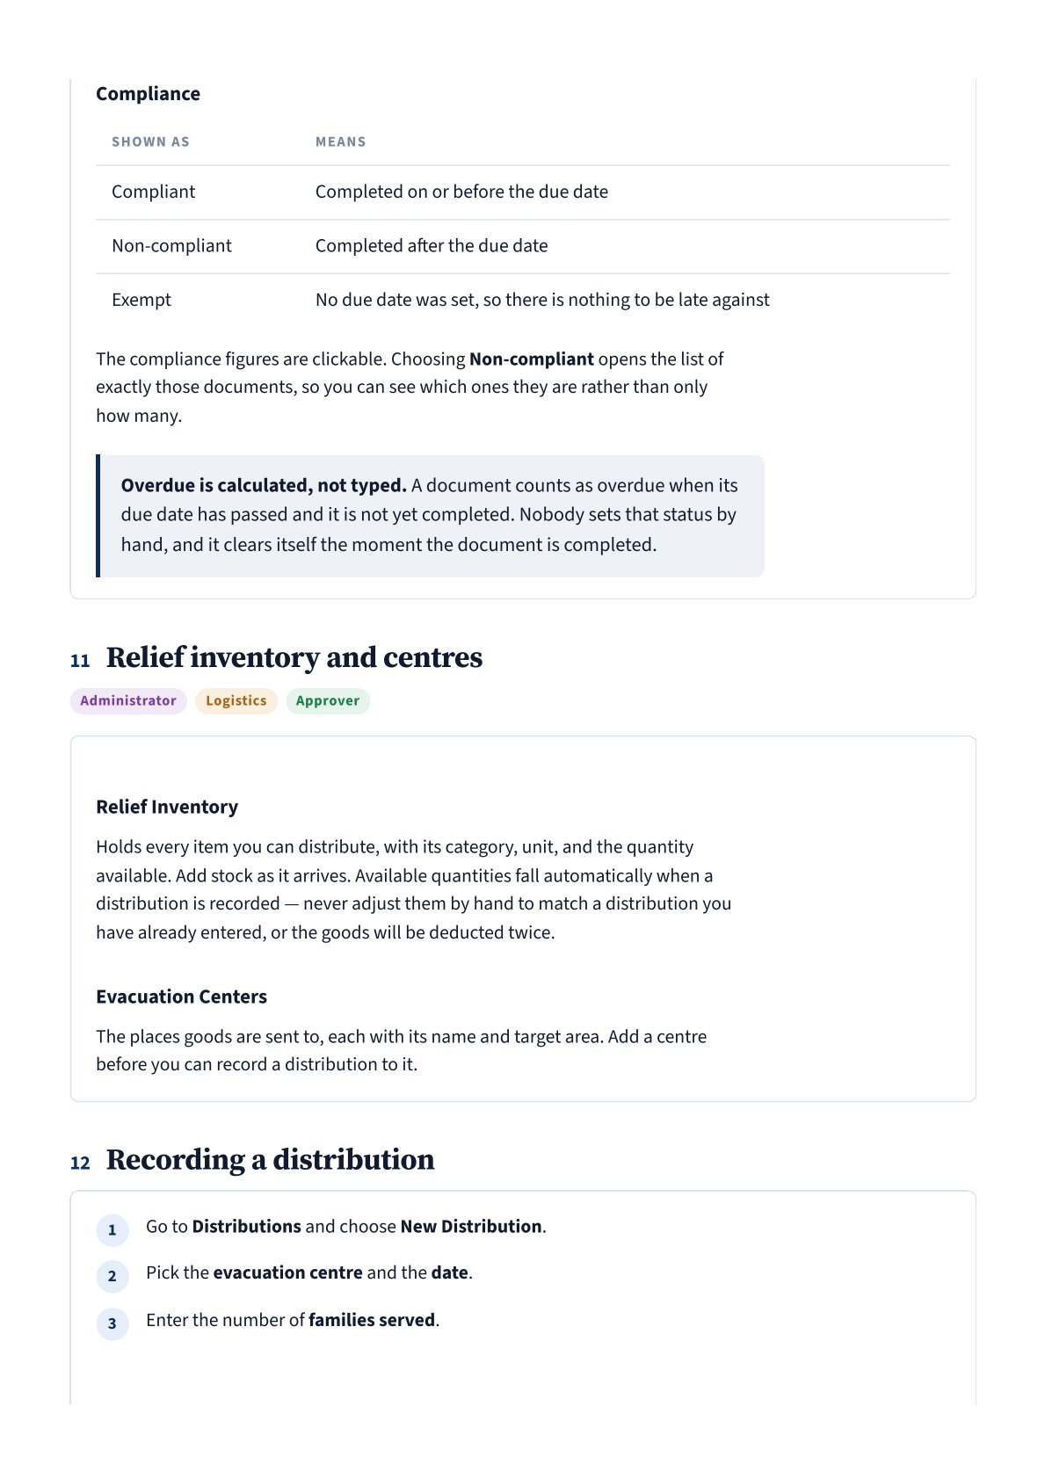
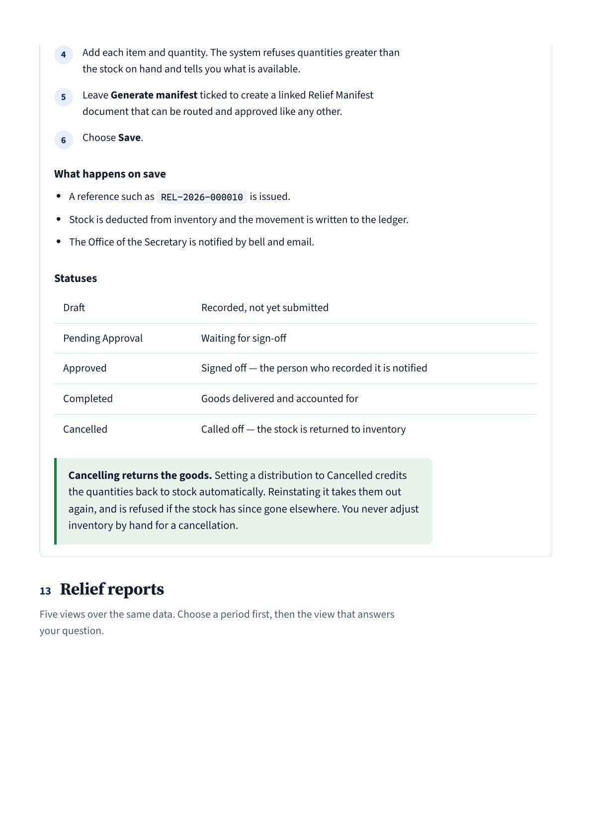
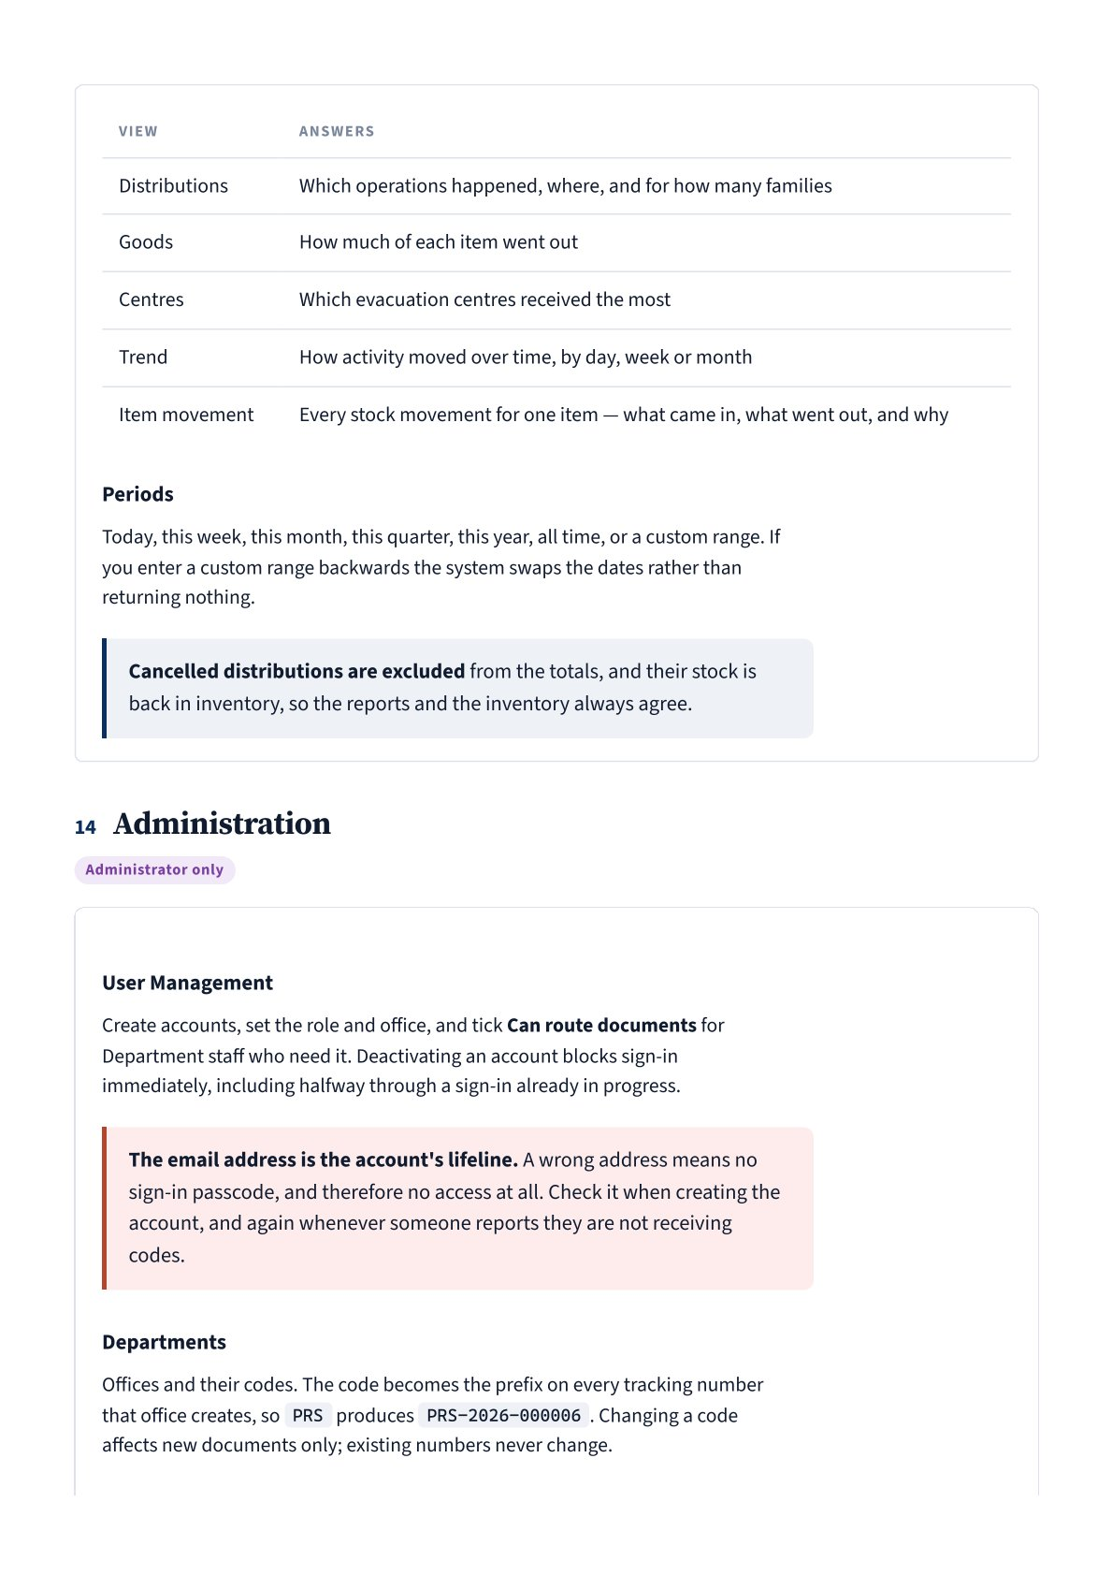
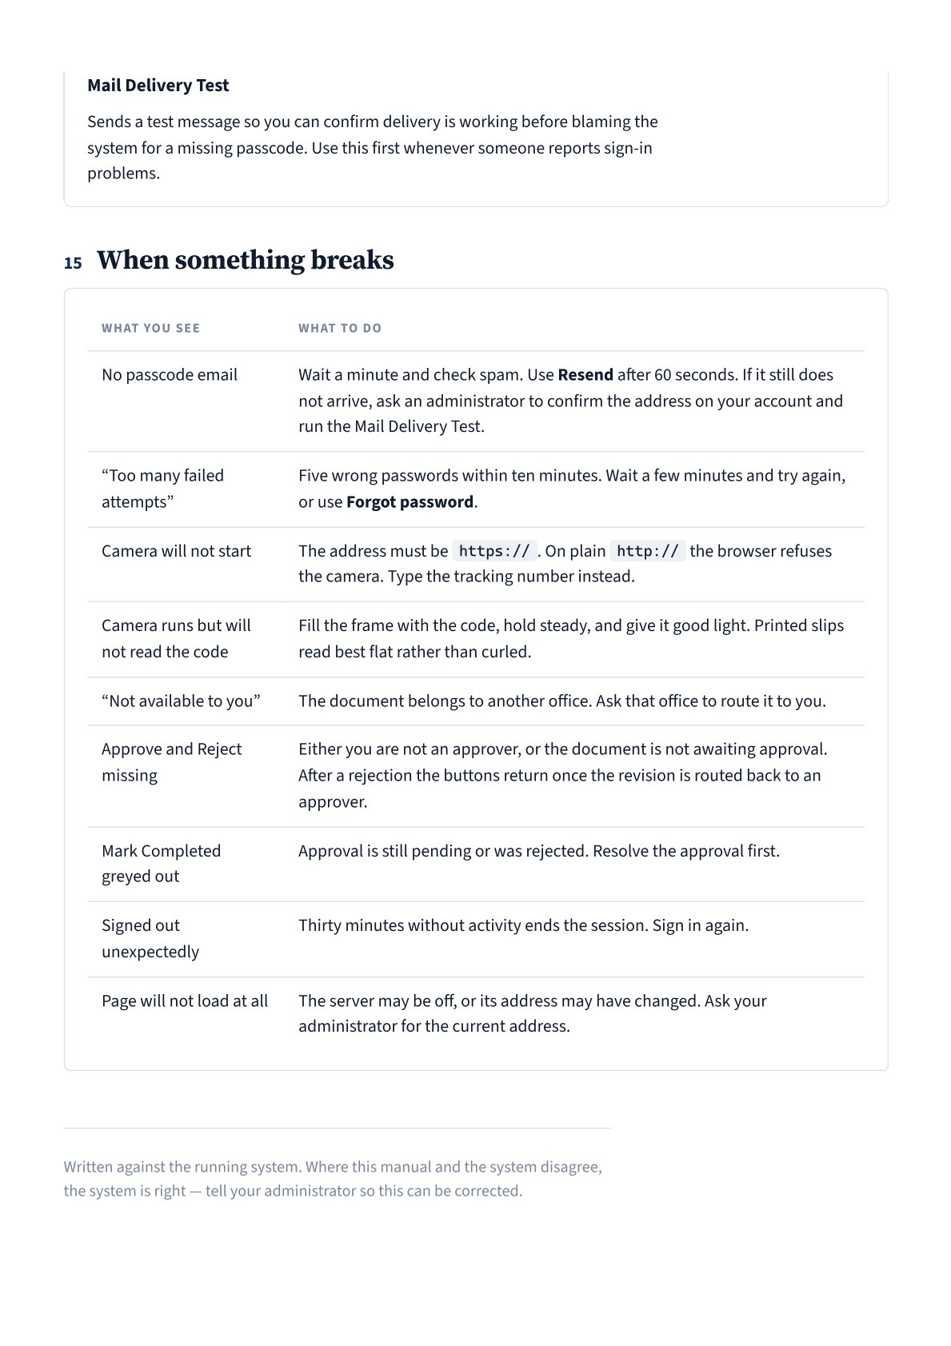

APPENDIX H
Transcripts of Interview / Observation (with photos)
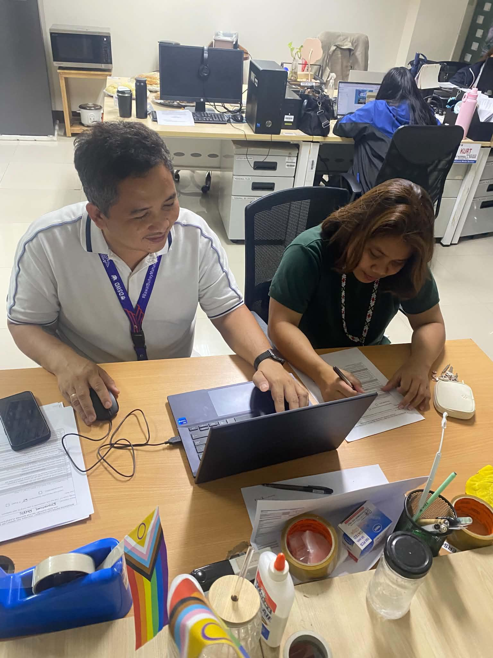
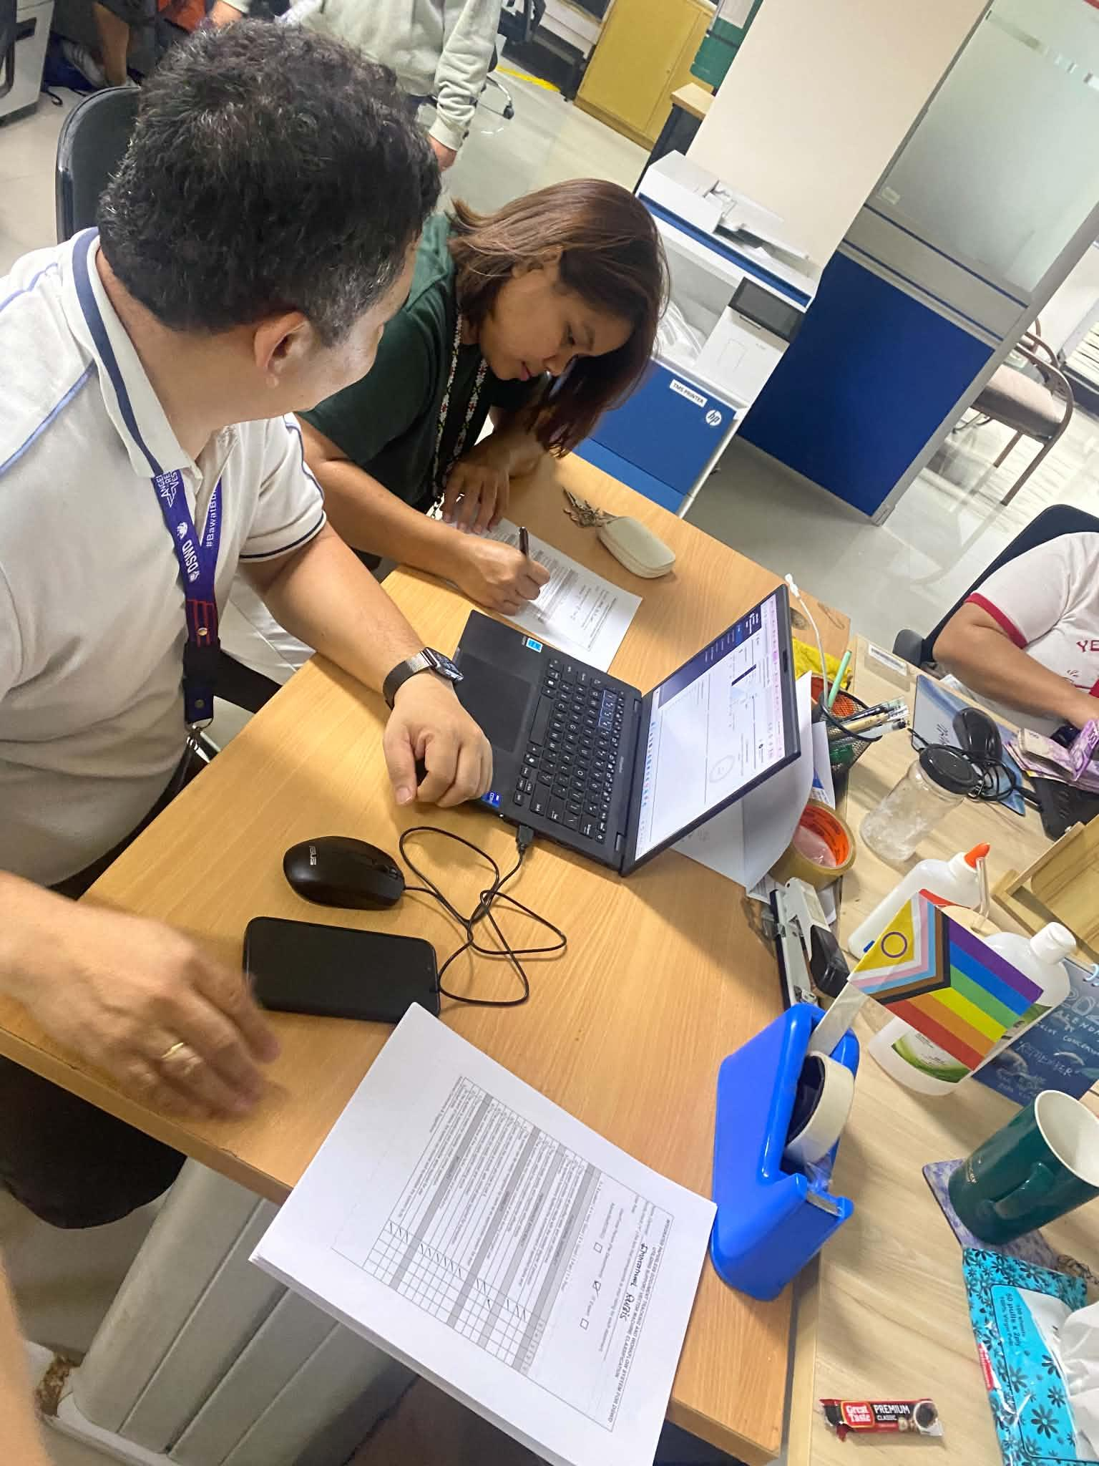

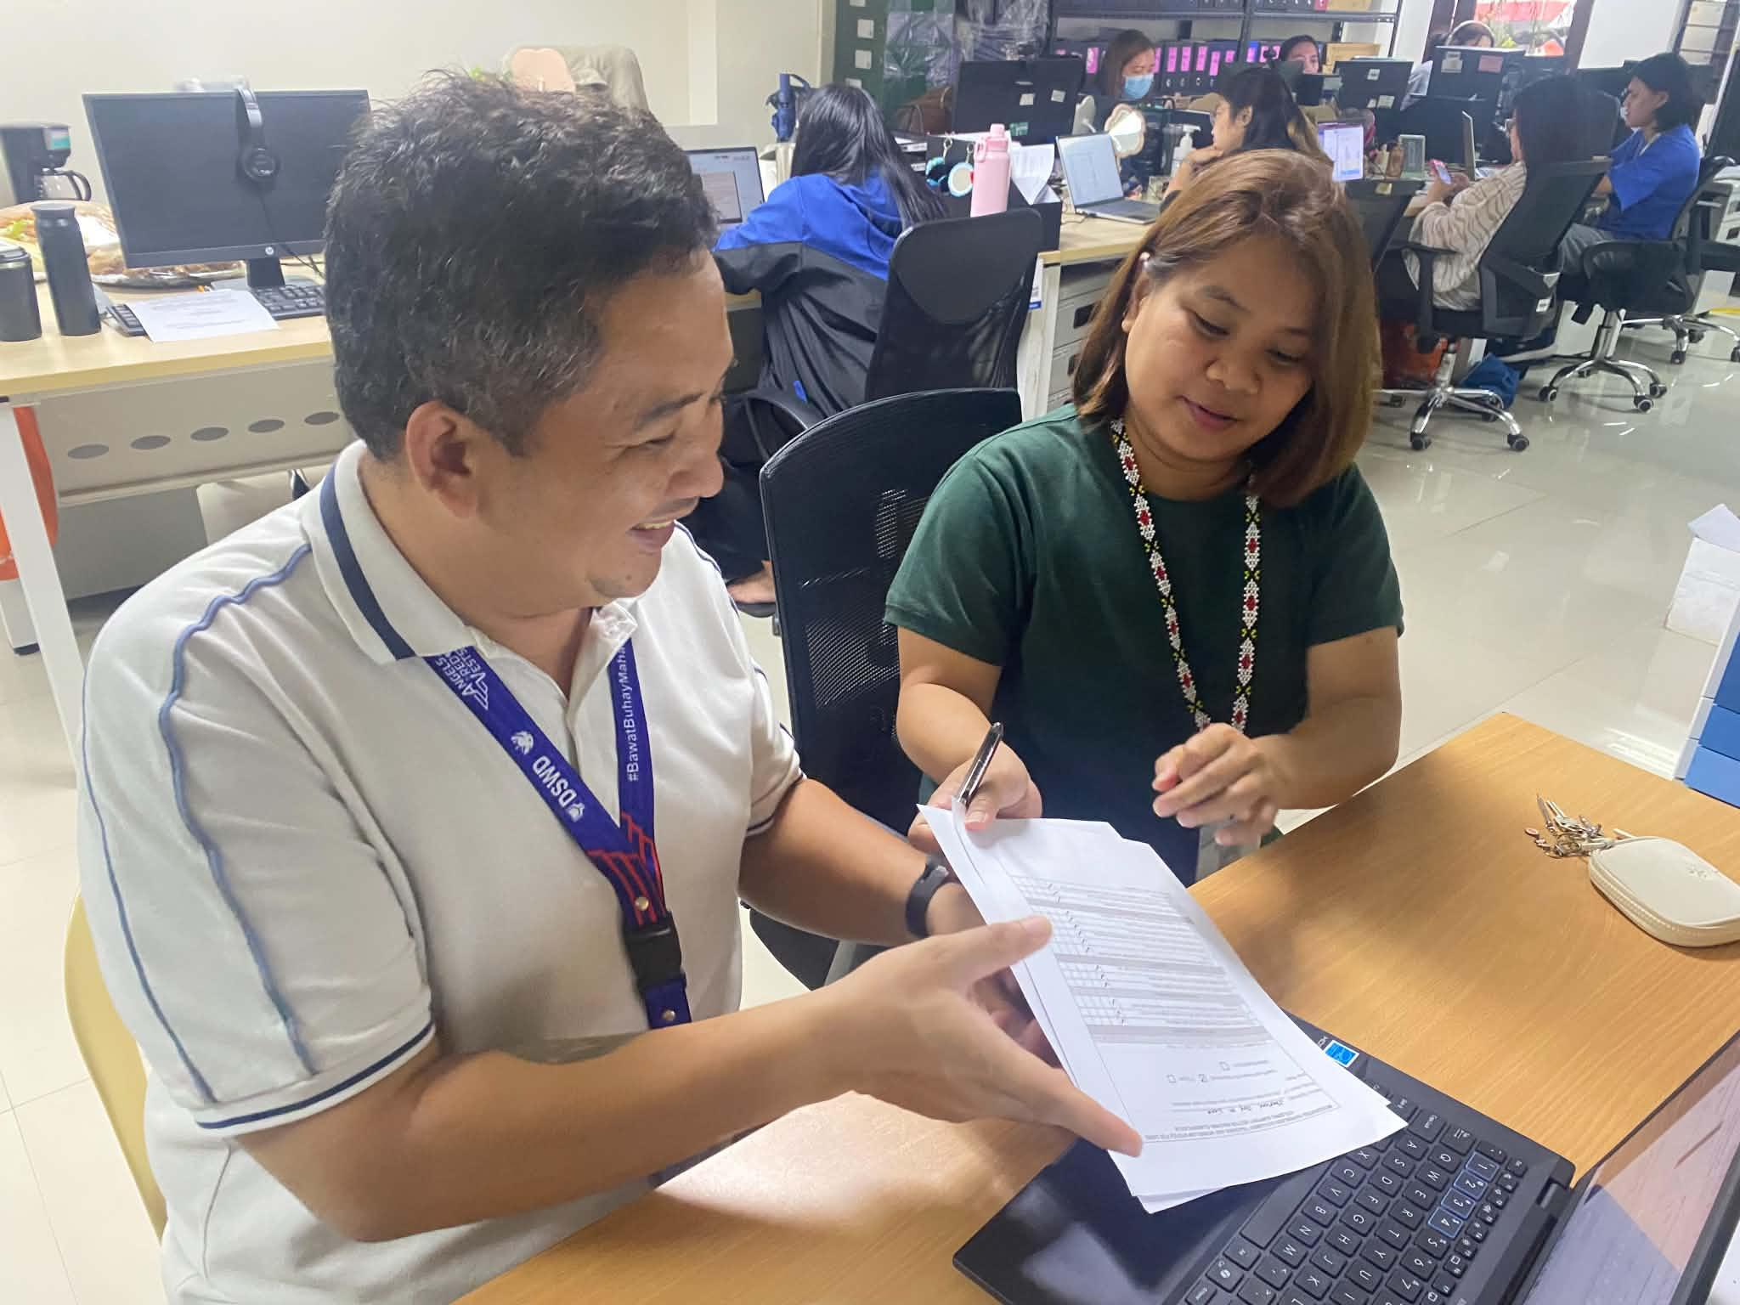

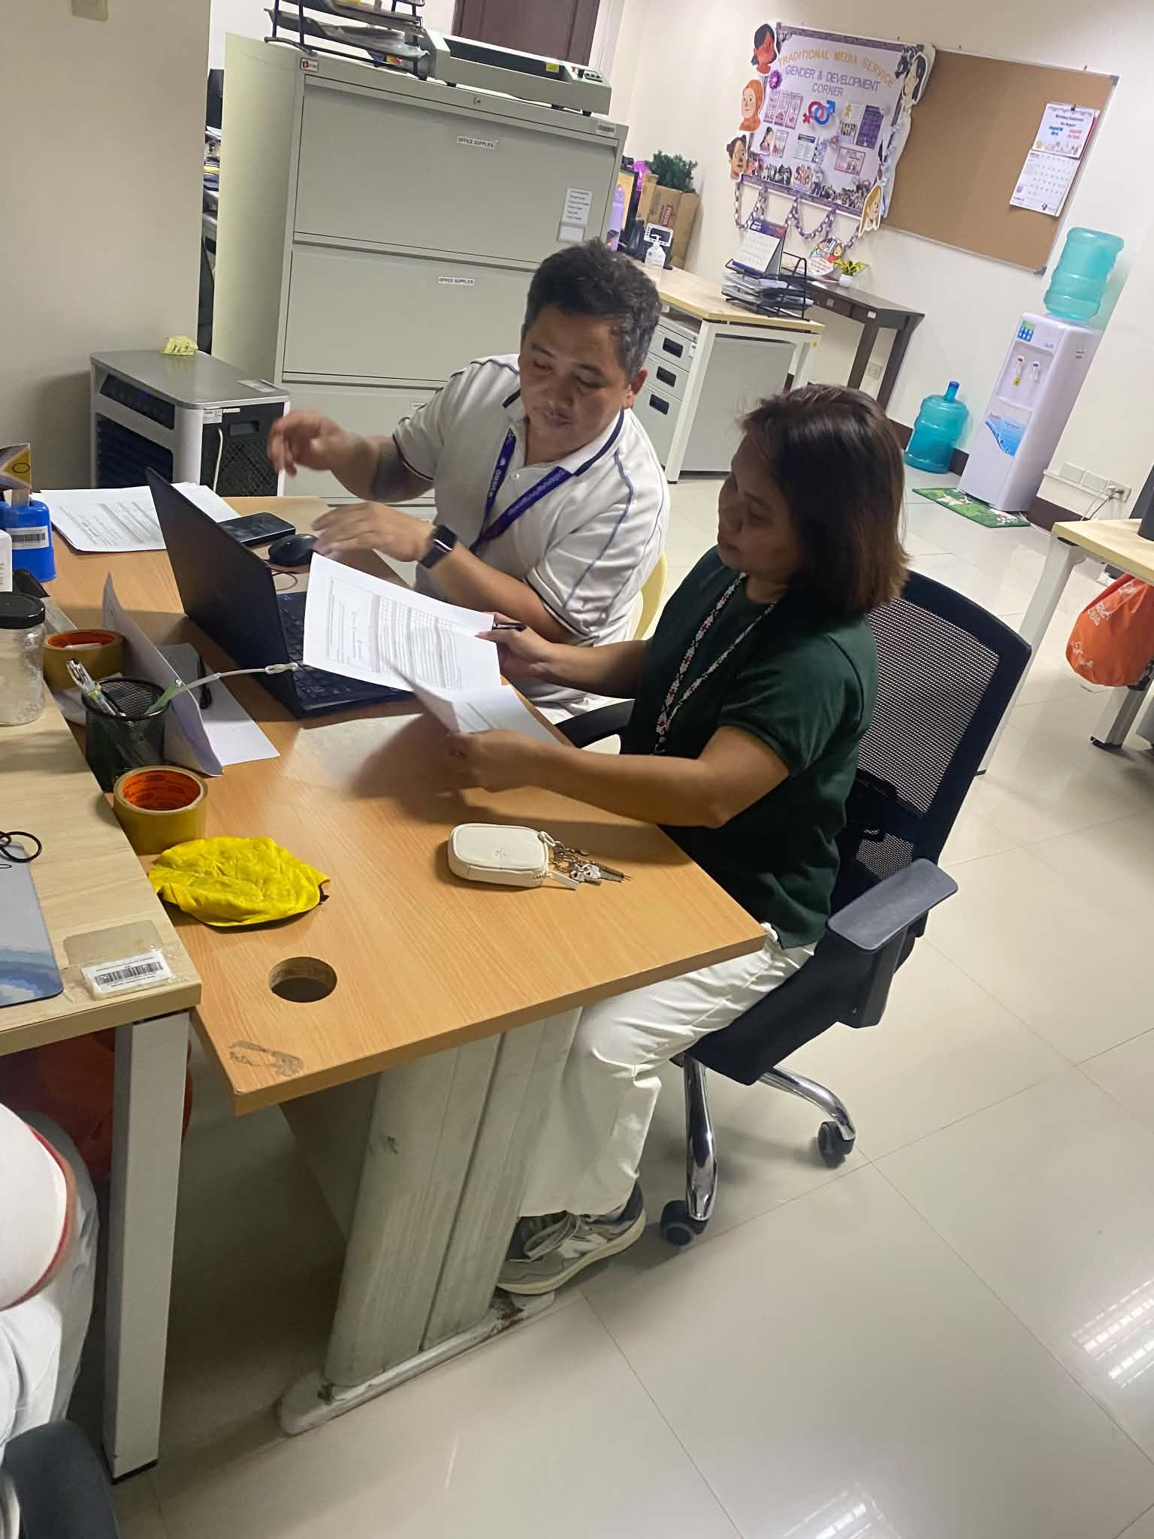

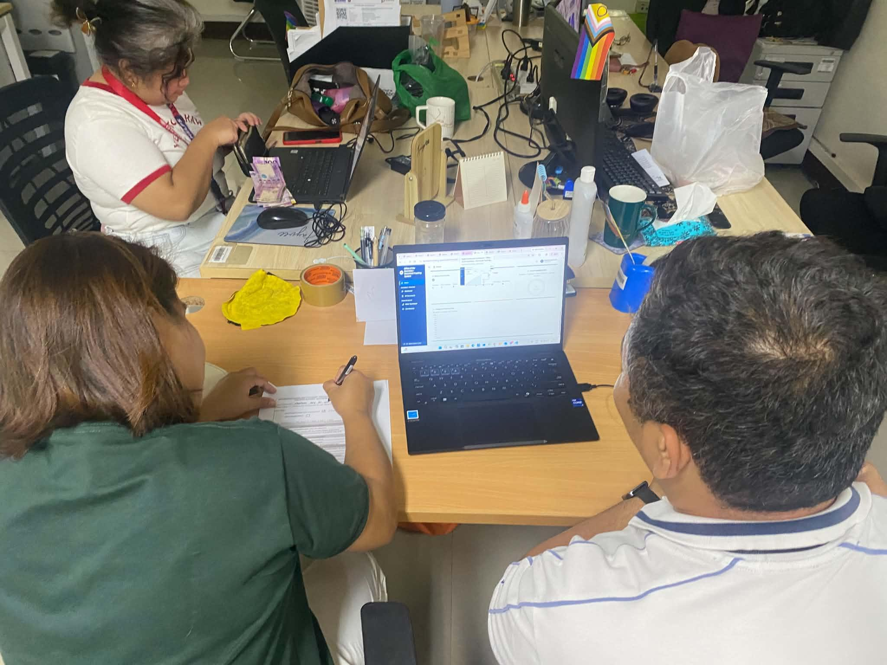

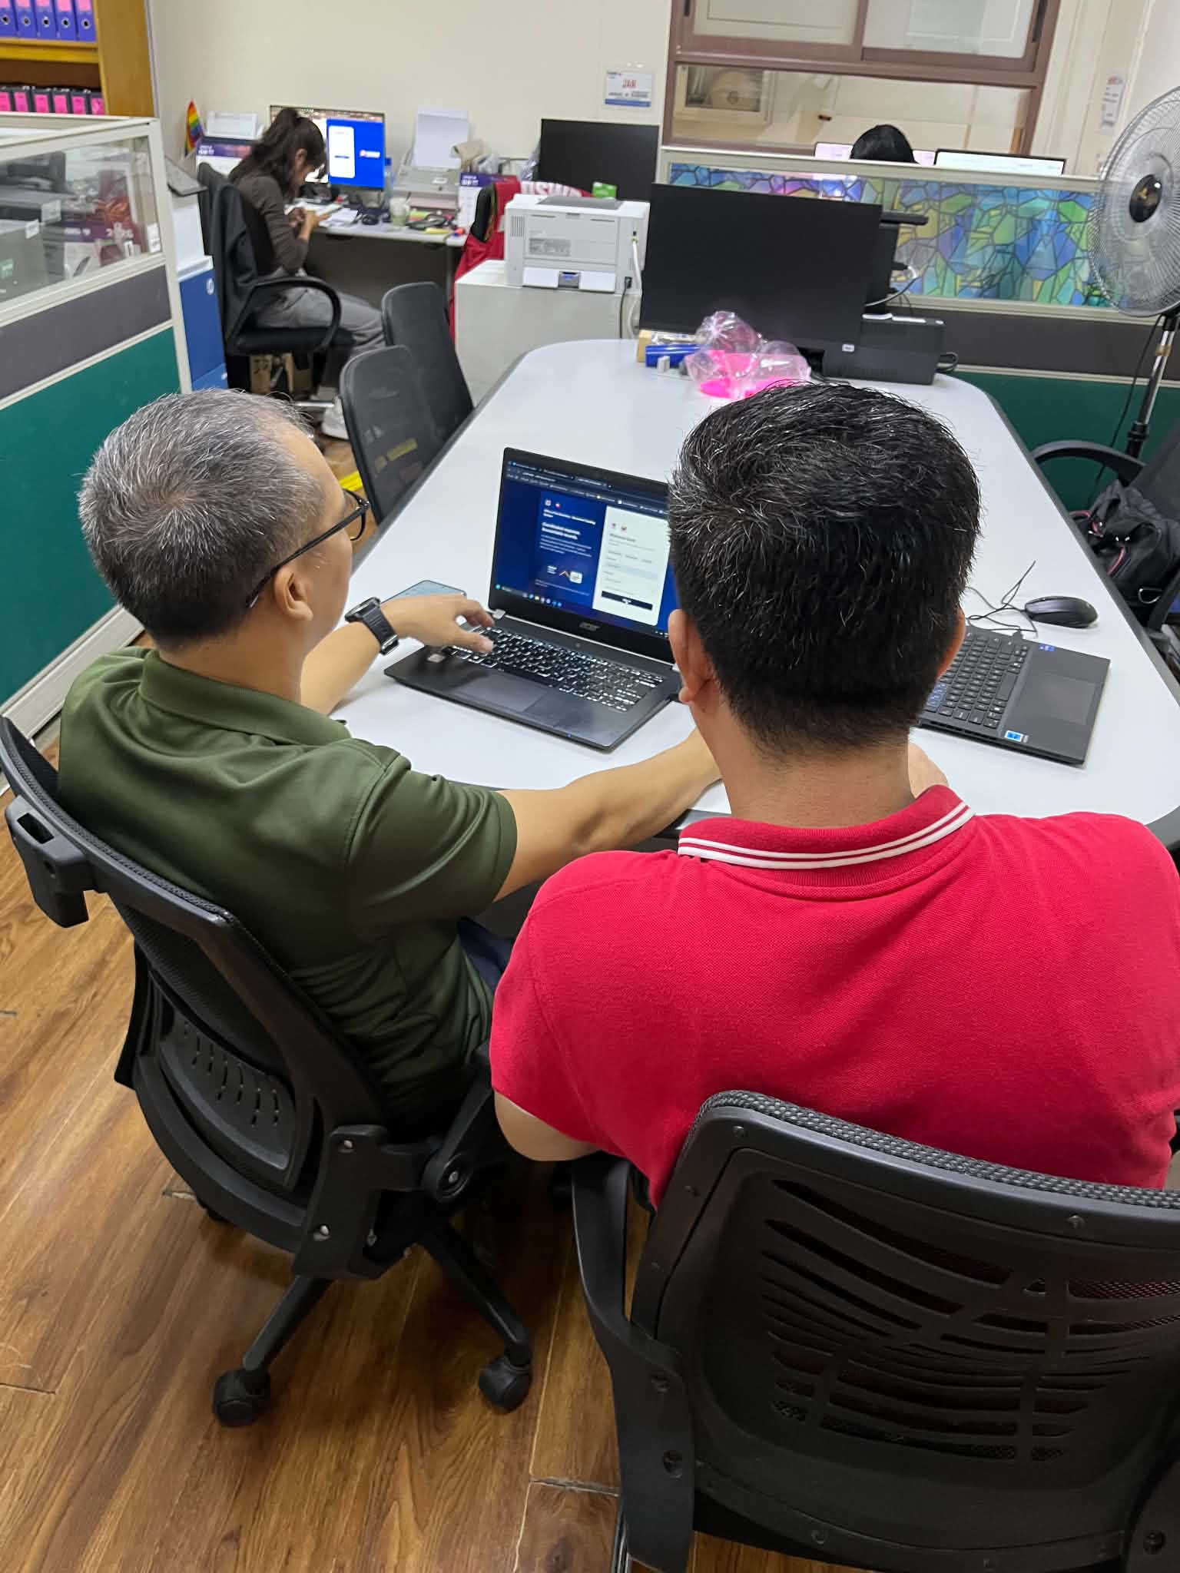

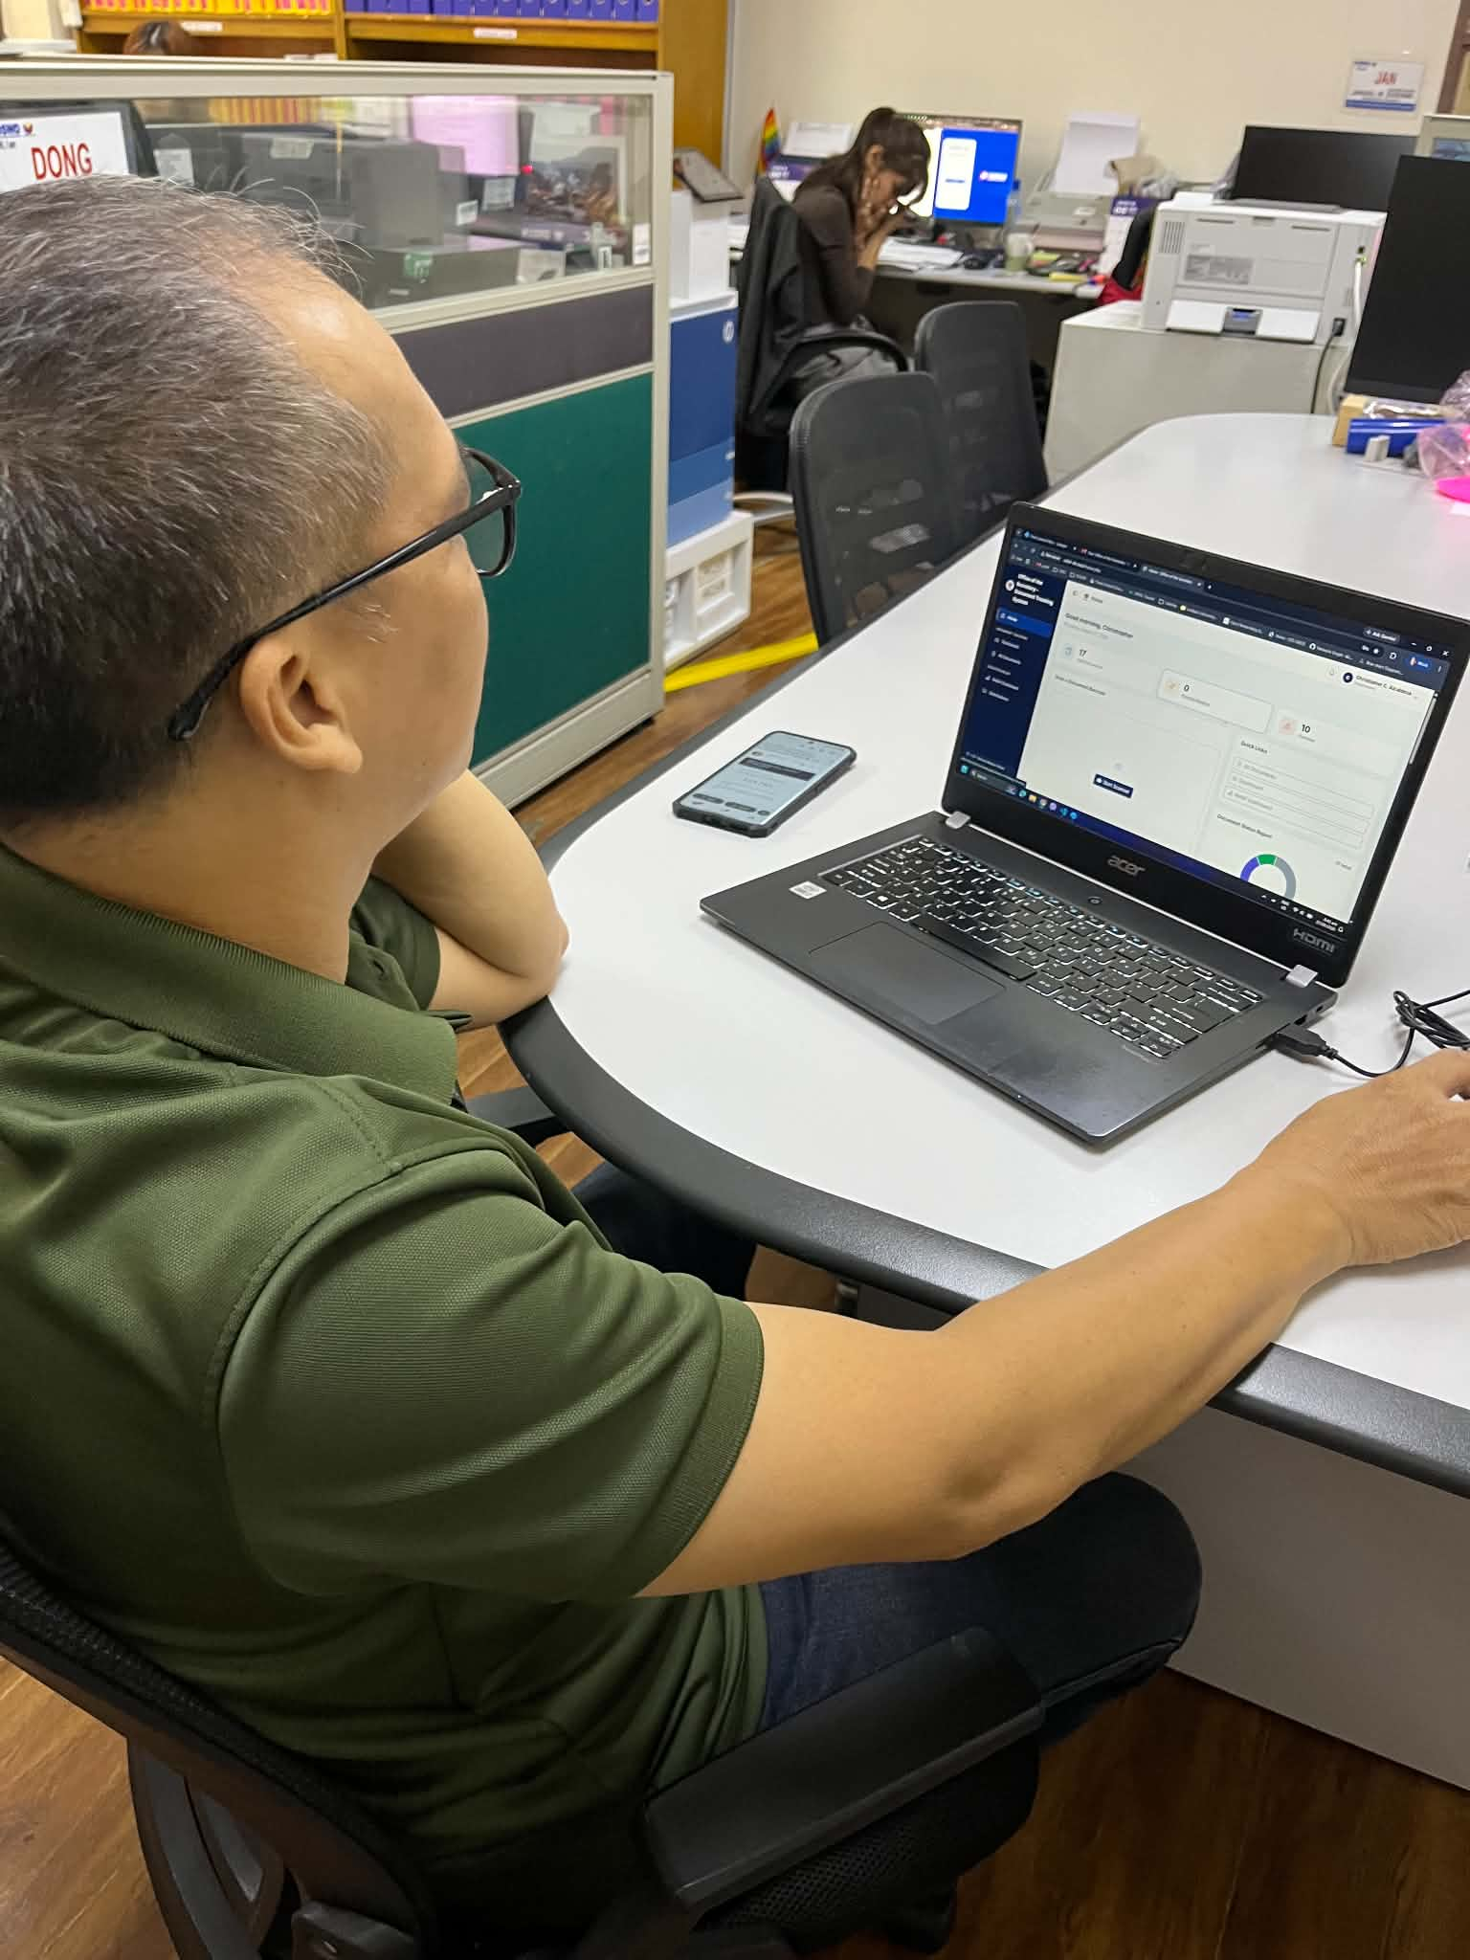

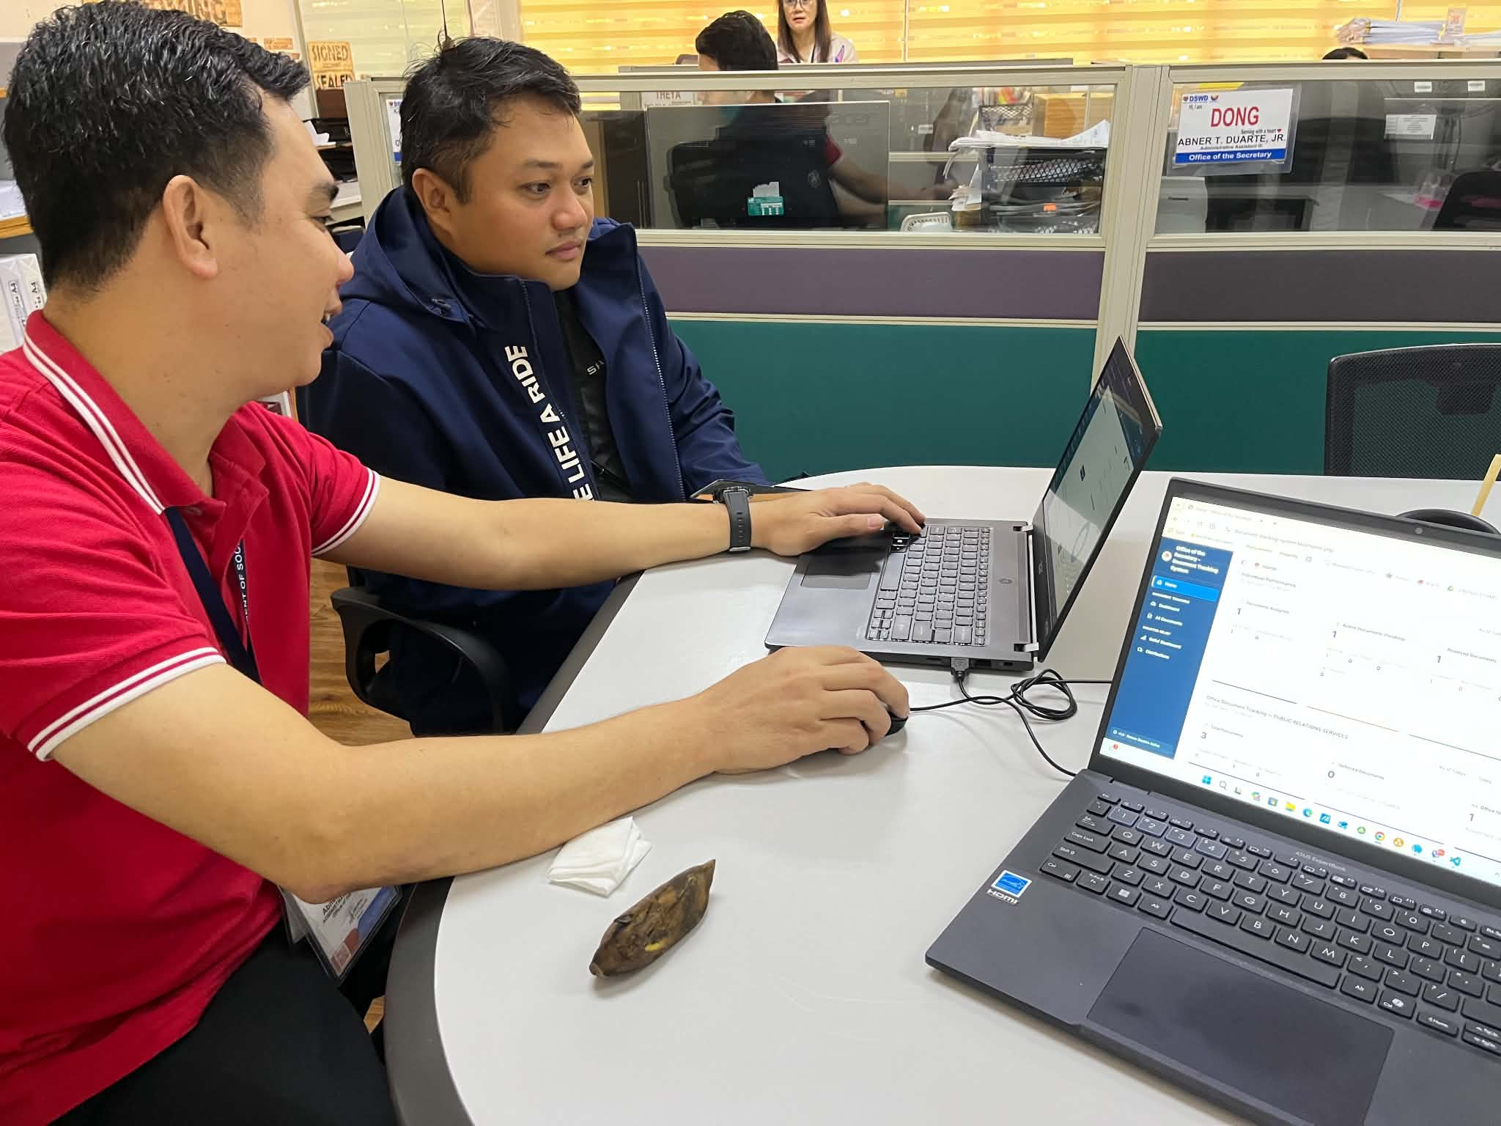

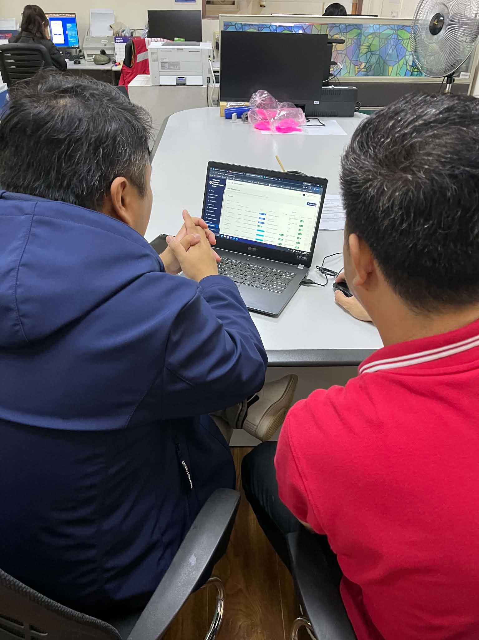

The user acceptance testing was carried out at the respondent's own workstation at the DSWD Office of the Secretary, during office hours and alongside the respondent's normal work. The respondent was given hands-on access to the system's core modules on a laptop and worked through the assigned tasks while the researcher observed. On completing the tasks, the respondent accomplished the printed rating instrument, a copy of which is reproduced in Appendix C.
Two observations were drawn from the session. First, the Department user found the system easy to use and complete. The respondent was able to carry out the assigned tasks and considered the features provided sufficient for the requirements of the office, without identifying any function that was missing. Second, the system was found easy to navigate, the respondent moving between the modules without difficulty in locating the pages or the controls required by each task.
These observations are consistent with the ratings the respondent recorded on the instrument, the same session having produced both. No difficulty was raised during the session that required the observer to intervene, and no defect was reported for correction arising from it. Photographic documentation of the session forms part of this appendix, each photograph being itemised in the User Acceptance Testing Photograph Log together with the module tested, the user-respondent shown, and the date.

APPENDIX I
TOPICAL OUTLINE
Title of the Project Study: INTEGRATED PAPERLESS DOCUMENT TRACKING AND WORKFLOW SYSTEM FOR DSWD UTILIZING SUPPORT VECTOR MACHINE CLASSIFICATION
- Document Tracking System
- Disaster Relief Distribution Monitoring
- Importance of Document Tracking System in the Government
- Paperless Office Automation System (OAS) and Online Tracking of Non-automated documents
- Implementation of Paperless System for Documentation Process
- Development Tools
6.1 Visual Studio Code
6.2 PHP (Hypertext Preprocessor)
6.3 HTML
6.4 CSS
6.5 LARAGON
6.6 Bootstrap
6.7 JavaScript and AJAX. JavaScript

- Evaluation System

- ISO 25010

- Testing
9.1 User Acceptance Testing

APPENDIX J
INTERVIEW QUESTIONNAIRE

